**Hassell Primary School**

**How to use our school’s Google Classroom**

Please help your child to follow these steps so they can continue to complete learning activities, hand them in, and get feedback from teachers while they can’t come into school.

**Note:** your child will need their log-in details for their school G Suite for Education account to complete the steps below. If they can’t remember these log-in details, please email your child’s class teacher

**Smartphones and tablets: download the free Google Classroom app**

| **Android devices** | **iOS devices (iPhones, iPods, and iPads)** |
| --- | --- |
| Open the Play Store app  Search for ‘Google Classroom’  Tap ‘Google Classroom’  Tap ‘Install’ | Open the App Store app  Search for ‘Google Classroom’  Tap ‘Google Classroom’  Tap ‘Get’ |

Once the app has downloaded, open it.

Then, your child needs to:

* Log in to their G Suite for Education account
* Tap the '+' icon (in the top-right corner), then 'Join class'
* Enter the class code that their teacher has provided, then tap ‘Join’

Computers and laptops: log in to Google Classroom

Your child needs to:

* Go to [www.classroom.google.com](http://www.classroom.google.com)
* Log in to their G Suite for Education account. This uses the gmail address sent home.
* Click the '+' icon (in the top-right corner), then 'Join class'
* Enter the class code that the teacher provided, and click ‘Join

When you have logged in click on the dots and then on google classroom

Where it says sign in at the top right, click then enter your child’s school email address and password to log in

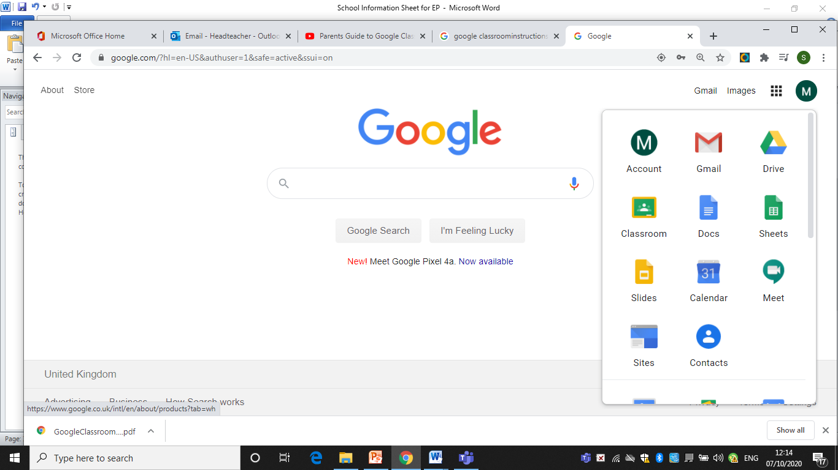

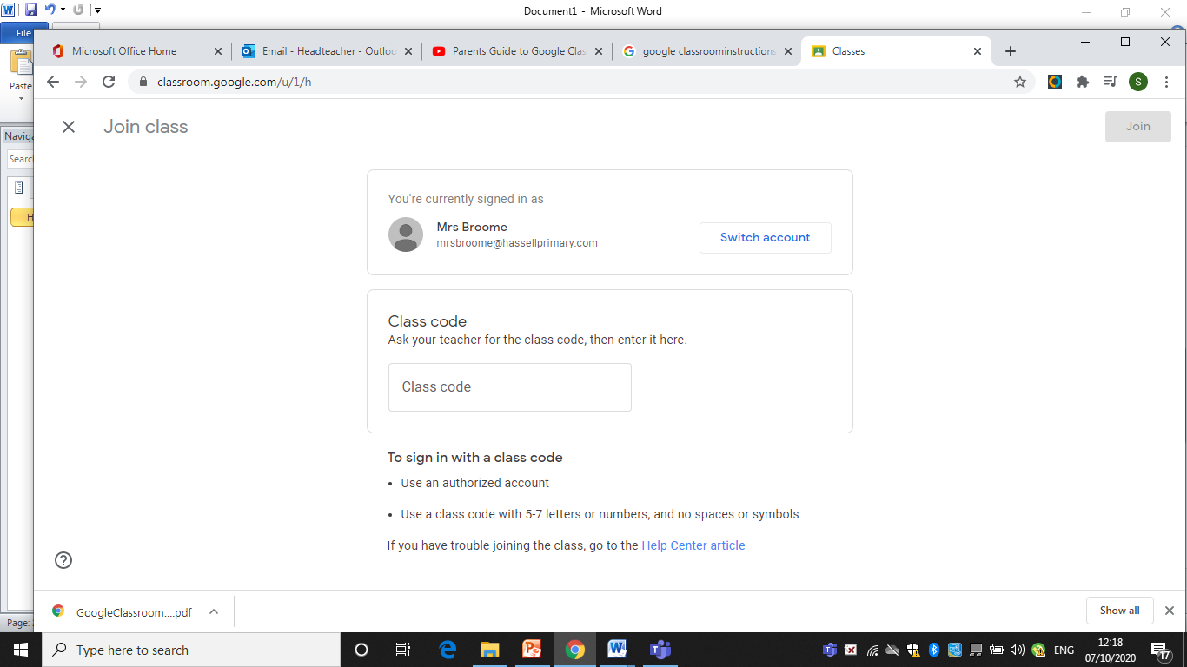

Enter code here.

This will take you to your child’s class page

A screen like this will come up 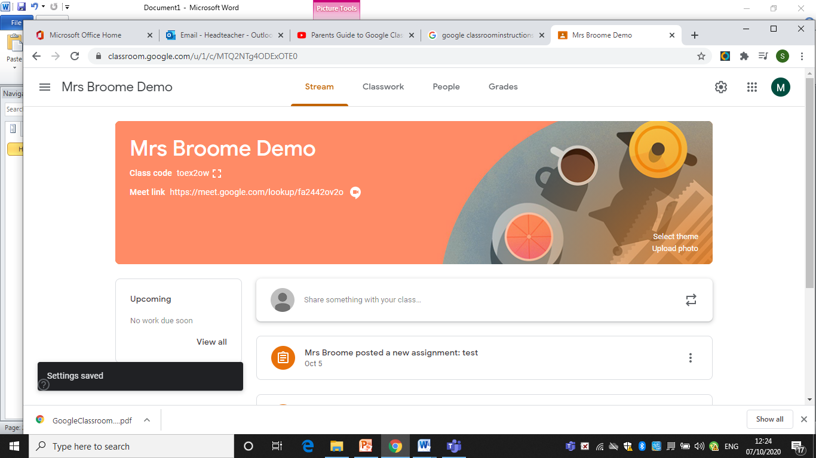:

This is where your child can access their class work and hand things in.

This is the stream where messages from your class teacher will be displayed

A google meet link allows your child to click on it and join a class video call each day. This will be at a set time and is controlled by the teacher. Children will be able to see each other as well.

**How to get and hand in work (computers and laptops)**

Your child needs to:

Go to Google Classroom (see link above)

Click ‘Classwork’

Click on an assignment, then ‘View assignment’

On the right-hand side of the page, click ‘Add or create’. Follow their teacher’s instructions on how to complete their work

Once they’ve finished, click ‘Hand in’, then ‘Hand in’ again to confirm

**Made a mistake?** Click ‘Unsubmit’ to return the work, and follow the last two steps to resubmit it.

**How to hand in work (mobile devices – Android or iOS)**

Your child needs to:

Open the Google Classroom app

Tap on their class, then ‘Classwork’ (at the bottom)

Tap on an assignment, then the arrow at the bottom

Tap ‘Add attachment’. Follow their teacher’s instructions on how to complete their work

Once they’ve finished, tap ‘Hand in’, then ‘Hand in’ again to confirm

**Made a mistake?** Tap ‘Unsubmit’ to return the work, then follow the last two steps to resubmit it.

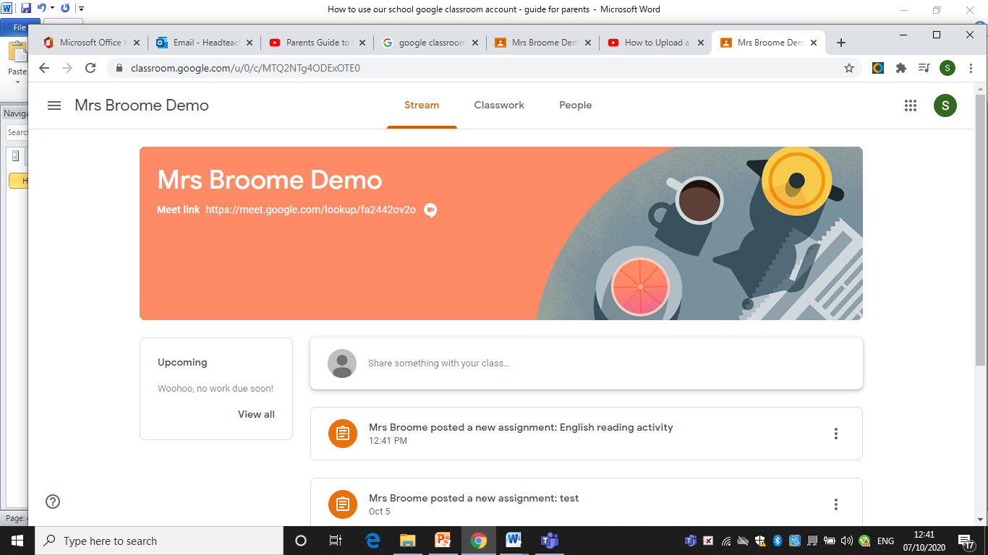

This is where you can see work that it is set.

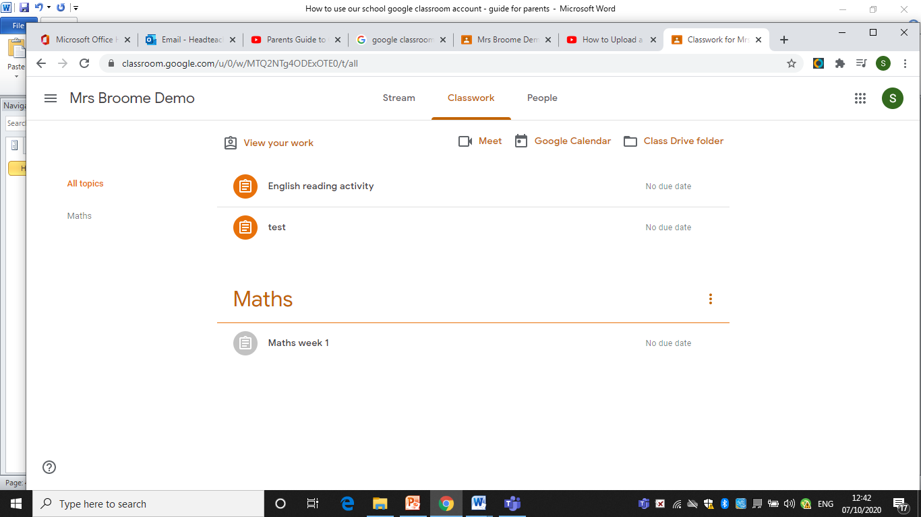

Click on classwork and you can see a list of work set.

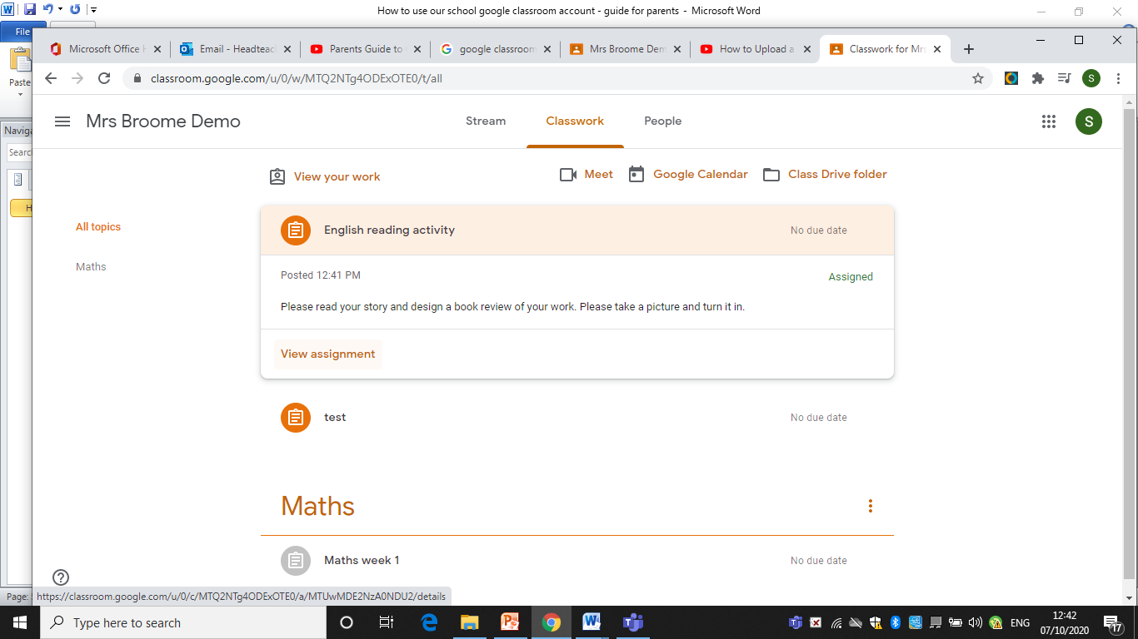

Click on view assignment and further details come up

**Adding a photo**

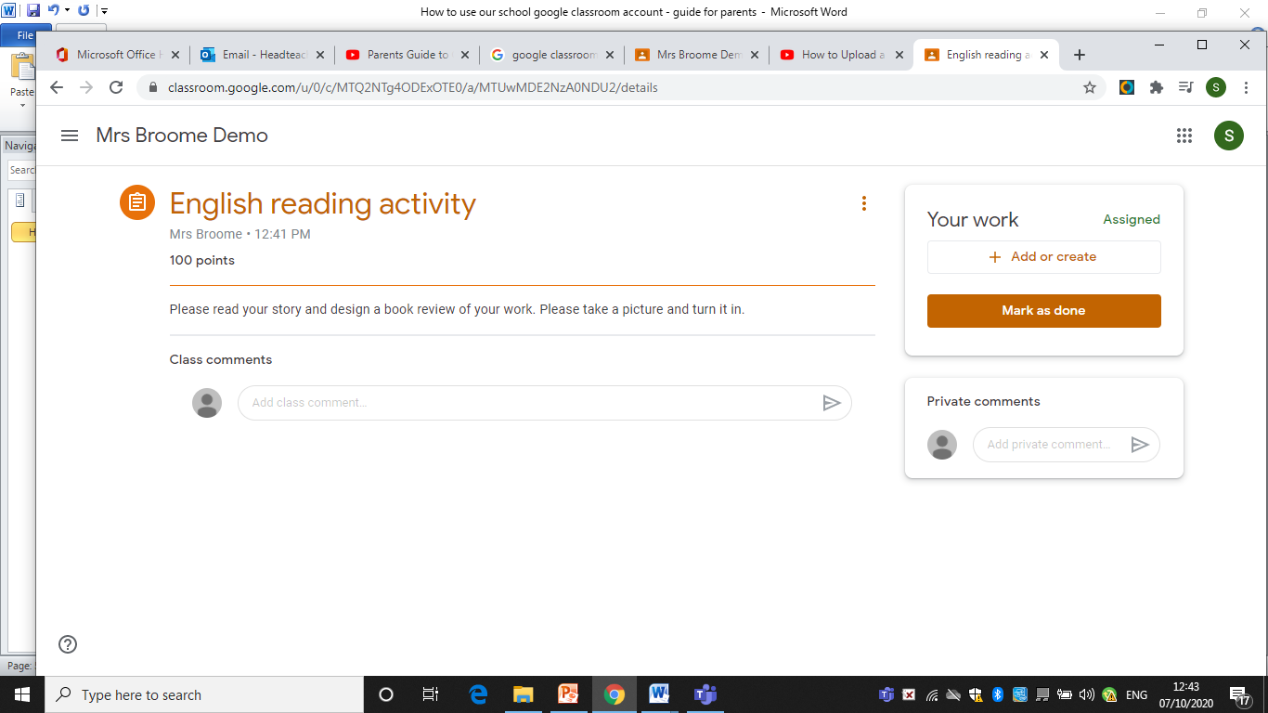

To add a photo, click on add or create

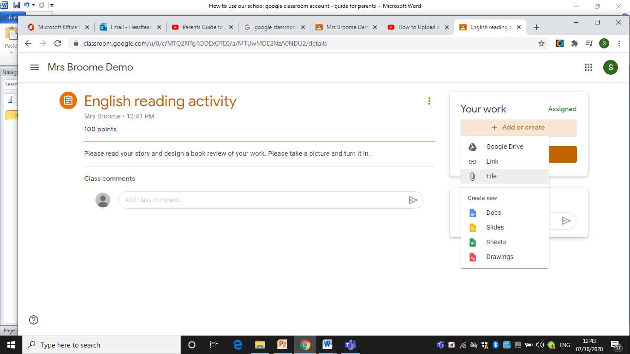

Click on file and choose the photo from your phones files.

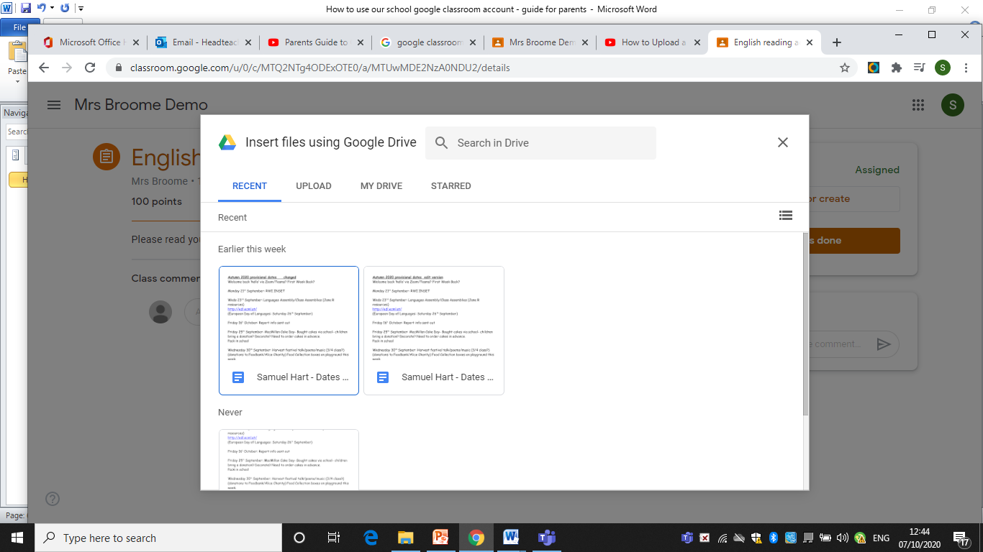

Click upload and you can browse and select the photo on your device. Next upload it.

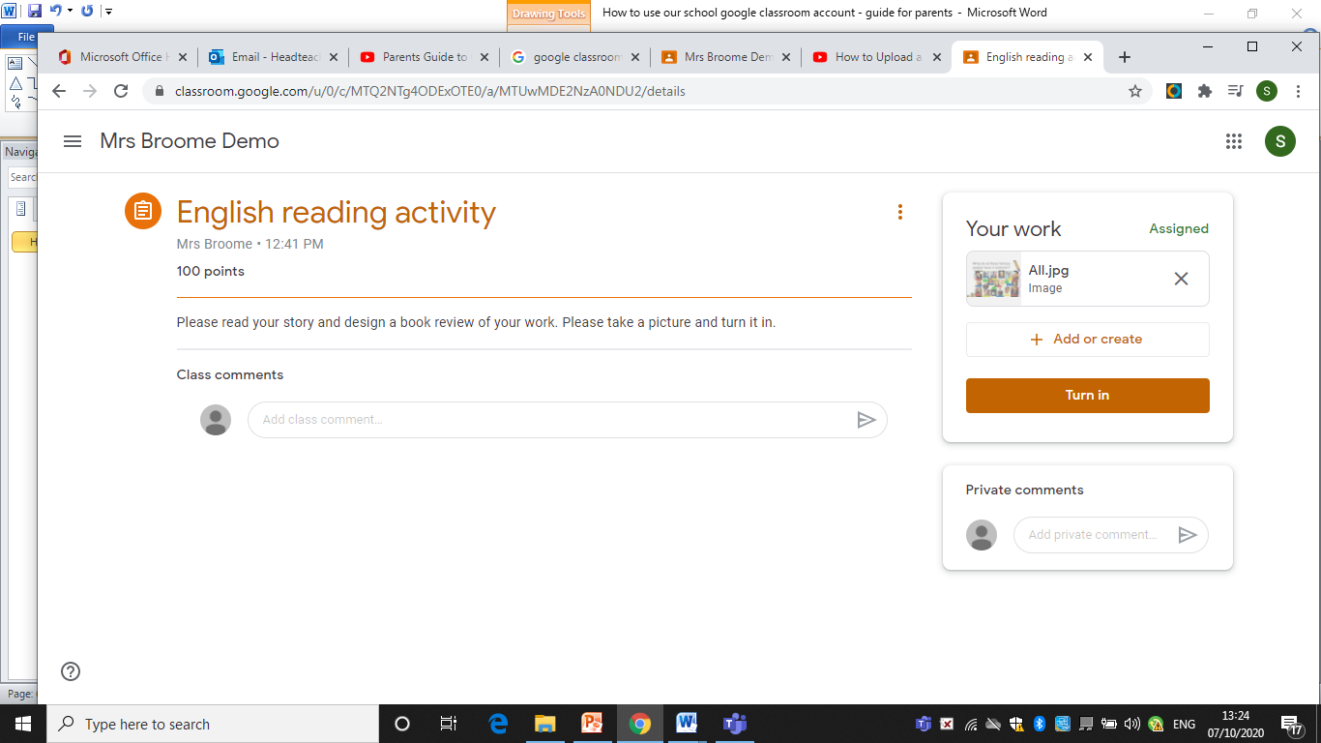

Finally, click turn in and your work will be sent to the teacher.

Your class teacher will email you with comments about your work or click on the photo and add their comments there.

If you have any problems accessing your child’s information, please email your class teacher in the first instance and if it can’t be resolves please email Mrs Broome at [headteacher@hassell.staffs.sch.uk](mailto:headteacher@hassell.staffs.sch.uk)