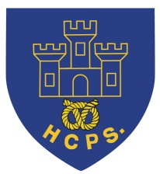 **Hassell Primary Update 15.11.2021**

Dear Parents and Carers,

It has been another busy week with lots of learning taking place at home and school. Thank you once again to those children who are accessing their lesson content via Google Classroom and sending work back. If you have any problems accessing the information, please let us know and we will help all we can. It is really important that we have **DAILY** contact with all of our children, so if you are home learning and we haven’t been able to contact you this week, please get in touch with us on Monday.

If anyone has problems with connectivity or resources, please let us know and we will do all we can to help. We have emailed a range of help documents fo Google classroom and have also added these to our school website. All children have at least 2 opportunities per day to have live sessions with our teachers, but don’t hesitate to contact us if you have problems and need additional support.

**Year 5/6 Closure**

Sadly, we have had to close our year 5/6 bubble until the 25th January due to a positive case. Although everyone is doing all we can to stay safe, we do have a significant number of children in school within all year groups. The Government advice currently remains the same that we are open to vulnerable children and those who have parents that are critical workers. However, we do ask that parents really consider whether their children need to be in if it is possible for them to stay at home. Children who are entitled to places can also come in on a part time basis if they are able to stay at home on any days. We really appreciate your support with this in order to limit contact between people and keep everyone in our school community as safe as possible.

**Additional PE lessons**

There may be opportunities for classes to have additional PE lessons during the week. We will let parents know via text message if this is the case so that your children can come to school prepared for their lessons.



**Water bottles and snacks**

Please can all children remember to bring their water bottles with them into school each day so that they are able to access water easily. Fruit snacks can also be brought in for breaktimes due to the limited availability of deliveries.

Our kitchen staff are continuing to prepare hot meals at lunchtime for the children. We are currently having to have a reduced menu but hot food is available daily. Any parents who pay for meals should continue to do so via parent pay.



**Half Term Holiday**

The February Half Term holiday is from the 15th to the 19th February. Currently there are no plans for this to change but if anything alters we will let parents know accordingly.

**SATs tests**

All key stage assessments (Y1 phonics, Y2 Sats, Y4 tables check and Y6 Sats) have been cancelled for this academic year. Teacher assessments will continue as normal.

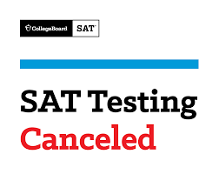

Have a lovely weekend

Kind Regards

Kirsty Broome

Headteacher