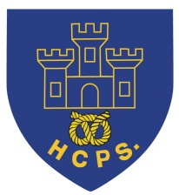 **Hassell Primary Update 17.12.2020**

Dear Parents and Carers,

As we near the end of term the children are busy having fun and celebrating with their classes. Friday 18th December is the last day in school and is non uniform. (No charge, just for fun).

I would like to say well done to all our children who have been invoved in class songs, class assemblies and a bigger production with the Orme Academy. All recordings will be posted via google classroom and, where possible, via the school facebook page. We hope you enjoy watching them.

Below is the information regarding the Song Book project that Year 5/6 have taken part in:

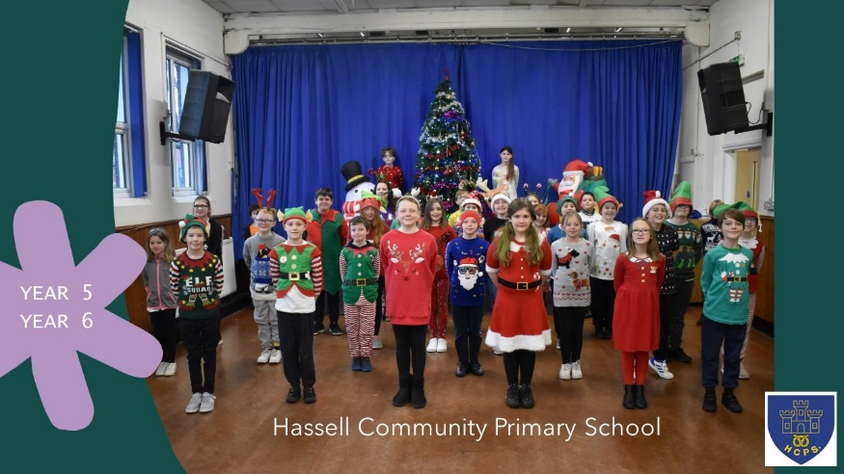

**Songbook 2020 - A Whole New World 300 Children - 8 Schools - 1 Voice**

After a long period of dedication, the pupils have finally reached their goal.

The smash hit single has just been released!

Please now let’s support the pupils and show them that we appreciate their efforts, despite an extremely challenging 2020.

The students and teachers have all been amazing. Without their commitment none of this would have been possible.

Please click the link below to view and share the video via YouTube. The children are expecting 1 million + views before Christmas 😊 <https://youtu.be/W6JSBdqFCpQ>

We hope you enjoy the ‘magic carpet ride.' To donate please click here <https://www.justgiving.com/crowdfunding/songbook2020awholenewworld>

Feel free to share the clip as far and wide as you can to spread the success of this wonderful project.

**Thank you**

Thank you to the PTFA for providing a selection box gift for all of the children. Some classes also had a special ‘virtual’ visit from Santa during their Christmas parties. We hope the children enjoy their treat.

**Covid Reporting Update:**

During the first 6 days of the school holidays we still need to know if your child has a positive test so that we can report the information to the Local Authority. In order to help with out of hours contact, I have set up a separate email address that will be monitored for these 6 days. This is

[**covidreporting@hassellprimary.com**](mailto:covidreporting@hassellprimary.com)

If your child has a positive test between Saturday the 19th December and Thursday 24th December, please contact school on this email address. We **ONLY** need to be told of positive test results. This address can also be used for out of hours positive case reporting. This address is **NOT** to be used for any other email contact.

We sincerely hope that all our children and their families stay safe over the Christmas period and we will not need to use this reporting tool. Any information will also be passed to careclub if required so they do not need to be contcted separately.

**School Gate Times**

As we return to school on Tuesday 5th January, the school day will now return to the usual start time of **8.50**. End of the day will remain the same. Please ensure that your child is in school by 8.50 so that they are not recorded as late to lessons. In the the last few weeks we have had an increasing number of children arriving after 8.55 and this causes a significant disruption to their classes. Please help us out by ensuring that your child/ren arrive on time. Thank you.

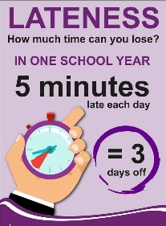

**Books Donations– can you help?**

Mrs Brownwould like to develop our school library in order to help encourage our children to be fabulous readers. We have had questions from families about ways in which they can support school as we have not been able to have the Christmas Fair this year and thought this might be a solution. If you have any good quality second hand children’s books that you feel may be useful to us, please can they be sent in to school after Christmas. We will store the books for 72 hours and then put them into our school library. Mrs Brown has put together a wish list on amazon of examples of the types of books that could be donated but we would be grateful for other titles too. The books on amazon can also be purchased for school if anyone wishes to do so. Plesae click the link to see the book examples.

<https://www.amazon.co.uk/hz/wishlist/ls/ZETYMLIO77P1?ref_=wl_share>

**PE Uniform:**

Please can we remind everyone that the school PE uniform is: plain navy or black shorts, leggings or tracksuit bottoms, a white t shirt and a hassell school jumper or PE hoodie. We appreciate your help and support in providing the correct uniform for your child. If you have any problems accessing school uniform, please let school know as we can often help.

**Reception places 2021: click on the link below for online applications**

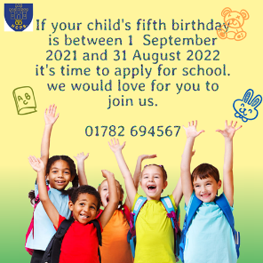

[**https://www.staffordshire.gov.uk/Education/Admissions-primary/home.aspx**](https://www.staffordshire.gov.uk/Education/Admissions-primary/home.aspx)

**Online safety**

With Christmas only a few days away, I’m sure there will be many new internet devices in action soon. Below are the 12 online safety tips which you may find useful over the holiday period and beyond.

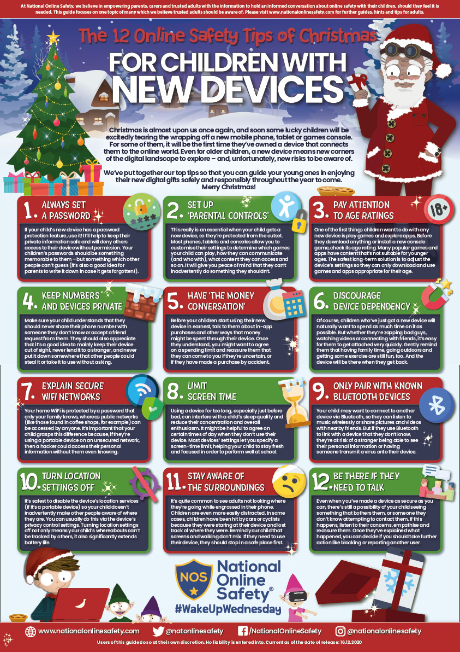

**Return to School**

Children return to school on Tuesdy 5th January. Monday 4th January is a staff training day.

I hope everyone has a well deserved rest during the Christmas holidays. Although for many of us it may not be quite what we had originally planned, I hope you enjoy the time together with your families. Please stay safe and we look forward to seeing you in the New Year.



Thank you for your continued support.

Kind Regards

Kirsty Broome

Headteacher