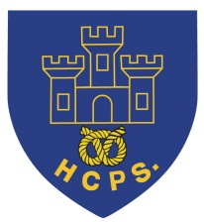 **Hassell Primary Update 23.10.2020**

Dear Parents and Carers,

I would like to start by saying thank you for everyone’s cooperation and support during the last half term. It has certainly been a busy one with lots of changes and adaptions. I am really proud of the children for the way that they have embraced their new classes, rules and routines and I’m sure that you are too.

**Goodbye**

It is with great sadness that we say goodbye to Mrs Delves today. Mrs Delves has worked at Hassell for over 20 years but is leaving us to pursue a new career. We wish her every success and luck in her new job but will really miss her at school!

**Congratulations**

Last academic year we entered the Primary Engineer Award competition. I am delighted to announce that we have two winners for the central region – Jake B and Poppy W. This is an amazing achievement and I am sure you will join me in congratulating the children in their tremendous work. We also had a number of children who received runner up awards – well done everyone! If you would like to see the winner’s presentation for the central region, please click on the following link:

<https://leadersaward.com/2020-central-gallery/>

**PTFA**

The children have had / will bring home a little sweetie treat from the PTFA today. We would normally have had a Halloween disco for all the children this week but sadly this has not been possible this year.

**Charity Support**

Thank you to everyone who supported Miss Dale with the Hello Yellow campaign for mental health. We have raised over £200 which is to be split between Mind and school. The school money will be put towards new wellbeing resources for the children to access. Thank you also to Jessica and James’ family who have kindly donated some super books to school which support children’s mental health – we really appreciate it.

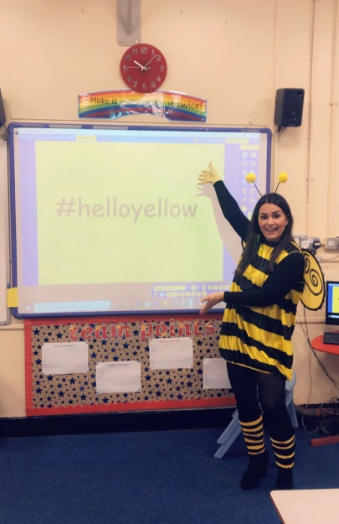 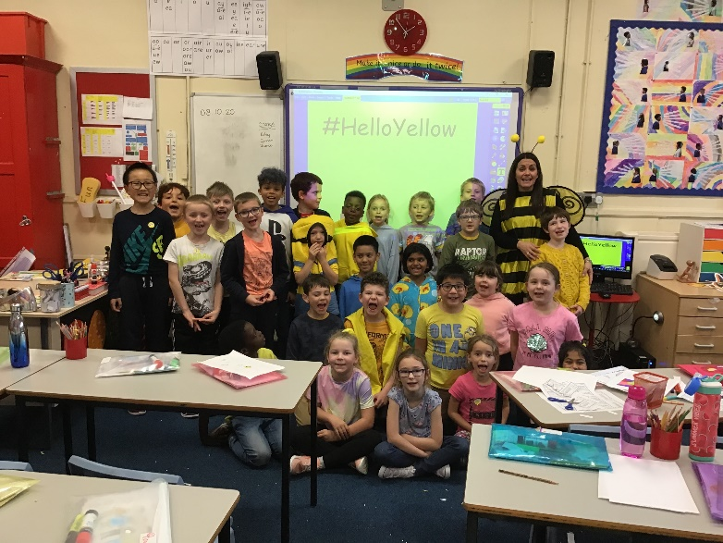

In addition, thank you to everyone who donated for the Harvest collection this year. The food was split bewtween the Newcastle Food Bank and the Alice Charity. I have also attached a letter of thanks from the food bank and the Alice charity have put a message on their facebook page. In difficult times, it is lovely to know that we have so many generous families despite the circumstances they may find themselves in.

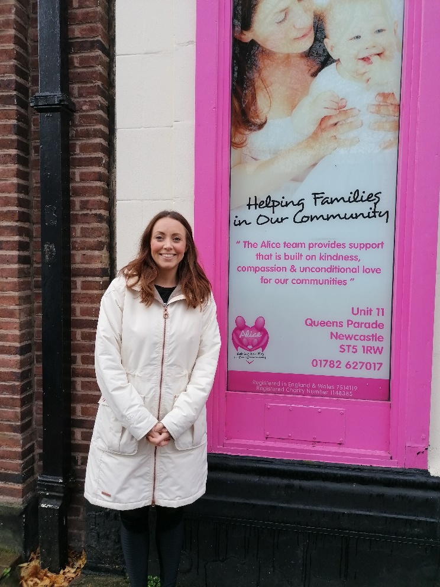

**Half term building work.**

During the half term break, there will be some continued building work on site – firstly to the chimney stacks for some repair work. Additionally the path at the front of school is being resurfaced. The plan is for this all to be completed over the holidays so we hope for decent weather to ensure that this happens.

**Google classroom**

The children have all had their log in to google classroom. Thank you to everyone who has already logged in to check that their child’s account works. If you haven’t already done so please can you have a look over half term and let us know if you have any problems.

**Inset Day**

Finally, just a little reminder that **school is closed to pupils on Monday 2nd November** for staff training. School re-opens for the children on Tuesday 3rd November.

I hope that you all have a lovely half term break with your families and manage to spend some quality time together despite the current restrictions.

Kind Regards

Kirsty Broome

Headteacher