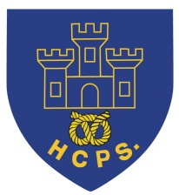 **Hassell Primary Update 27.11.2020**

Dear Parents and Carers,

Thank you to those parents who have been supporting us this term by abiding by all the covid regulations. Sadly, we have heard that Newcastle will be in tier 3 as we come out of lockdown. This means that the measures we have in place remain incredibly high priority. Just to be clear, we really need all parents to:

* Wear masks on the playground when dropping off and picking up

* Walk on the left of the path when entering and exiting the playground.

* Wait in a socially distanced spot – 2 meters away from other people

* Keep children with you with when they are waiting so that children in different bubbles don’t mix

* Stop children going on the large play equipment at the beginning and end of the day.

This week has been quite a learning curve for us in school too. Miss Dale has had to work from home due to her son’s class going into isolation. To ensure she doesn’t miss time with her class, Miss Dale has been teaching remotely using teams. The children have been supervised in their room by the teaching support staff in Year 3/4. Well done Miss Dale, staff and the children in 3/4 for making these changes so smoothly.

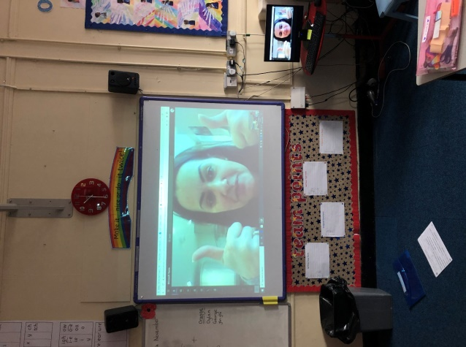

**Pokemon Holiday Calendar**

We have been very luck to receive a generous donation of a Pokemon Calendar to raffle for the children. The calendar includes 16 characters and 6 accessories (retailing at approximately £35). Tickets are available on parent pay for £1 each. The draw will take place on the afternoon of Monday 30th November, ready for the 1st December.

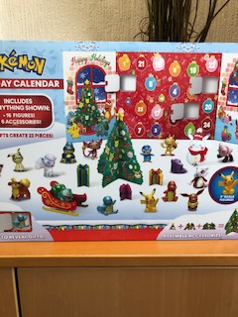 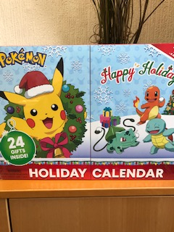

**Date reminders for this half term**

**4.12.2020 –** Elf Day – Christmas dress up with £1 donation to support the Alzheimer’s Society.Children may wish to join in with bright coloured or Christmas themed clothes, or come to school dressed as an elf – the choice is yours!

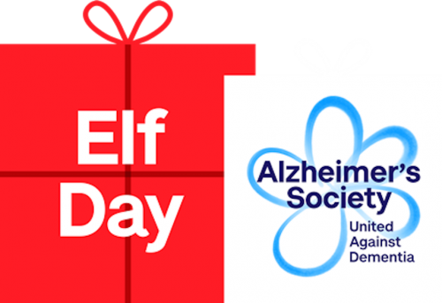

**16.12.2020 Christmas dinner day**

This year our Christmas Dinner is on Wednesday 16th December. A link to preorder dinners has been sent out. Please can **any** children wishing to have a Christmas dinner send their orders in by next Friday 4th December in order to help the kitchen prepare. Children who pay for their school dinners can do so as normal via parent pay. This year there will be roast turkey with all the trimmmings, or vegetable wellngton, followed by Christmas iced biscuits.

**Water Bottles**

Please can I remind all children that they need to bring named water bottle (containing water not juice) into school for drinks during the day. Some children are forgetting to bring their drinks with them and this means they struggle to access the water dispensers without the use of plasic cups. Individual water bottles also helps us to minimise the risk of infection spreading within classes.

**Hassell Primary School – New facebook page.**

We have changed our school facebook page. Please search for Hassell Primary which is our new business page. This will be regularly updated with news and information and links to our Hassell Nursery Page and Happy Times Care Club.

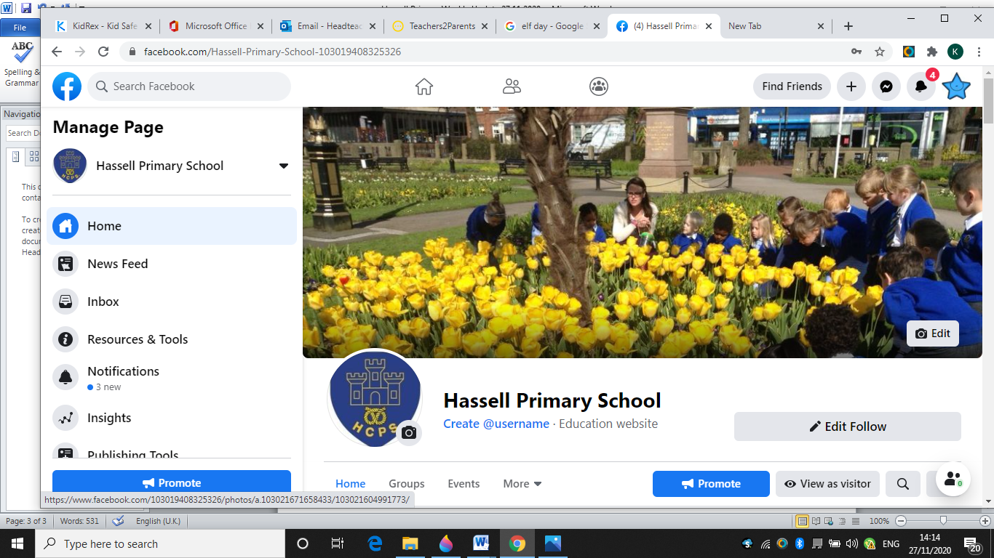

Thank you for your continued support.

Kind Regards

Kirsty Broome

Headteacher