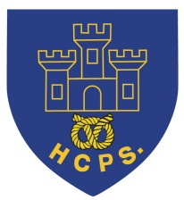 **Hassell Primary Update 4.12.2020**

Dear Parents and Carers,

We have finished off this week with a great day supporting Elf Day for the Alzheimer’s society. It has been fantastic to see so many children and staff taking part in their Elf costumes and Christmas clothes. The children have completed some lovely activities and these, plus examples of costumes, will be posted on the school facebook page for you to see. We also had a visit from Buddy the LMA elf today and I’m pleased to report that he did behave himself for most of the day! Thank you to Miss Smith for organising the day for us all.

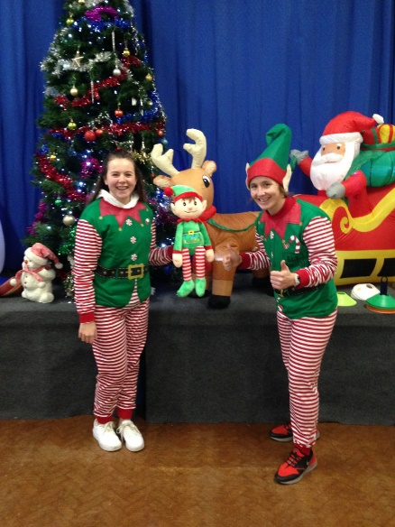

**Google classroom**

Earlier this week, it was lovely to welcome back those children who had been completing remote learning due to isolation. One thing that this method of learning has taught us is how important it is for all of our students to access their google classroom account. If you haven’t already done so, please can we request that you log in with your child to ensure you can access their class page. If you have any difficulties please let us know.

From Monday, in KS1 and KS2, all work for remote learning will now be set on google classroom. This is for those children who are having to work from home due to individual isolation or in the case of any bubble closures. Children who are attending school DO NOT have to complete the google classroom work in addition to their normal lessons.

**Christmas Cards**

Just a little reminder that this year we have asked the children not to send lots of Christmas cards to one another, but to write one for their class for the teacher to read instead. This is to help limit the number of objects passing from one household to another as we remain in tier 3.

**Christmas assemblies, singing and productions.**

Unfortunately, this year we are not able to put on the normal level of Christmas productions as would normally go ahead. The children in different bubbles are working hard to put together some performances and these will be sent out via google classroom for parents to watch. Details will be provided from each year group when these are available. We will still be hosting Christmas activities for the children, such as class parties, within the last week of term. All resources for these activities will be provided by school to help prevent the risk of infection across bubbles.

**Nursery places:**

We still have a few Nursery places available for January starters. If you would like a place for your little one we can provide 15 and 30 hours funded places. Please get in contact for more details.

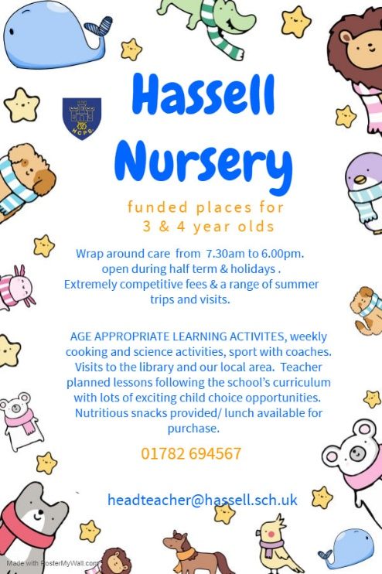

**Reception places 2021: click on the link below for online applications**

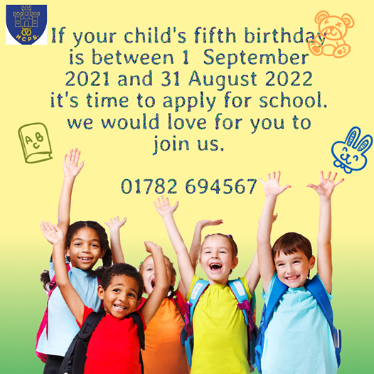

[**https://www.staffordshire.gov.uk/Education/Admissions-primary/home.aspx**](https://www.staffordshire.gov.uk/Education/Admissions-primary/home.aspx)

**Hassell Primary School – New facebook page.**

We have changed our school facebook page. Please search for Hassell Primary which is our new business page. This will be regularly updated with news and information and links to our Hassell Nursery Page and Happy Times Care Club.

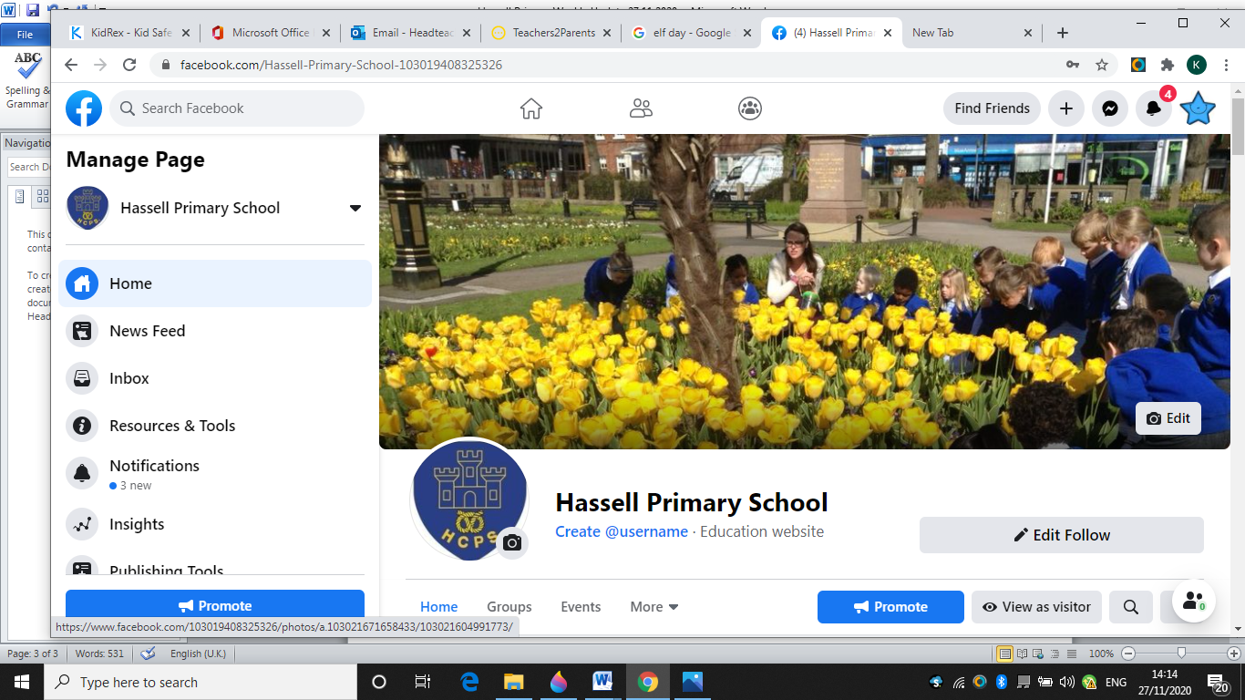

Thank you for your continued support.

Kind Regards

Kirsty Broome

Headteacher