 **Hassell Primary Update 8.01.2021**

Dear Parents and Carers,

Well, I think I can safely say that I don’t think this week has gone quite how anyone was expecting! After Monday evening’s announcement it has been all hands on deck – both at home and school. A massive thank you to all of our families for their help, patience and understanding while we got going with all of our home learning and Google Classroom Meets. The responsive from every one has been fantastic.

It is really important that we have regular contact with all of our children, so if you are home learning and we haven’t been able to contact you this week, please get in touch with us on Monday. If anyone has problems with connectivity or resources, please let us know and we will do all we can to help. We have emiled a range of help documents fo Google classroom and will also add these to our school website. You may also find this link useful:

[https://youtu.be/IgS-hoSIjnw](https://l.facebook.com/l.php?u=https%3A%2F%2Fyoutu.be%2FIgS-hoSIjnw%3Ffbclid%3DIwAR20ZWDDkOlZYQDgRmB0q2PeP2CfpzdWBvnOt_exJ_C84Q55DVUeBLNHp_s&h=AT1jY_kYMHD-eCVf68Dqpz_U3lxMQ2w2J8gWpY7PPqKyEyB_lRnSWRnz5FKJDaoSSoSSA_xbeqOY0Xvay3GGCE3OLpFJCeTohqn-ryFnT-JaLsOCRFb6Em_gG7GLnQzcuJyL&__tn__=-UK-R&c%5b0%5d=AT2NwIvCz9x8SBWZIYGudYhtOJEPK3HC78Y5l0YseIQNacgLNMJLgfLXNU_ZT-EeNNJV5L5TA3zc56lpfzdiZhalTruaBa0ppLp4cJtbYkYvokjgALzy9a1fVqBG07meMBXh2ChOwofilmipIHSqIZPgMa0tZ26STODeZat4veiUD0vNB2uzkvA4GbeERt6X6mwABIt39iG9Cfgvv-ac)

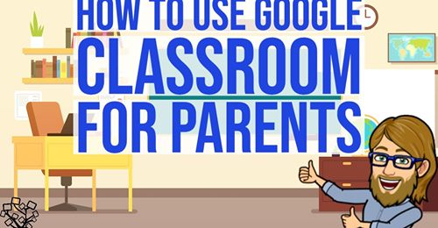

There will be a variety of changes to our home learning for different year groups from Monday, as we begin to introduce new opportunities for additional live sessions for children who are working at home. If you have more than one child at home and clashes with devices, or the timings are not suitable for your work commitments, please feel free to go back and watch them on Google Classroom at a more convenient time.

We have chosen the range of lessons and activities to try and best meet the needs of all our families as we appreciate that everyone’s circumstances are different. The maths and English lessons follow video lessons from White Rose Maths and Oak Academy (KS1 upwards) so that your children have guidance and instructions to follow from a real person. Classes have suggested timetables for the work to be completed, but please adapt these to suit your personal circumstances.

We also appreciate that individual home learning children may get through some work faster than those in school who are working as a class. If this happens, please feel free to supplement with activities from BBC bitesize, CBBC programmes or any other activities you feel are appropriate. It is also important that the children have regular opportunities for breaks and relaxation, as working in front of a digital device can be very tiring. Whilst there is the expectation that all children will engage in home learning, it also needs to be manageable for your circumstances. Please let us know if you need any further help.

**GDPR**

It is very important that all of our students understand that they cannot screen shot or video any of the live sessions and post on other social media platforms as they do not have permission for this. Google Classroom is intentionally set up as a closed system for our school so that we can ensure our children’s safety. Please ensure that your families understand this so that we do not have any data Protection conflicts.

**Online Safety**

The National Online Safety Team have produced some helpful information for remote learning at home. There is a guide for parents and a guide for children (see below). The website has lots of other useful information and is worth a visit if you would like any further advice or online safety tips. The link is:

<https://nationalonlinesafety.com/>

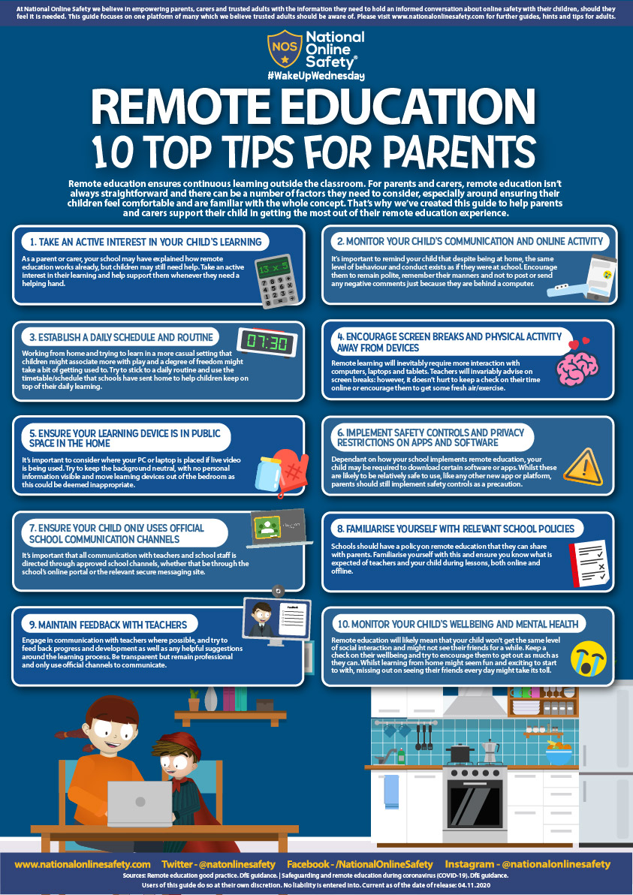

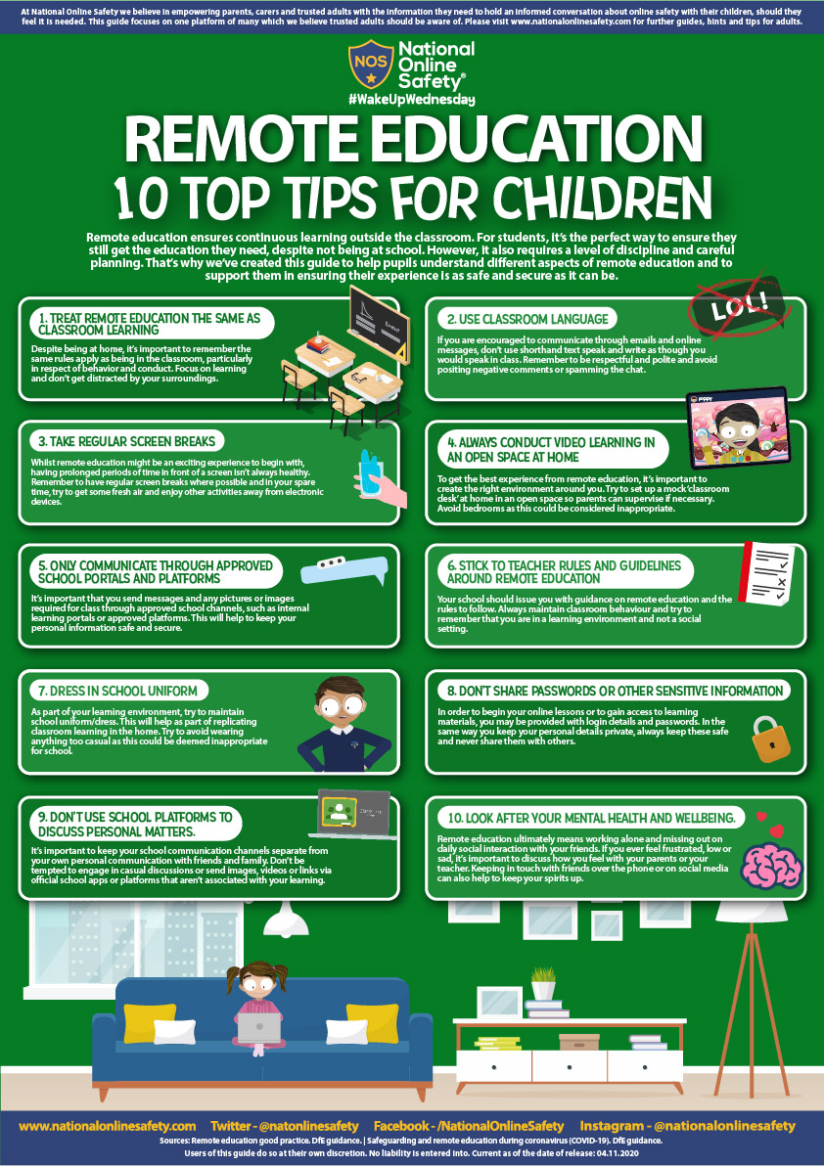

**Covid Reporting Update:**

During school hours, please let us know of any positive cases in your household by contacting the school office. If it is out of school hours, I have set up a separate email address that will be monitored regularly. This is

[**covidreporting@hassellprimary.com**](mailto:covidreporting@hassellprimary.com)

Please contact us during weekends on this email address so that we can make appropriate arrangements if at all necessary.

**School Gate Times**

As we returned to school on Tuesday 5th January, the school day has now returned to the usual start time of **8.50**. End of the day will remain the same. Please ensure that your child is in school by 8.50 so that they are not recorded as late to lessons. In the the last few weeks we have had an increasing number of children arriving after 8.55 and this causes a significant disruption to their classes. Please help us out by ensuring that your child/ren arrive on time. Thank you.

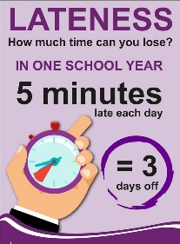

**Books Donations– can you help?**

Mrs Brownwould like to develop our school library in order to help encourage our children to be fabulous readers. We have had questions from families about ways in which they can support school as we have not been able to have the Christmas Fair this year and thought this might be a solution. If you have any good quality second hand children’s books that you feel may be useful to us, please can they be sent in to school after Christmas. We will store the books for 72 hours and then put them into our school library. Mrs Brown has put together a wish list on amazon of examples of the types of books that could be donated but we would be grateful for other titles too. The books on amazon can also be purchased for school if anyone wishes to do so. Plesae click the link to see the book examples.

<https://www.amazon.co.uk/hz/wishlist/ls/ZETYMLIO77P1?ref_=wl_share>

**PE Uniform:**

Please can we remind everyone that the school PE uniform is: plain navy or black shorts, leggings or tracksuit bottoms, a white t shirt and a hassell school jumper or PE hoodie. We appreciate your help and support in providing the correct uniform for your child. If you have any problems accessing school uniform, please let school know as we can often help.

**Reception places 2021: click on the link below for online applications**

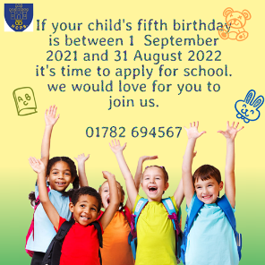

[**https://www.staffordshire.gov.uk/Education/Admissions-primary/home.aspx**](https://www.staffordshire.gov.uk/Education/Admissions-primary/home.aspx)

Thank you for your continued support.

Kind Regards

Kirsty Broome

Headteacher