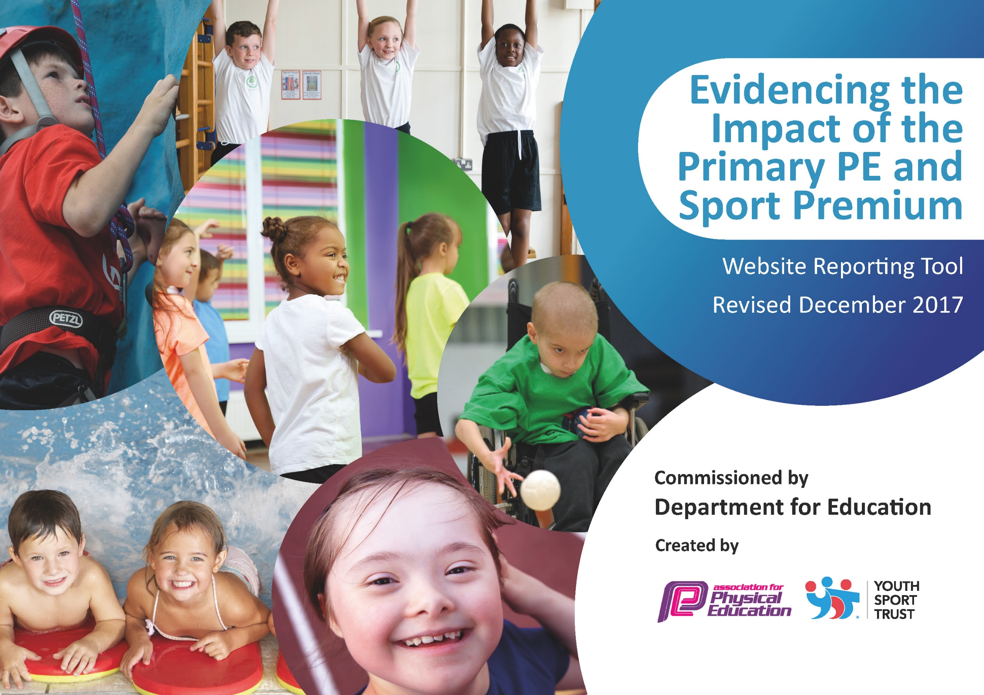

Support for review and reflection - considering the 5 key indicators from DfE, what development needs are a priority for your setting and your students now and why? Use the space below to reflect on previous spend, identify current need and priorities for the future.

Key achievements to date: | Areas for further improvement and baseline evidence of need:
Gold Primary Games award  Involvement in local school competitions (inter sports) including some 1st/2nd/3rd place allocations and county attendance at cross country.  Raised profile of physical exercise and physical education across the school.  Large range of sporting opportunities available  Most pupils have a good understanding of and adhere to healthy life choices  Increased number of pupils access sports activities after school.  Intra and inter school competition participation | Vision for PE and Sport needs further refinement  Extension of provision during lunch times  Some pupils do not engage with extra-curricular sports clubs  Some pupils do not adopt healthy eating patterns
Meeting national curriculum requirements for swimming and water safety |  | Please complete all of the below*:
What percentage of your current Year 6 cohort swim competently, confidently and proficiently over a distance of at least 25 meters? |  | To be completed per class at start and end of swimming block
What percentage of your current Year 6 cohort use a range of strokes effectively [for example, front crawl, backstroke and breaststroke]?
What percentage of your current Year 6 cohort perform safe self-rescue in different water-based situations?
SchoolscanchoosetousethePrimaryPEandSportPremiumtoprovideadditionalprovisionforswimming but this must be for activity over and above the national curriculum requirements. Have you used it in this way? |  | Yes/No  All pupils from year 3-6 attend 30 minutes swimming lessons each week for a minimum of 10 weeks per year.

Action Plan and Budget Tracking
Capture your intended annual spend against the 5 key indicators. Clarify the success criteria and evidence of impact that you intend to measure to evaluate for students today and for the future.

Academic Year: 2019/20 | Total fund allocated: £ | Date Updated: September 2019
Key indicator 1: The engagement of all pupils in regular physical activity – Chief Medical Officer guidelines recommend that primary school children undertake at least 30 minutes of physical activity a day in school |  |  |  | Percentage of total allocation:
 |  |  |  | %
School focus with clarity on intended impact on pupils: | Actions to achieve: | Funding allocated: | Evidence and impact: | Sustainability and suggested next steps:
Increase physical  development in Early Years | Promote physical fitness as being fun in order to make being active a lifelong and natural habit. | £250 | Children are able to acquire basic body management skills such as, balance and control and spatial awareness as well as having good fine motor skills. | Add to resources as necessary
Promote Healthy Lifestyles | Children to enjoy participating in a range of physical activities to promote healthy living and understanding the importance of making healthy choices, through cross curricular work.  Daily active challenge to encourage all pupils to be more active during the school day. This can be through lessons or during non curricular time including after school clubs. Focus on children who are not naturally active and don’t take part in other activities.  As part of Sports Relief, physical activity to be completed everyday by all pupils. Earn points for their houses, fun competition – accessible to all children. | Free | Children are healthier and more active. They are encouraged to live a healthy lifestyle through healthy eating and being physically active.  Progress records kept of activities, i.e. Distance covered, jumps completed etc. All pupils to be actively involved. KS2 to support KS1 linked to Potamus challenge using playleaders training. Opportunities cut short due to Covid-19  Information sent out to parents and photos to be taken during all events and published on school website and social media page.  Team games/ activities being attended by pupils. Leadership skills being developed in the leaders. | Also link to science curriculum and PSHE in 2020  When Covid-9 allows, children to continue with sports leader cross bubble activities.  Look at ways to extend opportunities within year 5/6 bubble.  .
Purchase new equipment – allow for delivery of new sports | Children are able to access sports equipment for new sports to develop their interest in PE and sport. Equipment will allow for new and exciting after school clubs / lunchtime activities to increase number of participants. | Climbing wall  £1500  Athletics equipment  £300  Renew of pottamus challenge equipment  £300 | Number of children attending after school clubs increased.  Number of children participating in level 2 sports games increased.  Number of children involved in level 1 activities at lunchtimes increased, particularly with KS1 playleaders supporting. | Continue with playleader coaching in 2020/2021
Increase physical development during break times. | Year 6 pupils completing award September 2019 with Stoke via playmaker programme  Meetings required with play-ground staff so they can oversee the activities. | £200num package  Stoke in the community platinum package | Play Makers organising play-ground activities for the rest of the school during lunch time play. This is to include wet play time.  Certificates given to play makers on completion of course. Photograph activities | This can be continued indefinitely as part of the daily school routine, with the activities becoming more complex as the children develop.
Increase levels of physical activity outside of school hours | Creation of physical activity bags for pupils to access outside of school hours. Bags to include suggested activity cards and the necessary equipment. | £200 | Questionnaire about accessing physical activity to be completed at the beginning and end of the year. Results to be analysed for increased uptake outside of school hours.  Sporting bags regularly accessed by pupils. | Cut short due to covid restrictions but participation up to March showed % of pupils involved in physical activity clubs.

Key indicator 2: The profile of PE and sport being raised across the school as a tool for whole school improvement |  |  |  | Percentage of total allocation:
 |  |  |  | %
School focus with clarity on intended impact on pupils: | Actions to achieve: | Funding allocated: | Evidence and impact: | Sustainability and suggested next steps:
Inspire children to have a continued positive attitude towards PE and Sport via use in other curriculum areas. | Children to experience practical sport activities in other curricular lessons. (KS1 practical maths, KS2 English project)  Staff to attend the PE conference for training and ideas. | Via Stoke platinum package | Valuable experience for pupils – positively impacting on motivation and achievement in other curriculum areas and PE. | C  .
 | Children to participate in additional games / dance activities during Culture week. Theme for 2020 is: South Asia | Free –completed in PE lessons | All pupils had the opportunity to participate in games such as boccia within lessons. Dance activities completed with Bollywood style dance routines.
 | Inspirational sports person to visit the school to inspire and encourage children to be involved with sport.  Completed with Stoke City players visit December 2018 – new colleagues to be identified | Free via Stoke City | Children meet professional players and ‘buzz’ is created. Children participate in activities following on from the visit.  Unavailable due to covid
 | Certificates for any sporting achievement to be presented in Celebration Assembly to ensure the whole school is aware of the importance of PE, sport and health. Premier League, Primary Stars certificates to be awarded: ‘Be connected, Be ambitious, Be inspiring, Be fair’ to be awarded during Celebration Assembly. | Free | Sporting achievements celebrated in assembly with details of event/sport and sports clubs – inspiring other pupils to get involved. Questionnaire about accessing sports to be completed at the beginning and end of the year. Results to be analysed for increased uptake. Parents invited to attend celebration assembly – parents value PE and Sport. | End of year awards presented remotely due to covid.

Key indicator 3: Increased confidence, knowledge and skills of all staff in teaching PE and sport |  |  |  | Percentage of total allocation:
 |  |  |  | %
School focus with clarity on intended impact on pupils: | Actions to achieve: | Funding  allocated: | Evidence and impact: | Sustainability and suggestednext steps:
Specialist coaches to deliver PE curriculum alongside staff members and provide extra curricular staff, whilst developing CPD for staff. | Employ a specialist sports coach to work alongside the staff in KS1 and 2 to allow for sharing good practice.  Sports coaches to support and promote a variety of after school clubs and sports competition opportunities. | £TBC | High quality teaching and learning in PE curriculum.  More opportunities for pupils to access extra curricular activities.  CPD – sharing good practice and team teaching to upskill teaching PE and coaching in clubs. | Staff team teach and share good practice
PE lead to work alongside staff and external sports coaches, and organise extra-curricular activities. | Sports lead to arrange additional sporting opportunities for pupils via internal and external clubs, competitions and training in a range of sports including cross country, football, tennis and cricket. | Via teaching salaries  £1500 coaching costs for the year | Good practice shared. Staff up skilled through PE lead disseminating key information. PE lead confident in her role. PE and Sport have a high profile within school.  After school running club established. More pupils attending inter school cross country events.  Football for fun, Cricket for fun, afterschool clubs run weekly.
High quality PE and Sport in early years with high number of children achieving their milestones for physical development. | Children in early years access 1 hour per week of high quality PE and sport activities. Physical development opportunities available through continuous provision throughout the rest of the week. | As part of PE leads role | Children in Early Years to access high quality PE lessons to develop early development of fundamental skills.  High number of children achieving physical development objectives by the end of the year.

Key indicator 4: Broader experience of a range of sports and activities offered to all pupils |  |  |  | Percentage of total allocation:
 |  |  |  | %
School focus with clarity on intended  impact on pupils: | Actions  to achieve: | Funding  allocated: | Evidence and impact: | Sustainability and suggested  next steps:
Continue to offer a wide range of activities both within and outside the curriculum. | Survey parents to ascertain sporting clubs that pupils already attend. Invite local providers to offer demonstration sessions in school and to advertise their services in the foyer. | Free | More pupils will be involved in a wider range of sporting activities both in school and the wider community. | Look at additional organisations that hold taster days at reduced costs.
Alter lunchtime provision to incorporate team game activities and individual challenge games | Sports coach to lead lunch time games and activities to support KS2 initially, then KS1 and EYFS if successful. | £ | Higher number of children involved in both rotation of team game activities each week and the individual physical activity challenge tasks | If successful at KS2 also deliver at KS1 and EYFS
Broader experience of a range of activities | Children in Key Stage One( Year 2) to participate in the Pottermus Challenge (Stoke City) – inter schools competition | Free event  £75  transport costs | Sports ambassadors to report back to the Stoke City steering group (written report) | Sports leaders continue the games at lunchtime with support from the lunchtime supervisors.
Increase range of activities on offer in school | Bikeability year 5/6  Year 5/6 residential trip to Laches Wood (outdoor activities)  Sports Relief Challenge Week | Free | Children in year 5 and 6 to have the opportunity to take part in Level 2 bikeability  High percentage of children join the new visit to Laches Wood in Sept 2020 (60+ places booked)
Increased percentage of pupils being able to swim 25m | Children in Years 3-6 will access weekly swimming sessions with a qualified instructor (30 minute sessions) for a minimum of 10 weeks per year. | £  Includes transport | Pupils able to swim 25 metre with confidence. Swimming records to show achievements. | Possible increase in hours available for those children not meeting 25m standards.
Increase pupils participation in  competitions and/or festivals | Arrange transport to sporting events | £750 towards transport | Attend all Newcastle School Competitions  Children feel confident to take part and are able to understand and explain competition. | Parental contributions might be necessary in the future to support transport costs.

Key indicator 5: Increased participation in competitive sport |  |  |  | Percentage of total allocation:
 |  |  |  | %
School focus with clarity on intended  impact on pupils: | Actions to achieve: | Funding  allocated: | Evidence and impact: | Sustainability and suggested  next steps:
Increase number of pupils participating in competitive sports | The pupils will continue to compete in the Newcastle Schools Tournaments.  Hold practice sessions for the different events in PE lessons and at other times to enable the pupils to have a sound knowledge of the sport before competing in the tournament. Book transport and send consent letters to parents. | £750 (as above) | Results from the tournaments. The impact of these are:  Team bonding  Increased fitness  Wider range of sports knowledge  Experience of competition against other schools. | Transport is the only funding issue that would need to be sustained.  To look at non-school competition that our pupils may like to get involved in.
Increase participation | Register and work towards the School Games Mark in order to maintain Gold this year Sports lead to look at the Schools Games Mark criteria and put together the application. | Free | Gain Gold award.  Raising the schools profile. Evidence to be displayed in sports display area and on the schools social media. | continue to work to those standards.

