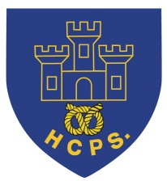 **Hassell Primary Weekly Update 10.12.2021**

Dear Parents and Carers,

**Covid update**

Unfortunately this week has seen a significant rise in the number of children testing positive within year 5 and 6. We now have 15 cases in the year group. The number of cases in 5/6 Pezz has gone beyond the threshold of 25% of the class. As a result of this we have had to move to online learning for 5/6 Pezz for Friday and Monday and this will be reviewed on Monday depending on the change (if any) to the number of cases. All other children within 5/6 have been asked to take a PCR test if they haven’t had covid within the last 90 days. I would like to say thank you to the families of our 5/6 children for their support as we fully appreciate how difficult this is for everyone.

**During this weekend, if any children test positive, please let me know by emailing** [**headteacher@hassell.staffs.sch.uk**](mailto:headteacher@hassell.staffs.sch.uk) **as soon as possible. Decisions will be made about any further actions, depending on the number of cases we have.**

On Monday we will work with the local outbreak team to make a decision about 5/6 Pezz returning to school and look at the outcomes of PCR tests for the year group as a whole. For the remainder of term we will be keeping the 3 classes separate whilst in the school building and we will not have any mixing between years 3/4 and 5/6 at any point in the day. All other measures such as additional cleaning will continue as they have done all year.

Of the children who have tested positive, there have been several who are not showing any symptoms and have remained well through their isolation period so far. However, several of the adults have become quite unwell. We wish those who are ill a speedy recovery and thank everyone who has been for a PCR for being so supportive.

I am pleased to say that we only have a small number of positive cases within the rest of school (1 in year 1, 1 in year 2 and 1 in year 4).

**Craft Afternoons**

Thank you to everyone who attended the Christmas carol and craft afternoons on Tuesday and Wednesday. The children made some fantastic creations and we hope everyone had a really enjoyable afternoon.

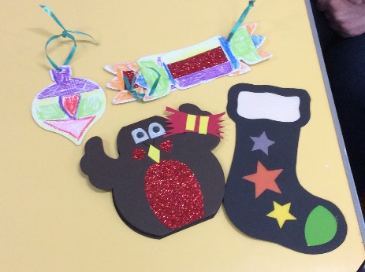 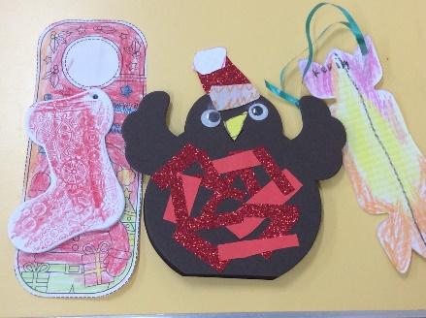 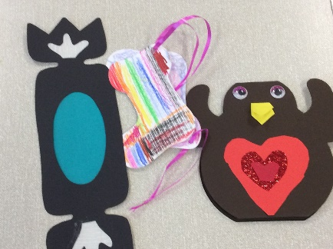

**Rock Steady concert cancellation**

Sadly, we will not be able to go ahead with the Rock Steady concert due to the number of positive cases within KS2 as a whole. Unfortuantely, there are a significant number of children in year 5/6 who are isolating and will be unavailable to perform in their group. However, we will record the 3/4 children and send this to parents to see their performance. I will notify everyone whether this will be via google classroom or via the Rock Steady Portal as soon as I have confirmation from Mark, the band leader. We hope to record the year 5/6 children in the new year.

**Non Uniform Day**

Friday 17th December is the last day of term. Children are able to come to school in their own choice of clothes – no charge this is just for fun at the end of term.

**Diary Dates:**

**December**

Monday 13th – last week of school. Class parties this week

Tuesday 14th – Reception class craft afternoon at 1.30pm.

Wednesday 15th – Nursery Craft afternoon at 1.30 (letters sent)

Wednesday 15th – Christmas dinner day

Thursday 16th – Virtual Festival of Christmas for Y5/6

Friday 17th December – Last day of term. Own clothes day for fun (no donation)

**We return to school on Tuesday 4th January**

If you have any questions or things you would like to discuss with staff, please feel free to talk to myself or the staff on duty in the mornings or give the office a ring and leave your child’s class teacher a message and they will get back to you as soon as possible. We are also available via the office email on [office@hassell.staffs.sch.uk](mailto:office@hassell.staffs.sch.uk)

Kind Regards

Kirsty Broome

Head Teacher