 **Hassell Primary Weekly Update 11.2.2022**

Dear Parents and Carers,

**Covid update**

I’m delighted to say that we don’t have any positive cases in school at the current time. Thank you to evryone for your support and we hope we can now stay covid free.

As we progress through the year with things getting back to ‘normal’ we will continue to reintroduce some of the trips, activities and events that normally happen. For example sports days with parental spectators, topic based class trips and external visitors. Further information will be provided for families as these are organised.

**Children’s Mental Health Week**

Today we have been taking part in the own clothes day to ‘express ourselves’ as part of children’s mental health week. Thank you to everyone who has taken part. We have had everything from ballerinas to pilots, dinosaurs and dragons as well as the great favourites of PJ’s and onesies. The money raised will be split between the ECO council and their ‘growing together’ activities and the children’s mental health charity Place2B. Thank you to Mrs Brown and the student council for their super assembly on Monday to start the week off and to all the children for their amazing leaf designs.

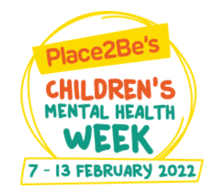**Children’s Mental Health Week 2022 - Growing Together**

**Safer Internet Day**

On Tuesday we learnt more about Safer Internet Day and this year’s theme of Respect and Relationships online. The children have joined in with assemblies and given some really thoughtful ideas about how to show respect to one another when online. They also considered what to do if they felt unsafe or that someone was being disrespectful online. If you would like further information, please visit:

<https://saferinternet.org.uk/safer-internet-day/safer-internet-day-2022/advice-for-parents-and-carers>



**Stoke City 7’s**

On Thursday, Year 2 and Year 3 had a visit from Stoke City as part of their City 7’s activities. The children received their goody bags including Stoke shirts. In addition, all of the children in school have been given a letter with information about discounted tickets for a Stoke match. If you would like to buy tickets for the game, please send your completed forms and payment back to the school office by Wednesday 16th February. Forms received after this date cannot be sent via school.



**Valentines Disco**

We will be having class Valentine’s celebrations during the last week of school. On Thursday 17th Feb, the children in Nursery, Reception, Year 1 and Year 2 will be having their celebration afternoon. Children in these year groups can come dressed in their own clothes for the day on Thursday.

The children in KS2 (Y3-6) will be having their celebrations on Friday 18th February. The children in KS2 can come dressed in their own clothes on Friday.

There is NO charge for either afternoon.

**Culture Week**

The school’s culture week this year will be on the week beginning 14th February and will focus on North America.

The children will undertake a range of activities to help them learn about the culture, including dance routines, stories, art etc.

If you have some knowledge of this area and would be willing to share your expertise with the children, please contact Mr Murdoch at [a.murdoch@hassell.staffs.sch.uk](mailto:a.murdoch@hassell.staffs.sch.uk) or speak to your child’s teacher. This could be to teach the children some words from a new language, to share some food or to simply tell the children what the country and its people are like.

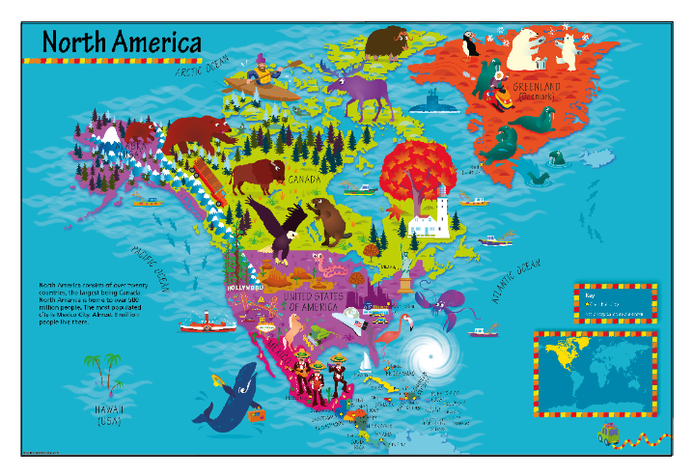

**Care Club**

As you may be aware, our care club runs before school, after school and during the holidays. We currently have spaces before and after half term. If you would like to have a place, please contact Miss Barlow at [happytimesltd@outlook.com](mailto:happytimesltd@outlook.com) or contact school for further details.

**Diary Dates: These will be updated as the term progresses**

**February:**

Week beginning 14th Feb – Culture week. Theme is North America

Thursday 17th Feb – Nursery, Reception, Y1 and Y2 Valentines party day. Own clothes

Friday 18th Feb – KS2 (Y3,4,5,6) Valentine’s party day. Own clothes

21st Feb to 25th Feb – Half Term

Monday 28th Feb – INSET DAY. School closed to pupils

Tuesday 1st March – children return to school

Tuesday 8th March – Dental Survey for R and Y1 children

Week beginning 11th March – Science week.

If you have any questions or things you would like to discuss with staff, please feel free to talk to myself or the staff on duty in the mornings or give the office a ring and leave your child’s class teacher a message and they will get back to you as soon as possible. We are also available via the office email on [office@hassell.staffs.sch.uk](mailto:office@hassell.staffs.sch.uk)

Kind Regards

Kirsty Broome

Head Teacher