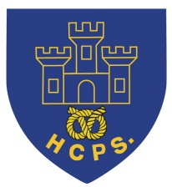 **Hassell Primary Weekly Update 12.11.2021**

Dear Parents and Carers,

**Covid Update and illness**

As you are aware, we have had several positive cases reported before half term. I am really pleased to report that these numbers have dropped rapidly and we currently have only 2 confirmed cases at present (Reception and Y5). However, the rates within the Newcastle area are still continuing to be high so we request that anyone with symptoms has a PCR test. Thank you to everyone for your help and support in keeping our school community safe and we wish those who are poorly a speedy recovery.

After half term we returned to the ‘normal structure’ of EYFS, KS1 and KS2 and shared break times at KS2. All of the existing measures such as additional cleaning, hand sanitiser availability etc have continued. Please continue to notify school if your child tests positive, or is going for a test as we have to report information on a daily basis.

Please can I also take this opportunity to remind everyone that children should not return to school for 48 hours following any episodes of sickness or diarrhoea. This means 48 hours from the last time they were sick or had an upset tummy. This is to help limit the spread of infection to the other children and staff.

**Anti Bullying – Odd Socks Day**

Monday 15th November is the start of anti-bullying week. On Monday, the staff and children have been asked to wear odd socks in order to support the campaign. The children can wear any coloured socks – the brighter the better.



**Be Bright Be Seen**

Monday 15th November also starts the week of road safety awareness. During assembly we will highlight the importance of being bright and seen during the darker mornings and nights in order to help everyone stay safe.

Staffordshire CC have kindly donated some reflective prizes that the children can win by entering our school ‘Be Bright Be Seen’ poster competition. Posters should be A4 size and can be coloured in any medium. They should include the message ‘Be Bright Be Seen’. Posters should be returned to your child’s class teacher by Friday November 26th. Please remember to include your child’s name on the back.

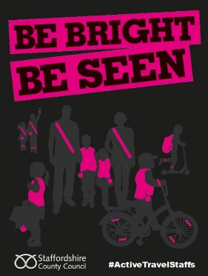 Winners will be announced on Thursday 2nd December.

**Cinema visits**

There will be 2 cinema visits for the children in KS2 this half term. The first is for film education week and the second is a Christmas treat. For both visits the children can bring a small snack that fits in their coat pocket (e.g, a ceral bar, packet of crisps, small popcorn, small bag of sweets, apple). All children need to bring their coat for the walk over to the cinema. Please see the dates below for the dates these are required.

**Children in Need**

Friday 19th November is Children in Need day. The children can come to school dressed in their own comfy clothes for the donation of £1. There is not set theme on this day, but the children are welcome to wear anything pudsy related, bright coloured, spotty, or simply something that makes them happy.



**TT Rockstars Day**

On Friday 26th November we will be having a maths day celebrating times tables and number work. The children will be able to come in dressed as their TT Rockstars avatar, or rockstar of their choice. Please watch out for the letter giving further details.



**Cold Weather**

As we now have colder temperatures and wet weather creeping in, please can I remind all children to bring coats on a daily basis. Please ensure that your child’s coat has their name in so that it can be returned to the correct person if left outside.



**Panto**

The children in Early Years and KS1 will be having a visit from the pantomime later this term. Please watch out for the letter giving further details which they willl receive next week.

**Diary Dates:**

**November**

Saturday 13th – open morning 10 – 12

Saturday 13th - Academy family photo shoots sat school (booked directly with Academy photos)

Monday 15th – Odd Socks day – children wear bright coloured socks for the start of anti bullying week

Monday 15th – Year 5/6 to Vue cinema for film education week

Monday 15th - Year 5/6 football team league matches at Chesterton

Tuesday 16th – Full Governors meeting

Wednesday 17th – Year 3/4 to Vue cinema for film education week

Friday 19th – Own clothes day for children in need. £1 donation

Friday 19th – Flu immunisations from Rec to Year 6. Please see letters from the immunisation team.

Tuesday 23rd – Entrust music visit with Year 5/6

Friday 26th - TT Rockstars Day

**December**

Friday 3rd – Elf / Christmas Jumper Day (details to follow)

Tuesday 7th – Class 1D parent craft afternoon (details to follow)

Wednesday 8th – Class 2 B parent craft afternoon (details to follow)

Thursday 9th – KS1 and EYFS Panto - in school

Monday 13th – last week of school. Class parties this week

Tuesday 14th – Rock Steady concert for parents (2.15pm)

Wednesday 15th – Christmas dinner day

Thursday 16th – Virtual Festival of Christmas for Y5/6

Friday 17th December – Last day of term. Own clothes day for fun (no donation)

If you have any questions or things you would like to discuss with staff, please feel free to talk to myself or the staff on duty in the mornings or give the office a ring and leave your child’s class teacher a message and they will get back to you as soon as possible. We are also available via the office email on [office@hassell.staffs.sch.uk](mailto:office@hassell.staffs.sch.uk)

Kind Regards

Kirsty Broome

Head Teacher