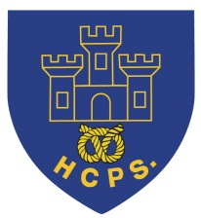 **Hassell Primary Weekly Update 17.12.2021**

Dear Parents and Carers,

**Happy Christmas**

We made it to the end of term! Thank you so much to all our families who have been incredibly supportive over the last term. It hasn’t been the easiest end to the year, particularly with the number of covid cases rising rapidly, but we hope everyone who has been affected is on the mend and will be able to enjoy their holiday time with families. I would also like to take this opportunity to thank the fantastic team of staff at Hassell for their hard work and dedication.

**Covid update**

Unfortunately, as you will be aware, we had to move to remote learning for 2 days within one class of year 5 and 6 while everyone in the cohort accessed PCR testing. Thanks to everyone’s prompt responses we have managed to contain this outbreak and had no further cases within school.

I am pleased to confirm that the children were able to return to school on Tuesday. However, the guidance for close contact with a positive person has now changed. Anyone who is identified as a close contact is now advised to take a PCR test and, where the result is negative, complete daily lateral flow tests for the next 7 days.

You may also have seen reports and comments in the news that suggest schools will be closed in January. We do not have any additional information on this and sincerely hope that this will not happen. However, if anything changes, I will send information out to families as soon as we have it. The children will bring home an exercise book that they will be able to use for any home learning activities, should it be required. Any home learning activities will be set via the children’s google classroom accounts. We all have our fingers crossed that we will be returning in January as normal, but would like to be prepared, just in case!



**Raffle Winners**

A HUGE thank you to the PTFA for their support and for helping to organise the Christmas raffle and to everyone who bought tickets. Congratulations to Sophia whose family won the Kindle tablet, to Darla who won the Morrisons hamper and Alicia and Zara’s family who won the chocolate hamper. There were 15 prizes in total including photography portrait vouchers, meal vouchers, drinks bottles and perfume. Thank you to everyone who donated and well done to all our winners. We have made nearly £400 from the sale of tickets which is amazing!

**Song Book 2021**

Well done to Year 5 and 6 for their work with The Orme Academy for the Song Book performance. This year they performed ‘Any Dream Will Do’. Please click on the link below to watch the children perform.

<https://youtu.be/5If2IW6sHGA>

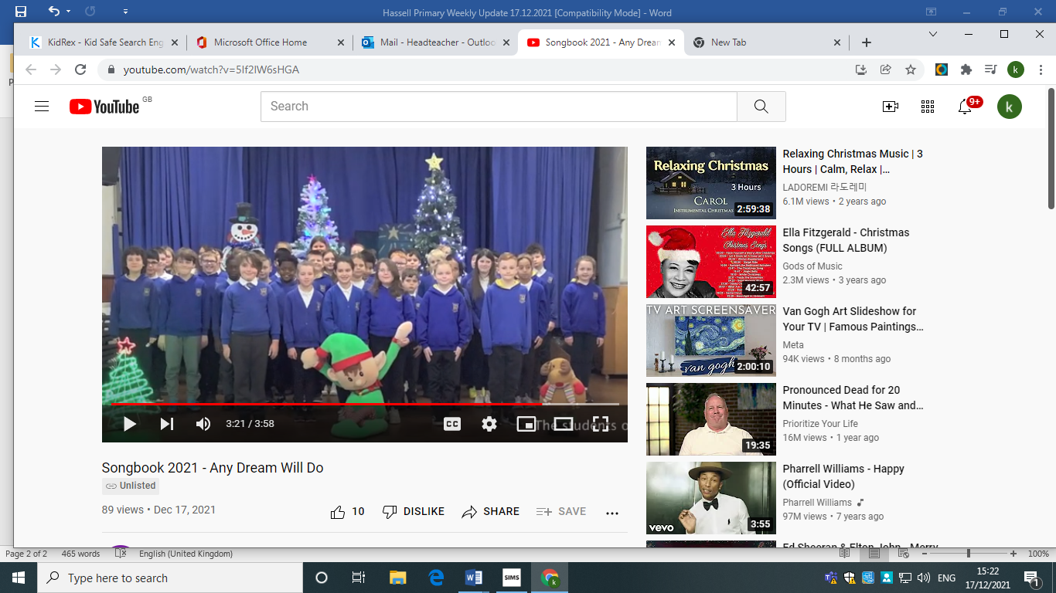

Finally, I would like to take this opportunity to wish all our families a happy and safe Christmas and New Year. I hope you have a really enjoyable holiday time. We look forwards to welcoming everyone back to school on **Tuesday January 4th 2022.**

Kind Regards

Kirsty Broome

Head Teacher