 **Hassell Primary Weekly Update 18.2.2022**

Dear Parents and Carers,

We made it to the end of of term and I’m delighted to report that we remain covid free this week. I hope everyone has a very well deserved half term and enjoys the opportunity to spend time with damily and friends. Just a quick reminder that Monday 28th February is an Inset day so school is closed to pupils. School is open for staff and those children booked into Care Club, but we return properly on Tuesday 1st March.

**Culture Week**

This week the children have had the opportunity to learn more about North America in our whole school Culture Week activities. This has included geographical mapping skills, the history of North America, arts and crafts such as making totem poles, worry dolls and dream catchers and some line dancing activities. The children have done a super job and produced some beautiful work. Well done everyone!

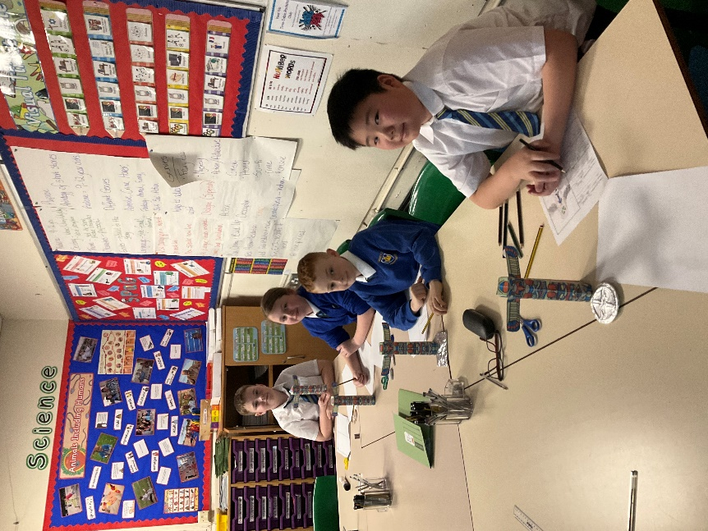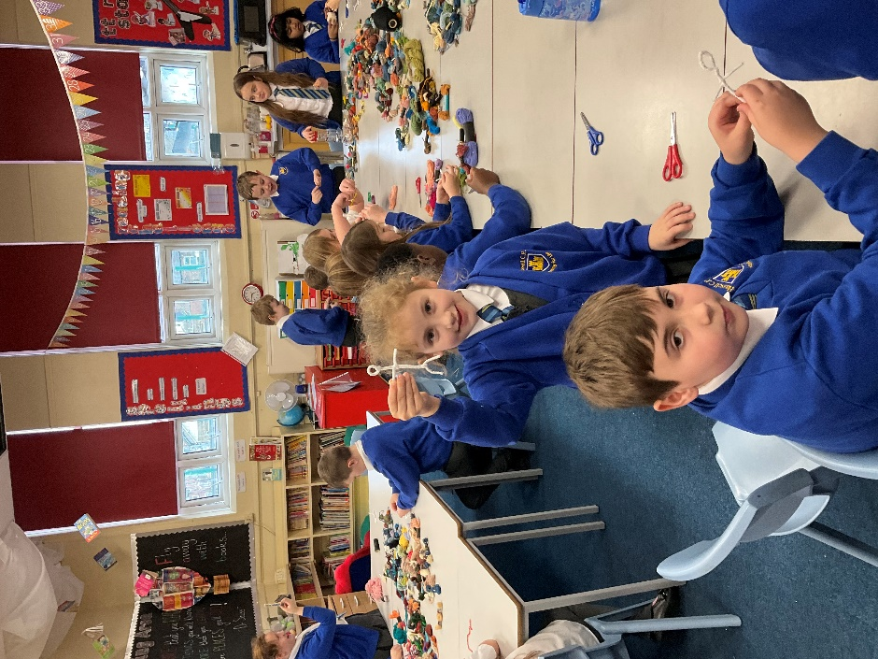

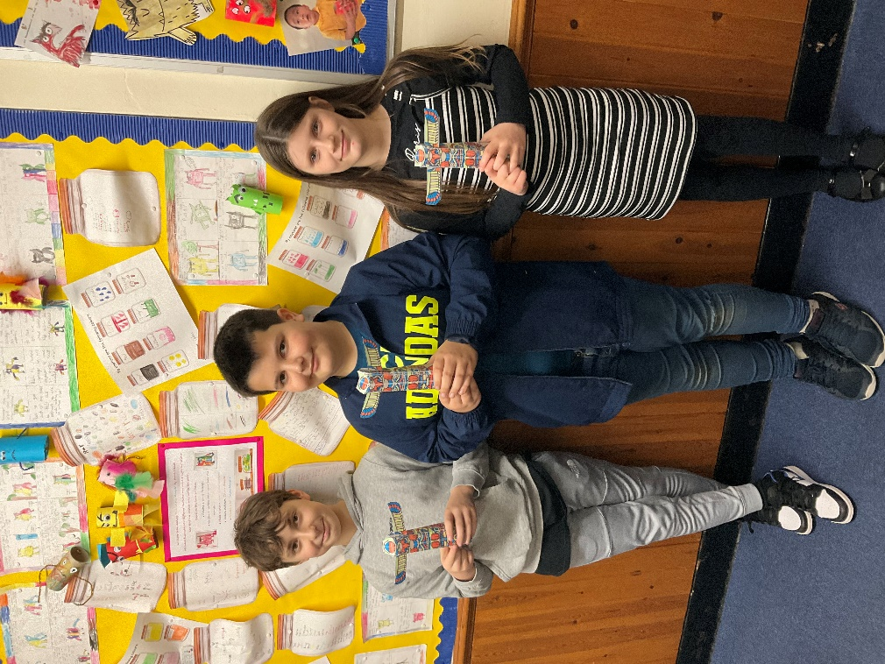 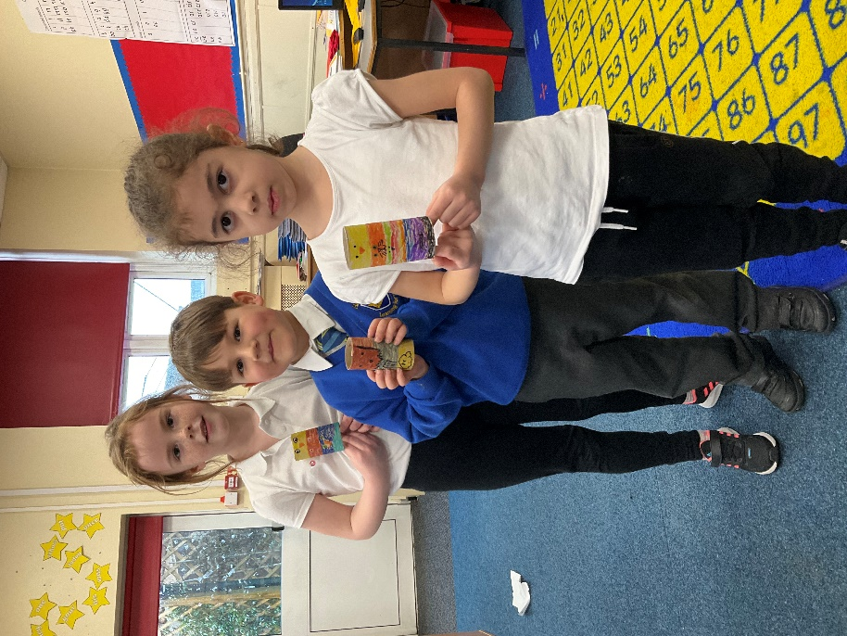

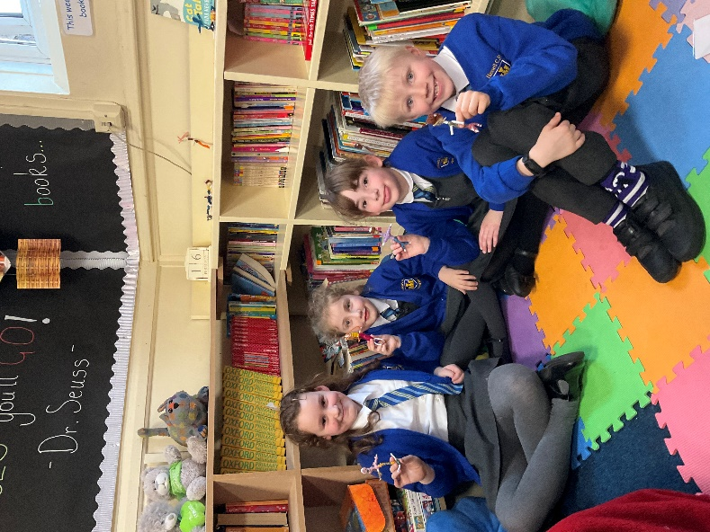

**World Book Day**



World Book Day takes place on Thursday 3rd March and we hope you’ll join us as we come together to encourage every child to be a reader and love books.

To celebrate World Book Day, we will have plenty of fun activities planned including:

* Key Stage 2 taking part in the live Story Makers World Book Day Show.
* A ‘Share a Story’ afternoon for Key Stage 1, Reception and Nursery- the children can bring in a teddy and a book that they enjoy.
* Key Stage 2 will also be creating their own World Book Day Scavenger Hunt and investigating writing in our favourite books.
* Key Stage 1 …….
* The fun will be topped off with story time and a little treat for everyone at the end of the day.

On World Book Day the children can come to school dressed in their own clothes. This could be comfy clothes, a character outfit or even pyjamas!

For World Book Day this year, we would love for children to take a ‘Shelfie’. 📚

This is a selfie (photograph of the child) in front of/next to a bookshelf/corner/area at home.

If you are able to email your child’s Shelfie to their class teacher, we would love to make a display of them in school.

If you are happy for your child’s Shelfie to be shared on our school Facebook page, please include a message to their teacher to say this when you email the photo in.

Shelfies can be emailed in anytime from now until World Book Day which is 3rd March 2022

We would also love to see any toilet roll tube, potato or wooden spoon book characters that you make at home. These can be brought in after half term- ready to display on World Book Day.

<https://www.worldbookday.com/fun-craft-favourite-characters/>

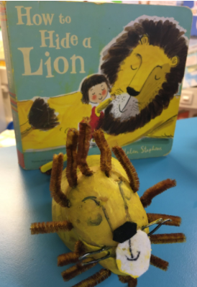

**Nursery Places**

Our Nursery currently has a small number of places left for the Spring and Summer Term. Places are available to children in the term after they turn 3 years old for 15 hours or 30 hours, depending on parent’s entitlements. If you would like to further information, please see the EYFS pages on our school website. Please contact the school office if you would like to book a place for this academic year or starting in September.

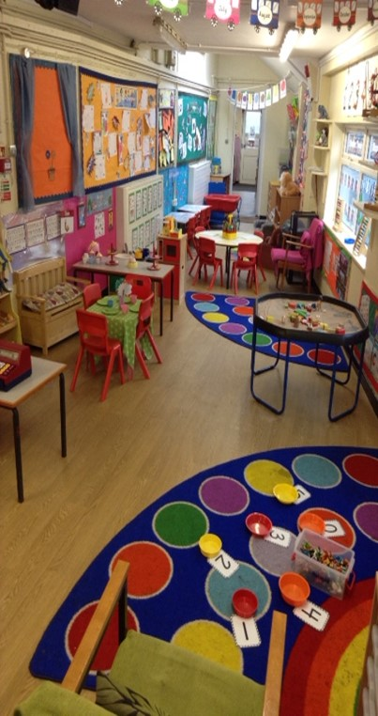

**Care Club**

As you may be aware, our care club runs before school, after school and during the holidays. We currently have spaces before and after half term. If you would like to have a place, please contact Miss Barlow at [happytimesltd@outlook.com](mailto:happytimesltd@outlook.com) or contact school for further details.

**Diary Dates: These will be updated as the term progresses**

**February:**

21st Feb to 25th Feb – Half Term

Monday 28th Feb – **INSET DAY. School closed to pupils**

**March:**

Tuesday 1st March – children return to school

Thursday 3rd March – World Book Day

Tuesday 8th March – Dental Survey for R and Y1 children

Week beginning 11th March – Science week.

Friday 18th March – Comic Relief own clothes day

Week beginning 21st – Book Fair in school (details to be confirmed).

If you have any questions or things you would like to discuss with staff, please feel free to talk to myself or the staff on duty in the mornings or give the office a ring and leave your child’s class teacher a message and they will get back to you as soon as possible. We are also available via the office email on [office@hassell.staffs.sch.uk](mailto:office@hassell.staffs.sch.uk)

Kind Regards

Kirsty Broome

Head Teacher