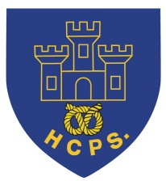 **Hassell Primary Weekly Update 21.1.2022**

Dear Parents and Carers,

**Covid update**

**Positive case isolation change**

As you will be aware, the guidelines for isolation periods altered again on Monday.

If we have any children test positive within school, they may now be able to have a shorter isolation period. If the positive person has a negative lateral flow test on day 5 and day 6, at least 24 hours apart, they can now come back to school on day 6. If day 6 is still positive on a lateral flow, they can continue to test and come in the day after 2 consecutive negative tests. E.g if day 7 and 8 are negative they can come back to school on day 9. We hope that this will help to limit the amount of time children are having to be absent from school.

**Close contact with a positive case**

If children are identified as a close contact, the advice is to have a PCR test, if possible, and to take a daily lateral flow test for 7 days after contact. Children who are identified as close contacts are still able to come to school as long as they do not have any symptoms. Anyone with symptoms should get a PCR test and remain in isolation until the PCR results are received.

Currently we have a small number of cases within school which are primarily within year 3, but it has been great to see the children returning to school after their periods of isolation. Hopefully, by continuing to take the measures that we have had in place since September, we will help to keep infection levels to a minimum.

If your children are unwell, but it is not covid, please follow the usual guidance regarding returning to school. Please note this is 48 hours after sickness or diarrhea to help prevent infection spreading to others.

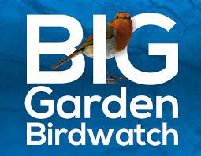

**RSPB Birdwatch**

The Eco Council are very keen for as many of our children to sign up to Bird Watch 22 as possible. The children can sign up on the RSPB website and then choose a time between the 28th and 30th January to spot any birds for the time period of 1 hour. These are then reported to the RSPB. Attached with this newsletter are the downloadable sheets to help the childrenwith their watch and bird identification.

**Music Lessons**

During the last 2 weeks we have had some visits from the perepatetic music teachers to demonstrate their wonderful brass and woodwind instruments. All the children from Year 2 upwards should have received a letter with further information about lessons. If your child is interested intaking up a musical instrument, please send your replies to Mrs Pezzaioli so that she can get the groups organised.

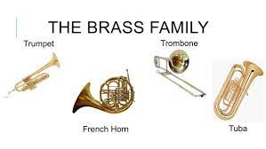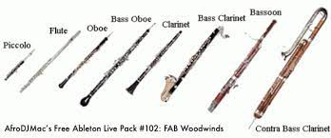

Year 3 and 4 children have now received their violins which they are using for their 6 week taster lessons this half term. If any children in Years 2-6 would like to have violin lessons, please contact school and we will do our best to arrange this for you.

Children in year 3 and 4 should remember to bring their violin into school each Monday for their lesson. Care instructions for the instrument are on the inside of the children’s cases.

**Parents Evening**

This term’s parent’s evenings will be remote via the children’s google classroom accounts. These will take place during the week of 31st January. If your family struggle with IT equipment for remote meetings, please let your child’s class teacher know and we will arrange an alternative time to call. Appointents will be available to book next week.

**NSPCC NUMBER DAY**

This year we will be taking part in the NSPCC Number day on Friday 4th February. We are inviting all children to come into school wearing clothing that has numbers on it or to come dressed as their favourite number or number character with the suggested donation of £1. Any funds raised will go to the NSPCC. 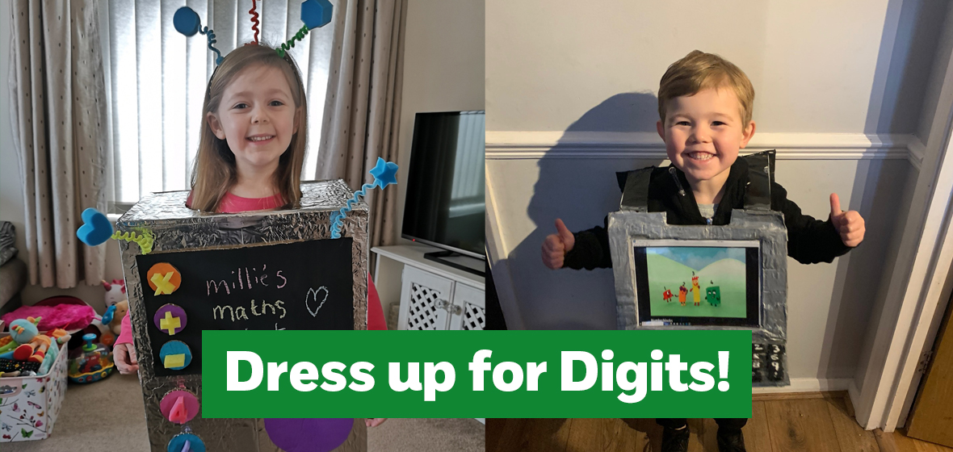

During the day there will also be a TT Rockstars competition that the children will be able to take part in should they wish to do so.

Further information can be found on the NSPCC website:

<https://www.nspcc.org.uk/support-us/events-fundraising/social-special-events/number-day/>

**Celebration Assemblies**

Each week we have a celebration assembly in KS1 and KS2. If your children have done anything that they are particulalry proud of, that they would like to share with their peers, please feel free to email me with the information / photo or video clip so that we can add their home achievements too. In the past this has included receiving football awards, gymnastics competitions, running in Race for life, drama productions, chess awards etc. It isn’t a show and tell assembly, but it would be lovely to celebrate the children’s home achievements along with their school based awards.

**Cold Weather**

The current weather forecast is very chilly, wet and possibly snowy over the next few days. Please can we remind all children to wear coats daily and to bring gloves and hats during cold weather. We do go outside for playtimes, wherever possible, so it is important for everyone to be dressed appropriately. Please can all clothing items be named so that they are easy to get back to the right person if lost.



**Reading Books**

The school reading challenge will continue this term, with children receiving reading awards for their home reading**. Please can all children bring their school reading books, ditty sheets or flash cards (these will change according to the children’s age) every day.** It is really important that the children can access their books in school as well as home so that we can support additional reading. This is really important for all children, but especially those in the younger year groups. Thank you for your support with this.

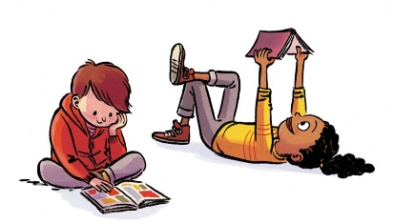

**Diary Dates: These will be updated as the term progresses**

**January:**

Week beginning 31st January – parents evenings, details to be confirmed.

**February:**

4th Feb – NSPCC Numbers Day, non-uniform day.

Week beginning 7th Feb – children’s mental health week.

Tuesday 8th Feb – safer internet day

Week beginning 14th Feb – Culture week

If you have any questions or things you would like to discuss with staff, please feel free to talk to myself or the staff on duty in the mornings or give the office a ring and leave your child’s class teacher a message and they will get back to you as soon as possible. We are also available via the office email on [office@hassell.staffs.sch.uk](mailto:office@hassell.staffs.sch.uk)

Kind Regards

Kirsty Broome

Head Teacher