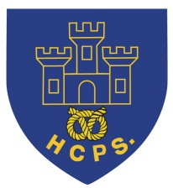 **Hassell Primary Weekly Update 24.9.2021**

Dear Parents and Carers,

I would like to say a HUGE THANK YOU to everyone for your incredibly generous cake donations and purchases at the after school cake sales. As soon as we have a total amount we will let parents know. All funds raised will go to Macmillan cancer support.

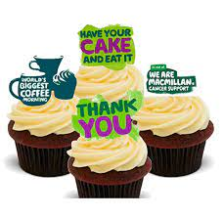

In addition, I would also like to thank all parents who have been getting their children to school by 8.50 am each morning. This really helps us to be on time and less disrupted during registration and lessons which start at 8.50 each day. I would also like to say well done to the children who are always wearing the correct uniform for both normal school days and for PE lessons. They look very smart and represent our school in a positive way.

**Covid Update:**

As you are aware, the national covid restrictions eased as we came back to school and currently, we are no longer having to maintain bubbles within school or isolate different groups if we have any infdividual positive cases. That being said, we still have the majority of procedures in school (good ventilation, additional cleaning, hand sanitiser stations etc) in order to try and keep our school community safe.

If your child/ren begin to display symptoms of covid, we ask that you arrange to have a PCR test and remain absent from school until the results are known. Lateral flow tests do not give as accurate results as the PCR tests and should not be relied upon to confirm a diagnosis if you have symptoms. I have included the main symptoms from the Gov.Uk website below, but during the summer holidays we had a small number of children who were unwell with covid. Their symptoms also included sore throats and cold type symptoms. If you are in any doubt, please contact 111 for support and book a PCR test.

**Coronavirus (COVID-19) symptoms in children**

Children can get coronavirus (COVID-19), but they seem to get it less often than adults and it's usually less serious.

The main symptoms of COVID-19 are:

* a high temperature
* a new, continuous cough – this means coughing a lot, for more than an hour, or 3 or more coughing episodes in 24 hours
* a loss or change to sense of smell or taste – this means they cannot smell or taste anything, or things smell or taste different to normal

**What to do if your child has symptoms**

If your child has any of the main symptoms of COVID-19, even if they're mild:

1. Get a PCR test (test that is sent to a lab) to check if they have COVID-19 as soon as possible.
2. Your child should stay at home and not have visitors (self-isolate) until you get the test result – they can only leave home to have the test. [Check if you and anyone else your child lives with need to self-isolate](https://www.nhs.uk/conditions/coronavirus-covid-19/self-isolation-and-treatment/when-to-self-isolate-and-what-to-do/).

[**Get a PCR test to check for COVID-19 on GOV.UK**](https://www.gov.uk/get-coronavirus-test)

**Important:Help from NHS 111**

Get help from NHS 111 if you're worried about your child or not sure what to do.

* For children aged 5 or over – [get help from NHS 111 online](https://111.nhs.uk/).
* For children under 5 – call 111.

**What to do if your child seems very unwell**

Children and babies will still get illnesses that can make them very unwell quickly. It's important to get medical help if you need it.

**Call 111 or your GP surgery if your child:**

* is under 3 months old and has a temperature of 38C or higher, or you think they have a fever
* is 3 to 6 months old and has a temperature of 39C or higher, or you think they have a fever
* has other signs of illness, such as a rash, as well as a high temperature (fever)
* has a high temperature that's lasted for 5 days or more
* does not want to eat, or is not their usual self and you're worried
* has a high temperature that does not come down with paracetamol
* is dehydrated – for example, nappies are not very wet, sunken eyes, and no tears when they're crying

**Immediate action required:Call 999 if your child:**

* has a stiff neck
* has a rash that does not fade when you press a glass against it [(use the "glass test" from Meningitis Now)](https://www.meningitisnow.org/meningitis-explained/signs-and-symptoms/glass-test/?gclid=CJWh-aLL8s0CFcE_GwodT4ALcg)
* is bothered by light
* has a seizure or fit for the first time (they cannot stop shaking)
* has unusually cold hands and feet
* has pale, blotchy, blue or grey skin
* has a weak, high-pitched cry that's not like their usual cry
* is drowsy and hard to wake
* is extremely agitated (does not stop crying) or is confused
* finds it hard to breathe and sucks their stomach in under their ribs
* has a soft spot on their head that curves outwards
* is not responding like they usually do, or not interested in feeding or usual activities

Please notify school if you are taking your child for a PCR test so that we can record it correctly on our attendance registers.

**Parents Evening:**

This term our parents evening will be online using google meet appointments. This information has been sent in a separate email. Staff have put links to the meetings on their class page. If you have any difficulties accessing this information, please contact the school office.

**Harvest:**

**A message from Mrs Blake:**

Dear Parents/Carers

For our Harvest Festival Appeal this year we will once again be supporting the **Alice Charity and the local Foodbank.** In the past we have been able to share your generous donations between these two charities, which have always been so gratefully received. The last 18 months have been a tough time for all of us, but none more so than for the families in our local area who rely on these charities to provide a healthy balanced meal for their own children.

Below is a list of items which are in really short supply this year.

* Tinned cold meat
* Tinned fruit
* Long life milk
* Long life juice
* Powdered mashed potato
* Sponge puddings
* Chocolate
* Biscuits
* Jam
* Nappies (all sizes)
* Toiletries

If you are able to help out in any way by donating something from the list above, please send your donations to school with your children from Monday 27th September until Friday 1st October. These will then be delivered to the Foodbank and The Alice Charity by a member of staff.

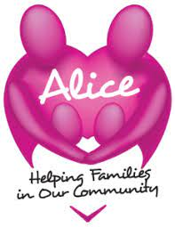 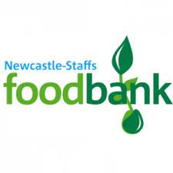

**Diary Dates:**

Sunday 26th September – European Languages Day <https://www.bbc.co.uk/languages/edl/> link to the bbc site

W/C 27th September – Parents evenings – please check for email with details on how to book your slot.

27th September – Harvest Festival Donations into school this week for the Foodbank and Alice Charity. Please see separate letter.

30th September – Year 6 to visit Newcastle Academy for STEM science

8th October – World Mental Health Day – Own clothes day, details to follow

21st October – Halloween Disco

22nd October – Show Racism the red card – own clothes day, details to follow

Half Term – Monday 25th – Friday 29th October

MONDAY 1st November - INSET DAY - SCHOOL CLOSED TO PUPILS

Tuesday 2nd November – All pupils return to school.

If you have any questions or things you would like to discuss with staff, please feel free to talk to myself or the staff on duty in the mornings or give the office a ring and leave your child’s class teacher a message and they will get back to you as soon as possible. We are also available via the office email on [office@hassell.staffs.sch.uk](mailto:office@hassell.staffs.sch.uk)

Kind Regards

Kirsty Broome

Head Teacher