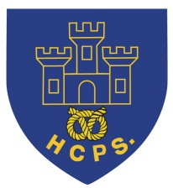 **Hassell Primary Weekly Update 3.12.2021**

Dear Parents and Carers,

**Christmas ELF / Jumper Day**

Today (Friday 3rd December) has been our Christmas Elf / Christmas jumper themed day. This was in aid of the Alzheimer’s society and children have come to school in Christmas themed outfits for the donation of £1. Those children who do not celebrate Christmas, choose to come in bright colours or an outfit of their choice. Thank you to everyone who supported this cause with their donations. We have raised XXX which is fantastic.

**Be Bright Be Seen Winners**

Well done to everyone who has entered the competition. The Eco Council judged our entries and the winners were presented with their goody bags in assembly. Well done to:

Aleisha, Jorgina, Jess, Elizabeth, Leo, Amana, Georgia andLily for their fantastic designs. Ryan Proctor, from the LA team, was very impressed!

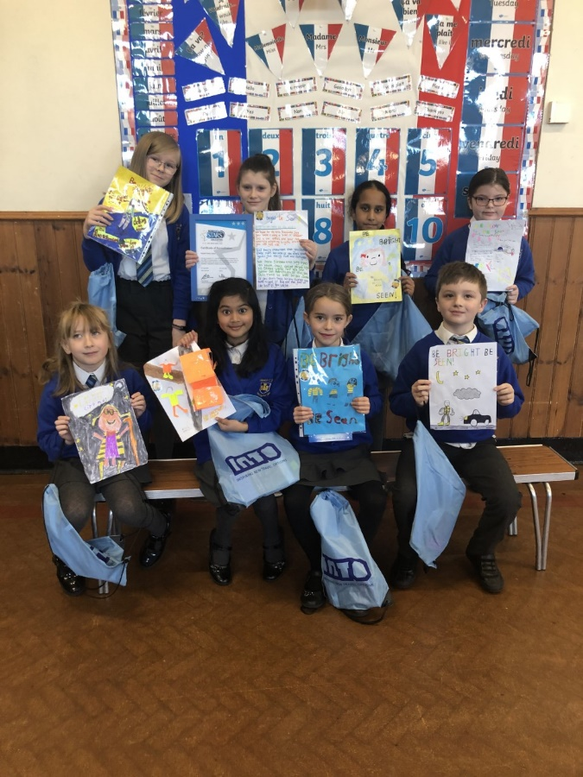

During assembly we also showed the children that we have achieved a silver award from the modeshift stars scheme in order to help reduce pollution and support sustainable travel plans within our school community. Well done to everyone who has been part of this and helped our school on this journey.

**Christmas Cards**

This year the children may send Christmas cards to one another if they wish to do so. There will be card post box in KS2 and a card box in KS1 so they can be delivered. Please remember to put the child’s name (First and surname) and their class on the envelope if they are to be put in the post box. Without this they may not get delivered to the correct person.

**Panto**

The children in Early Years and KS1 will be having a visit from the pantomime later this term. Letters have been sent out this week with all the information required. Please can parents pay for their child’s ticket via parent pay. The panto will take place in school so there are no additional travelling costs or difficulties.

**Christmas Dinner**

Christmas dinner is available to pre order this year via microsoft forms. Please click on the link that was sent out via text and select your child’s choice. This will help us to plan the correct number of meals with the kitchen. **Please complete your order by Monday 6th December.** For those children in KS2 who pay for school meals, please pay via parent pay as normal. Thank you. Below is a picture of last year’s christmas meal, for those of you who may want to see a little more.

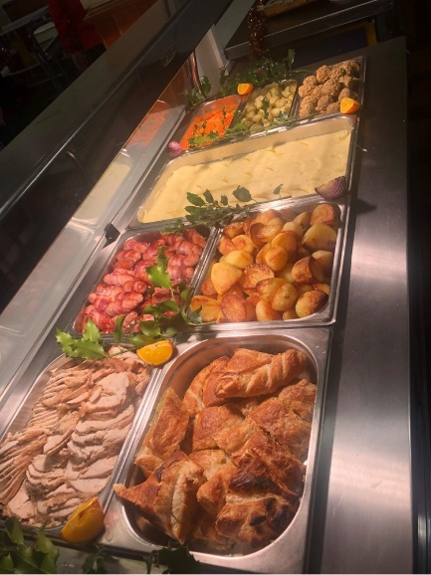 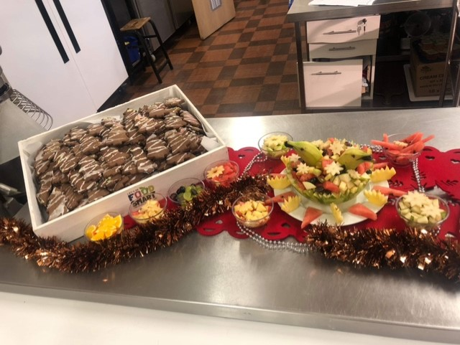

**Covid Update:**

As you will be aware, the government announced new measures that started this week in order to help prevent and slow down the spread of the new covid variant. As a result of this, all adults within school are required to wear masks in communal areas. This includes any parents who need to walk through the corridor to leave school when the gate is closed.

We currently have 7 positive covid cases within school:

Y2 – 1 case, Y4 – 1 case, Year 5/6 - 5 cases. Although these numbers are relatively low, we still very much appreciate your support by getting children PCR tested who are unwell. We do understand the frustration with isolating until PCR results are back, but unfortunately, we have had some children testing positive on PCR tests who have been negative on lateral flow tests. Hopefully, by continuing to test we can limit the amount of exposure that our children are getting and help to ensure people get to the Christmas holidays safely.

**Breakfast and Late arrivals**

In recent weeks we have seen an increase in the number of children who are arriving late at school. We also have children arriving at school who are still eating breakfast. Our school times are 8.50 – 3pm and late arrivals in the morning or children still eating, mean that they, and others, are missing important lesson time. In KS2 we start assembly so that intervention lessons can take place with teachers and teaching support staff. In KS1 and EYFS we start phonics lessons straight away. When children are late, this means that they might be missing lessons or interventions that they need, it also means that they disrupt lessons that have already started. This week, some intervention lessons could not go ahead because staff were caught up delivering children to lessons because they were late. We do not have the number of staff to support this.

I fully appreciate that sometimes, delays are unavoidable and cannot behelped. If this is the case, please call the school office and let us know. In all other circumstances, we would really appreciate parental support to ensure that children are in on time. Even being a couple of minutes late each day makes a difference. Our Education and Welfare service is happy to meet with myself and families to look at ways that we can offer support where families are having real difficulties. Please let us know if this is the case so that we can arrange a meeting. Thank you

**Diary Dates:**

**December**

Tuesday 7th – Class 1D parent craft afternoon (letter sent to parents)

Wednesday 8th – Class 2 B parent craft afternoon (Letter sent to parents)

Wednesday 8th or Wednesday 15th – EYFS Craft afternoon (letters sent)

Thursday 9th – KS1 and EYFS Panto - in school – please see letter 15.11.21

Monday 13th – last week of school. Class parties this week

Tuesday 14th – Rock Steady concert for parents (2.15pm)

Wednesday 15th – Christmas dinner day

Thursday 16th – Virtual Festival of Christmas for Y5/6

Friday 17th December – Last day of term. Own clothes day for fun (no donation)

If you have any questions or things you would like to discuss with staff, please feel free to talk to myself or the staff on duty in the mornings or give the office a ring and leave your child’s class teacher a message and they will get back to you as soon as possible. We are also available via the office email on [office@hassell.staffs.sch.uk](mailto:office@hassell.staffs.sch.uk)

Kind Regards

Kirsty Broome

Head Teacher