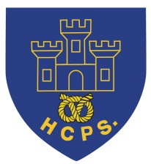 **Hassell Primary Weekly Update 3.9.2021**

Dear Parents and Carers,

Welcome back to the new term at Hassell, I hope you have all had an enjoyable holiday. It has been lovely to see so many new faces starting school, both in Nursery, Reception and throughout other year groups. I would like to welcome all of our new children and their families to Hassell and I look forward to meeting you all soon.

**The Colour Monster**

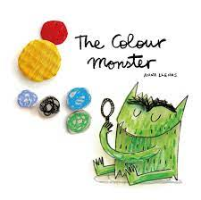

All classes have started this week by looking at the story of ‘The Colour Monster’ by Anna Llenas, which is all about emotions and how we are feeling. The children have produced some fantastic work and should be proud of themselves and their achievements. The normal timetable of lessons will start next week.

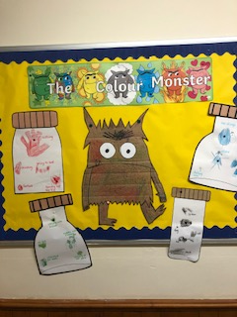 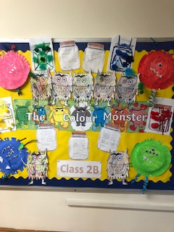 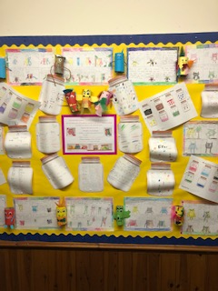

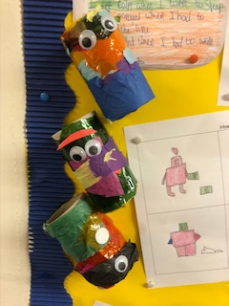 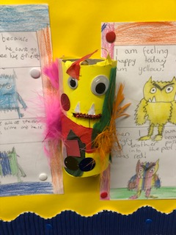 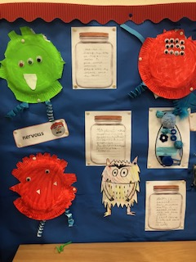

**School Uniform:**

It has been fantastic to see the children looking smart in their school uniforms at the start of term. Thank you for supporting us with this. Please can I remind all children that trainers should only be worn on PE days when children can wear their PE uniform. PE lesson days will be confirmed by your child’s class teacher through their class newsletter. Please can I remind parents that the PE uniform jumper is either the blue school jumper or the blue Hassell PE hoodie.

**Water Bottles:**

Please can all children bring a named water bottle to school each day which contains water (not juice). This is to help the children remain hydrated and can be refilled using the school water dispensers.

**School Day Times:**

Our school day starts promptly at 8.50 and all children need to be in their class by this time. Registration and lessons all start straight away and late entry means that children and staff are disrupted. Please support us by ensuring that your child is in school each day on time.

Where children are ill or absent from school, please contact the school office each morning on 01782 694567 to let us know.

**Toast and break time snacks.**

Children in KS2 may order toast for break time at a cost of 20p per slice. Maximum of 2 slices per child. Please send toast money in to your child’s class teacher for this to be ordered, ideally on a Monday for the rest of the week. Alternatively, KS2 children may bring in their own healthy snack such as fruit or cereal bars. Sweets, crisps and chocolate etc are not allowed at morning break. Children in Nursery, Reception and KS1 are provided with a daily fruit snack at break time each morning.

**Diary Dates:**

W/C 13th September – LMA sports clubs commence

15th September – International day of democracy

W/C 20th September – European Languages Day introduction

23/24th September – McMillan Cake sale – details to follow

W/C 27th September – Parents evenings – details to follow

27th September – Harvest Festival Donations into school for the Foodbank and Alice Charity

8th October – World Mental Health Day – Own clothes day, details to follow

21st October – Halloween Disco

22nd October – Show Racism the red card – own clothes day, details to follow

Half Term – Monday 25th – Friday 29th October

MONDAY 1st November - INSET DAY - SCHOOL CLOSED TO PUPILS

Tuesday 2nd November – All pupils return to school.

If you have any questions or things you would like to discuss with staff, please feel free to talk to myself or the staff on duty in the mornings or give the office a ring leave your child’s class teacher a message and they will get back to you as soon as possible. We are also available via the office email on [office@hassell.staffs.sch.uk](mailto:office@hassell.staffs.sch.uk)

Kind Regards

Kirsty Broome

Head Teacher