 **Hassell Primary Weekly Update 8.10.2021**

Dear Parents and Carers,

Today we supported World Mental Health Day with the #HelloYellow campaign. Thank you to everyone who took part and came to school dressed in their own clothes and for the donations given.

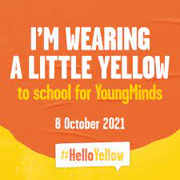

This week’s assemblies have also been about the children’s mental health and how to keep yourself mentally healthy. Please find a list of links below which can be accessed if your children or any family members feel they need more support.

***NSPCC***- advice on how to report concerns about children and advice on how to keep children safe

<https://www.nspcc.org.uk/keeping-children-safe/reporting-abuse/>

***CAMHS: Child and Adolescents Mental Health Service***

<https://combined.nhs.uk/our-services/children-and-young-people/child-and-adolescent-mental-health-services-camhs/>

***CAMHS: Autism Spectrum Disorder***

<https://combined.nhs.uk/our-services/children-and-young-people/camhs-asd/>

***Younger Minds North Staffordshire:***Offers 1-2-1 counselling and emotional support

<http://nsmind.org.uk/support-for-young-people/younger-mind/>

***Dove Service:***Bereavement, Loss and Life Changing Illness support for children, adults and families

<https://www.thedoveservice.org.uk/>

***Changes YP:*** a support service promoting the recovery of young people in mental distress throughout Stoke-on-Trent and Staffordshire***.***

<http://www.changesyp.org.uk/>

***Home-Start*:**The team provides support for families across a range of issues such as post-natal depression, coping with disabilities, isolation, low self esteem, parenting difficulties, routines and boundaries, nutrition and cooking, attending medical appointments and lots more. They offer both practical and emotional support for 2-3 hours, 1 day a week.

<https://www.hsnb.org.uk/>

***Glow Service*:**Support for children and families who experience domestic abuse or are at risk of domestic abuse

<https://www.findtheglow.org.uk/home/>

***Alice Charity:***Services include skills development, such as parenting techniques and budgeting; regular emotional and well-being support, signposting, emergency food parcels, as well as provision of essential equipment

<https://alicecharity.com/>

***Mind*:**For mental health advice and support for adults

<https://www.mind.org.uk/>

***Newcastle Food bank***

<https://newcastlestaffs.foodbank.org.uk/>

***Newcastle Borough Council Online Reporting-***

<https://www.newcastle-staffs.gov.uk/contact-us>

**01782 717717**

***First Response Staffordshire*** – to report a concern if you are worried about the safety of a child up to the age of 18.

Tel : 0800 1313126

<https://www.staffordshire.gov.uk/Care-for-children-and-families/Childprotection/First-Response.aspx>

**Road Safety**

As the dark nights begin to creep up on us please can we spread the message about road safety. We do cover this topic within school, but practical support from families when the children are walking to and from school is also invaluable. Thank you for your help in this matter.



**Halloween Disco**

There will be a Halloween themed disco on Thursday 21st October at school. Please watch out next week for the letter giving details and information about tickets. This will be a paper copy with a reply slip that the children can bring back into school.

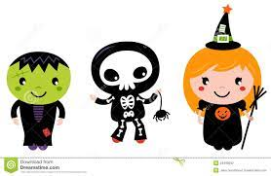

**Morrisons ‘It’s Good to Grow’ Vouchers**

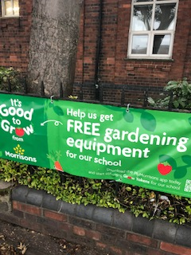 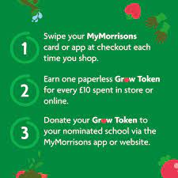

This year we have signed up for the Morrisons It’s Good to Grow voucher scheme. By collecting vouchers we can get free gardening equipment for our children to use in school. If you shop at Morrisons, one voucher can be collected for every £10 spent. Please take a minute to scan your card or APP at the checkout and collect the vouchers for us and then donate to Hassell Primary. Thank you!!

**Diary Dates:**

Until October 24th – collect Morrisons ‘It’s Good to Grow ‘ vouchers

21st October – Halloween Disco – ticket details to follow

22nd October – Show Racism the red card – own clothes day, details to follow

Half Term – Monday 25th – Friday 29th October

MONDAY 1st November - INSET DAY - SCHOOL CLOSED TO PUPILS

Tuesday 2nd November – All pupils return to school.

If you have any questions or things you would like to discuss with staff, please feel free to talk to myself or the staff on duty in the mornings or give the office a ring and leave your child’s class teacher a message and they will get back to you as soon as possible. We are also available via the office email on [office@hassell.staffs.sch.uk](mailto:office@hassell.staffs.sch.uk)

Kind Regards

Kirsty Broome

Head Teacher