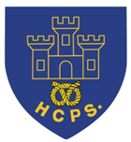
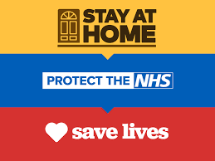

Calling all Year 5 and 6 Hassell pupils:
The NHS are working so hard at the moment to keep us all safe, so we thought you might like to enter this competition to say ‘thank you’ to them.

We know that things are a little different at the moment as we are not in school to give you the input we normally would, but if you look through the Powerpoint presentations attached, you will see lots of the different jobs which can be done as part of the NHS. The first and second Powerpoints give you background information about the NHS and the different types of jobs carried out by NHS workers (there are more than you think), and the third Powerpoint explains about the competition.
If you send a photo of your artwork, email a copy of your written work or send a copy of your video to your class teacher’s email address, we will send in your entries for you. (Please get your parents’ permission!!) You need to have sent your entry to your class teacher by Friday 10th June.
This entry can be done during school hours and can be part of your home schooling tasks. You do not have to enter, but we thought it would be a fun way of showing our thanks.
Like the poster says – get creative, and most importantly, have fun.
Mrs Goodstadt, Mrs Plummer and Miss Stokes. xxx

