WEEK 4- Food
Age Range: EYFS
I hope you are all well. Thank you so much for the emails and photos- I am really enjoying seeing them. It sounds like you have all been very busy! Please send any more to: mrslearhassell@gmail.com Take care and hope to see you soon,
Mrs Lear
Weekly Maths Tasks (Aim to do 1 per day) | Weekly Reading Tasks (Aim to do 1 per day)
- Watch a Numberblocks clip each day at: BBC or CBeebies. Use this guide here to give you ideas on what to do with your children whilst watching an episode.  - Working on Numbots - your child will have an individual login to access this.  - Play the Numberblocks add and subtract game.  - Explore weighing and measuring food on the kitchen scales. Ask, what happens as you place more on the scales?  - Look for numerals on packaging you find around the house. Can your child recognise the numerals and count out a matching amount? | - Read a variety of books at home. Favourites can be repeated. Hearing the patterns of language in a story will support your child’s language development.  - Reception age children: Children to read to parents daily. Visit Oxford Owl for free eBooks that link to your child’s book band. You can create a free account.  Complete the linked Play activities for each book.  - With your child, look in magazines, newspapers and books for the tricky words they are currently learning. They could use a highlighter to highlight in magazines and newspapers.  - Look at recipe books and food magazines. Encourage your child to use their phonics knowledge to decode the ingredients list. Select a recipe and make this together. Encourage your child to read the labels on packaging to figure out which ingredient it is.  Tricky word games to play.  Make a tricky word car park  Tricky word skittles, if you don’t have any skittles you could use pop bottles or milk cartons.
Weekly Phonics Tasks (Aim to do 1 per day) | Weekly Writing Tasks (Aim to do 1 per day)
- Sing Nursery Rhymes and songs together. Add in actions and change the words. Can children think of different rhyming words to add in? Repeat old favourites and learn new rhymes. You can find an A-Z of Nursery Rhymes.  - Daily phonics - Practice the sounds your child is working on and blend words. This can be oral blending (e.g. spoken out loud c-a-t) or written if appropriate. Interactive games.  There are daily Read Write Inc phonics lessons live on the Ruth Miskin YouTube Channel: Set 1 Sounds 9:30AM; Set 2 Sounds 10:00AM and Set 3 Sounds 10:30AM.  Most children in Year 1 and 2 will be learning the set 2 or 3 sounds. The videos are available for 24 hours after the live sessions (please be aware that this is on YouTube and so we recommend adult supervision).  https://www.youtube.com/channel/UCo7fbLgY2oA_cFCIg9GdxtQ  There is a parent guide to Read Write Inc. and online activities to practise writing and spelling at:  https://home.oxfordowl.co.uk/reading/reading-schemes-oxford-levels/read-write-inc-phonics-guide/  Play a phonics or spelling game:  ● https://new.phonicsplay.co.uk/  • https://www.topmarks.co.uk/english-games/5-7-years/letters-and-sounds  • https://www.topmarks.co.uk/english-games/5-7-years/words-and-spelling  Other activities:  Practise spelling common exception words (see your purple exercise book for the words).  Practise saying the months of the year. You could say them forwards through the year and backwards.  Practise spelling the months of the year- practise 2 or 3 each day to help.  You could write the months out on pieces of paper, mix the pieces up then put the months back in order. With someone: mix the months up then take one out. Can they work out which is missing?  - Pour flour, rice or lentils into a shallow tray or plate. Show your child a letter, digraph, trigraph or tricky word and ask them to ‘write it’ in the food using their finger. (sand, soil, glitter, shaving foam)  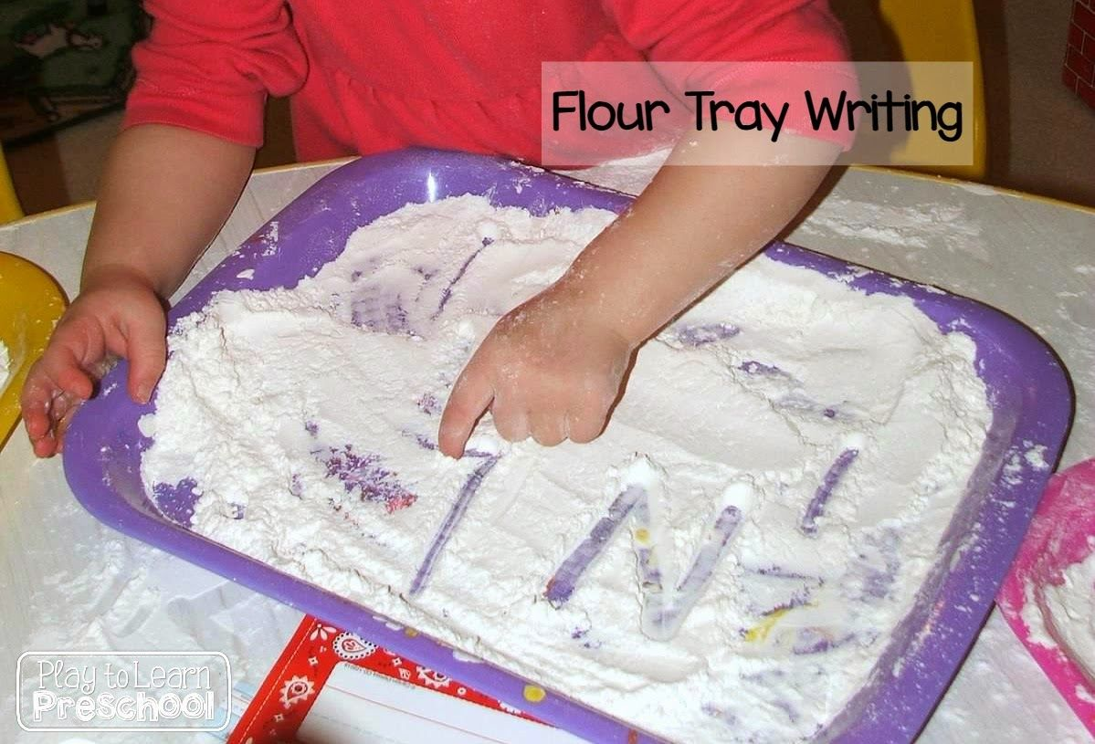 | - Practice name writing. Can they write their first name? Middle name? Surname? Using the correct formation (see the exercise book we sent home)  - Practice forming the letters of the alphabet. Follow the script.  - Ask your child to write out the tricky words they are working on at the moment on pieces of paper and turn them into a pairs game.  - Using recipes from books as a guide, ask your child to create their own recipe for their dream meal. They could draw out the ingredients and label them and draw the finished meal. Some children may be able to write a few short sentences as instructions.  - Look at a range of different packages found around the kitchen. Discuss with your child what makes it stand out to a customer. Support them to design a package for a treat of their choice.  If you are able to the main thing is to keep geeting your little one to write a sentence or two a week. (Sentence writing instrucations are in the exercise book)  Read Kitchen Disco (Everyone was sent a copy of this book from the book trust) If you don’t have the book see the link here.  https://www.youtube.com/watch?v=oPxZzuXX-Lw  Ask your little one to write about what they would do if they had a kitchen diso.  At my disco I would like……….it will be fun.  I will invite.  You could have your very own kitchen disco as a reward for writing the sentence.
Learning Project - to be done throughout the week
The project this week aims to provide opportunities for your child to learn more food. Learning may focus on where different foods originate from, what makes a healthy meal, opportunities to cook etc.
- Healthy/ Unhealthy-
  - Provide your child with a selection of items from your kitchen cupboards. Can they sort them into things that are healthy and unhealthy? Discuss why the food is good for you or bad for you. Look at the Eatwell plate to help figure out which foods they should eat a lot of or not very much of.

- Discuss how exercise is an important part of staying healthy. Watch and complete a 10 minute shake up.

- 5 a day-
  - Support your child to create a food diary to record how many pieces of fruit and vegetables they eat in a day. They could write these using their phonics knowledge or draw a picture of each item.

- Create a collage-
  - Ask your child to draw out a number of fruits or vegetables, large enough to fill a piece of A4 paper. Provide them with a selection of colourful packaging. Can they cut out and collage on to their picture to

- Play shops-
  - Using toy food or old packaging, set up a food shop for your child to act out being the shopkeeper and customer. You could introduce coins to support their developing knowledge of money. Give them a notepad to use as a shopping list to encourage in the moment writing.

- Potato/ Vegetable Printing-
  - Using a selection of vegetables available in your kitchen, support your child to print and explore the shapes and patterns created:
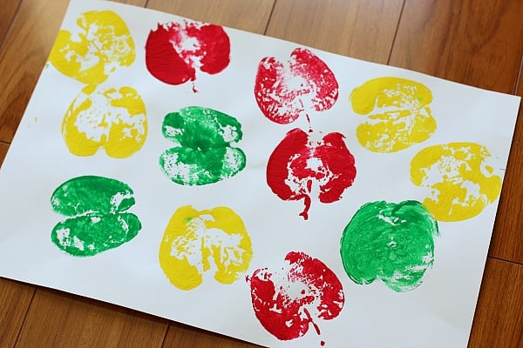
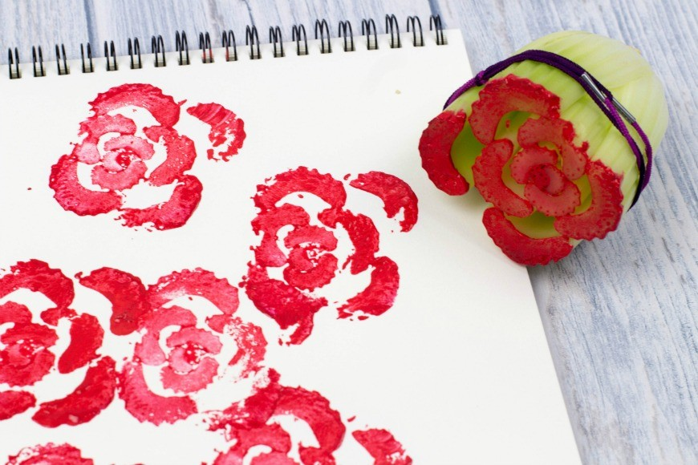
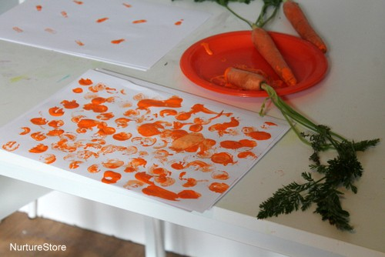

- Make cornflour gloop-
  - Mix cornflour with a small amount of water in a mixing bowl. It will make a slimy, stretchy mixture. Allow your child to explore the change of texture from wet to dry and the texture of the gloop.
Additional learning resources parents may wish to engage with
Classroom Secrets Learning Packs - These packs are split into different year groups and include activities linked to reading, writing, maths and practical ideas you can do around the home.
Twinkl - to access these resources click on the link and sign up using your own email address and creating your own password. Use the offer code UKTWINKLHELPS.
Headteacherchat - This is a blog that has links to various learning platforms. Lots of these are free to access.

