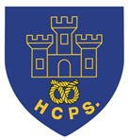
Year 5 Learning Project - TRANSITION
This learning project focuses on supporting you with transitioning to your new class.
It will give you the opportunity to reflect on your time in your current class, discuss your favourite memories and achievements whilst also considering your hopes and dreams for the next academic year.
Transition Activities
MEMORIES | Starting a new academic year is a time for you to say farewell to current teachers and classmates and hello to many new faces. It is important for you to cherish your favourite memories. Create a drawing or art piece of your special memory and frame it in a hand-made photo frame. You may choose to draw a favourite lesson, a funny moment with friends, a school trip, your favourite teacher or a job role you were proud of. You may choose to decorate the photo frame provided or to craft your own using card. Click here for photo frame ideas. Share at #TheLearningProjects.
ACHIEVEMENTS | You are unique and special. Over the course of the last year, you will have achieved so much. Whether that’s learning your times tables, swimming without armbands or having the confidence to put your hand up in class and offer an answer. Remind yourself that an achievement is something that has been accomplished through great effort, skill, perseverance or courage. Mind map all of your achievements this year, both in school and outside of school. Look at the mind map and identify your greatest achievement, write about this special achievement. How did you accomplish this? What barriers did you face? Who helped you? Record this as a story featuring yourself as the main character, a newspaper report or even write a rap!
SAYING FAREWELL | Ending the academic year can be a time that is full of mixed emotions. However, whilst many aspects of school life change, many remain the same too. Spend some time with your parents discussing all of the similarities and differences between your current class and the new class that you will be going into. For example, your lunchtime will remain the same or you will now get to learn how to play the ukulele. Following this, record the similarities and differences using the table on the next page.  A new year is also a great time to make new friends. Can you create a poster that illustrates top tips for making friends and showing kindness? You could speak to family members or your own friends to gather some ideas first.
INDIVIDUAL QUALITIES | Art can be a great tool for self-exploration and self-expression. Create a piece of artwork which represents your personality and highlights your individual qualities. This could be a picture or something more abstract using materials available at home. You may find listening to your favourite music encourages your own expression. Once completed, discuss your artwork with your parents. What did you want to represent in this piece? How did you try to show off your personality through your artwork?
GOAL SETTING | Setting goals is an excellent way for you to try and achieve things that you might not think is possible. Goal setting will also help you to improve your confidence and self-esteem when you see that you can achieve the target you’ve set. Create a ‘Wheel of Fortune’ (see below). Use the headings: Learning, Friendships, Physical Challenge, Wellbeing and Family. Under each heading, write a goal thinking carefully about how long it will take to achieve each goal, who or what can help you and any difficulties you may have to overcome.
Year 5- Transition Learning Project
Below are some ideas of how you could set out your work.
MEMORIES | ACHIEVEMENTS | SAYING FAREWELL | INDIVIDUAL QUALITIES | GOAL SETTING
 |  | 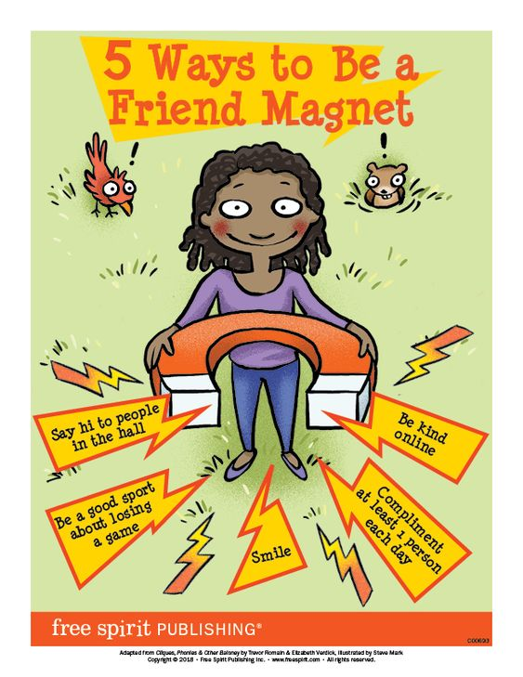 | 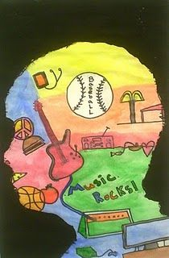
Additional Learning Resources Parents May Wish To Engage With:
- Tips and resources to support transition from Mentally Healthy Schools can be found here.
- Childline wants to help bring out the best in your child through some easy-to-do activities.
- The BBC Bitesize website has lots of helpful videos to support transition for both parents/carers and children.
- Parentkind provides handy hints to help prepare your child for their new class.
#TheLearningProjects

