Wc 22.06.2020: Learning Project - Around the World
Age Range: Y3/4
Well done everyone who has sent emails and pictures to their class teacher this week. We love seeing what you are getting up to at home. Remember, we are just has happy to see photographs of you getting out in the garden, enjoying time with the new people you are allowed to meet and any other fun things you have done at home!
Weekly Reading Tasks | Weekly Spelling Tasks
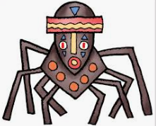  Monday- Share a story together, perhaps a story from another culture? Ask your child to identify any countries, cultures or food that are referenced in the story.  With a parent, watch the following story on YouTube:  Anansi and the pot of beans:  https://www.youtube.com/watch?v=Sau3E2LEfcI&safe=active | Monday- Your child can learn to spell the continents of the world. Practise writing them using pencils, pens, chalk, sticks, typing, etc.
Tuesday- Visit Ducksters and let your child choose a region to learn about. Ask them to identify major cities, rivers and information on its landscape. | Tuesday- Practise spelling these words: sadly, completely, usually, finally, comically. Can your child identify the spelling rule for adding the ‘ly’ suffix?
Wednesday- With a parent, watch the story of Romulus and Remus on YouTube.  https://www.youtube.com/watch?v=wA1D9wd29jI&safe=active  Can your child design a book cover for a well-known myth e.g. Romulus and Remus? Or can they write an alternative ending instead? | 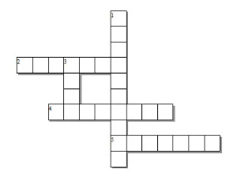  Wednesday- Can your child create their very own ‘Around the World’ crossword puzzle? Help them write clues and a family member can complete it.
Thursday- Visit Story Nory and let your child choose a story from around the world to listen to. Can they summarise the main events by drawing a comic strip? | Thursday- Trace it. Choose 5 Common Exception words and trace around each word. What does your child notice about the shape of each word?
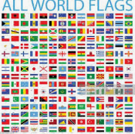  Friday- Look at this world flag poster together. How many flags does your child recognise? Ask your child to choose one of the countries and read online about their culture, cuisine, popular sport and significant/famous people from this country. | Friday- Ask your child to list adjectives and place names that begin with the same letter e.g. fascinating France, sweltering Sri Lanka, exquisite England. Can they put these into a list poem?
Weekly Writing Tasks | Weekly Maths Tasks- Multiplication and Division
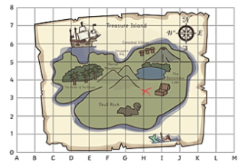  Monday- Visit the Literacy Shed for this wonderful resource on The Blackhat. Or your child could design a new island for people to visit by creating a detailed map from a bird’s eye view. | Monday- Your child can try to find real life arrays -this could be eggs in a tray, candles in a row, etc. Once found, get your child to write the calculation for that array.Can they find the fact family? (E.g. 3x4 = 12, 4x3=12, 12÷3 = 4 & 12 ÷ 4=3).
Tuesday- Ask your child to write a set of instructions explaining how to make an African mask. Remind them to include: equipment, headings, imperative verbs (bossy words), adverbs (e.g. carefully, slowly ) and a handy hint. | Tuesday-  Watch this video with a parent of the x5 rap song.  https://www.youtube.com/watch?v=LZAqhF_2vvs&safe=active  Choosing a times table of choice, ask your child to write a rap/song to help them remember the multiplication facts linked to this time table. Can they include the corresponding division facts in their rap/song too?
Wednesday- Discuss a holiday that your child has been on or a place they’ve visited. Get them to design a postcard and write about what they did there.  Free postcard template:  https://www.twinkl.co.uk/resource/t-m-279-postcard-writing-template | Wednesday- Get your child to make a multiplication flower for a times table of their choice like the one here.
Thursday- Get your child to listen to some Anasi stories. Ask them to write their own story featuring Anasi. What is she going to teach them? Encourage them to create their own book with a front and back cover and illustrations. | Thursday (theme)- Ask your child to think about the products that they use at home and how far these have travelled. Food, clothing, toys and electrical items often carry ‘Made in…’ labels. Calculate distances travelled and order from those made closest to home to those made furthest away.
Friday- After the reading task, your child can create an information report on their chosen country and organise their paragraphs using these headings: culture, cuisine, popular sport and significant/famous people. | Friday (theme)- Encourage your child to explore different currencies of money used around the world. How do these compare to pounds? E.g £1= $1.25.

Learning Project - to be done throughout the week
The project this week aims to provide opportunities for your child to learn more about countries and cities around the world. Learning may focus on different cultures and traditions, famous landmarks, food and clothing.

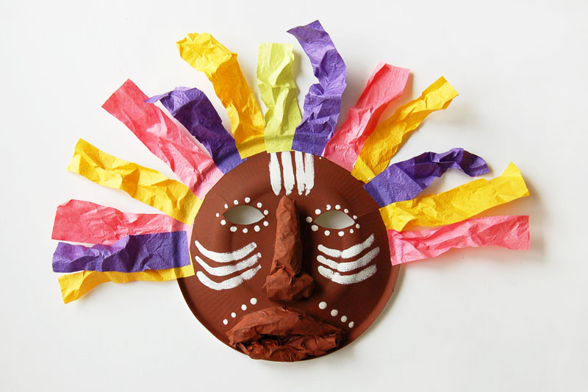
- Virtual Explorer - What are the continents of the world? Where are they located? What languages are spoken in these continents? Ask your child to use Google Maps to explore a continent of their choice. Can they create a continent fact file or choose a particular country they are interested in and create an information guide including the weather, tourist locations, landmarks, weather, traditional music, food, flags. Remember to tweet a photo of their fact file or information guide #TheLearningProjects.

- Mask Making - Ask your child to use paper or cardboard and a range of materials around the home to design and create their own African mask. Can they find out their importance to African culture by watching this clip?

- Dance Around the World - Use SafeYoutube to dance along to some different cultural dances from around the world, such as the Brazilian Samba, the traditional Diwali stick dance or the Spanish Flamenco. Your child can design a cultural costume for their favourite dance and label it with suitable materials. Why not record a video to share with your school’s Twitter? Encourage your child to watch the recording back and evaluate their dance. Recommendation at least 2 hours of exercise a week.

- Speak the Language - Encourage your child to discuss with their family the links they and their family have to the wider world. Find out places family members have visited on holiday, work/business links or simply countries they would like to visit in the future. Have a go at learning some simple phrases in different languages from around the world and write the phrases using the colours of the flag for that country. You could visit the Mrs Mandarin website here. You could also download the Duloingo app to learn a new language!

- Tribal Traditions –
With a parent, watch this video on YouTube all about Maori Traditions!
https://www.youtube.com/watch?v=_I_TxIZNOYM&safe=active
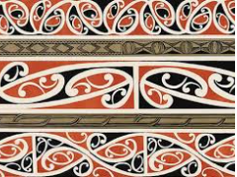
Can your child create some artwork inspired by one of the tribes?

Coronavirus and Wellbeing- Coping with Change
The change that Covid-19 has caused to our lives has been difficult and has provided countless challenges. For many children, the uncertainty and disruption to everyday life has caused worry and anxiety. These tasks are designed to help children process the current situation, begin to make sense of it and plan for returning to a different normal.

Think
- Explaining to children what the Coronavirus is and how to stop the spread can be a challenging task. This fact sheet does this in a child-friendly way. Alternatively, there is an animated version here.
Talk
- Talk to your child about their worries and anxieties, considering what they can control and what they cannot control e.g. I can keep up with my home learning by checking which tasks I have to do today. I cannot control when this will all be over. Scientists, doctors and governments will help to manage this.
Do
- Ask your child to make 2 lists: one listing all of the issues that are not within their control and the other listing issues that are within their control. After this, support your child with listing who is responsible for the issues out of their control and then what they can do to support the issues within their control. This activity should help your child feel more in control about the current situation.
Visit
- This document from Emerging Minds offers evidence based advice for anyone supporting children and young people with their worries.
STEM Learning Opportunities #sciencefromhome
Engineering Around the World – World’s Tallest Tower
- In 2020 the new world’s largest tower will be the Jeddah Tower, in Saudi Arabia. It will have 200 floors and will reach 1008 meters high.
- Use scrap paper and junk box materials to build a tower. You might like to search for photos of the ‘Jeddah Tower’ to help you with your design.
- What is the tallest tower you can build?
Staying Safe Online
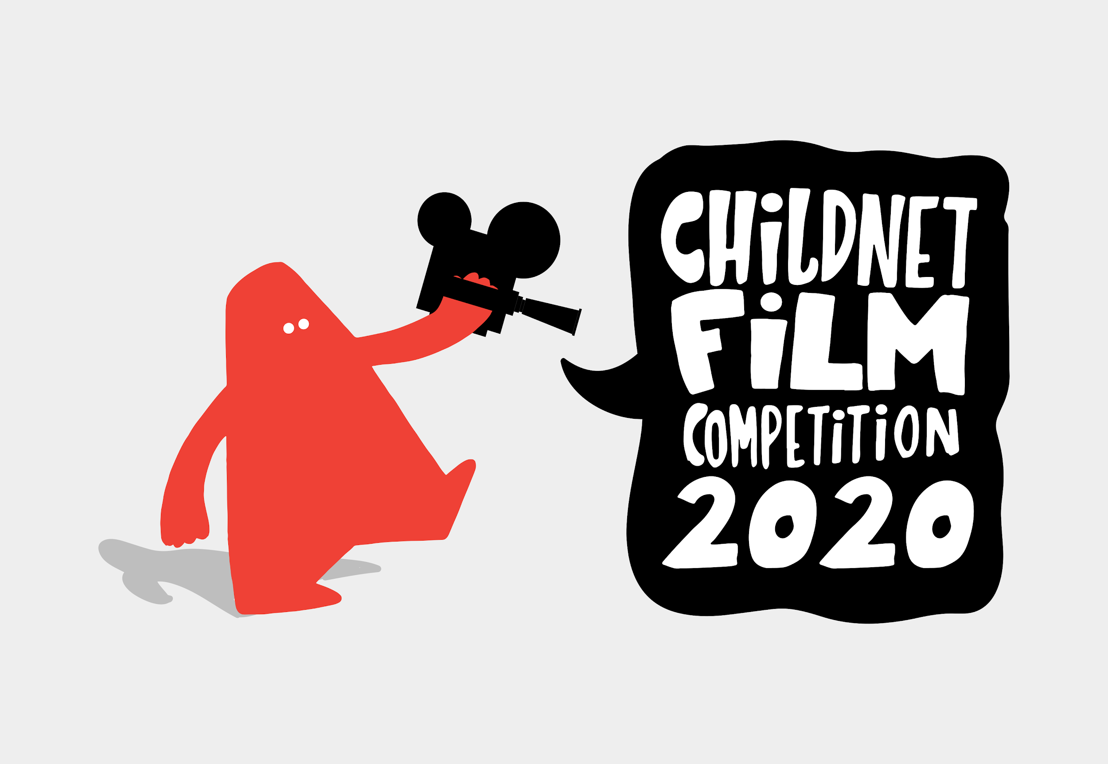
Staying safe online is called 'digital literacy' and this means having the skills and knowledge to use the internet safely and responsibly. It is where someone can manage online content and communication, spot possible risks, and find ways to protect themselves from these risks. You can find out more by visiting Childnet.

Your child could have a go at entering The Childnet Film Competition which invites young people aged 7-18 to create a 2 minute online safety film to inspire their peers to create a safe, supportive and fun online world around the theme ‘We want an internet where we’re free to…’ The entries that make into the final shortlist will be judged by a prestigious panel made up of representatives from BAFTA, the BBC, the British Board of Film Classification, the BFI, Disney and the Motion Picture Association. The young people who create winning films and storyboards will receive great filmmaking and creative prizes for their school or youth group. Whether used at school or as a home learning project, the competition is a great way of exploring important internet safety messages with young people of all ages. Find out more here.
Additional learning resources parents may wish to engage with
- BBC Bitesize - Lots of videos and learning opportunities for all subjects.
- Classroom Secrets Learning Packs - Reading, writing and maths activities for different ages.
- Twinkl - Click on the link and sign up using your email address and creating a password. Use the offer code UKTWINKLHELPS.
- White Rose Maths online maths lessons. Watch a lesson video and complete the worksheet (can be downloaded and completed digitally).
- Times Table Rockstars and Numbots. Your child can access both of these programmes with their school logins. On Times Table Rockstars, children should aim to play Soundcheck for 20 minutes daily.
- IXL online. Click here for Year 3 or here for Year 4. There are interactive games to play and guides for parents.
- Mastery Mathematics Learning Packs. Take a look at the mastery mathematics home learning packs with a range of different activities and lessons.
- Y3 Talk for Writing Home-school Booklets and Y4 are an excellent resource to support your child’s speaking and listening, reading and writing skills.
The Learning Projects are based on the National Curriculum expectations for the key stage which your child is in. It may be that your child finds the tasks set within the Learning Project for their year group too simple. If this is the case, then we suggest that your child accesses the Learning Projects which are set for the key stage above. Equally, if the projects are too challenging, then we advise that your child accesses the projects for the key stage below. If your child requires more of a challenge, or you believe that there are some gaps in their learning then Century Tech is a fantastic resource that is currently free for home learning. The app is designed to address gaps and misconceptions, provide challenge and enables children to retain new knowledge. It uses artificial intelligence to tailor the learning to your child’s needs. Sign up here.
#TheLearningProjects
in collaboration with
