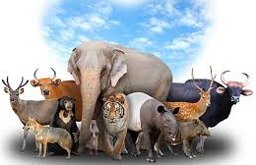
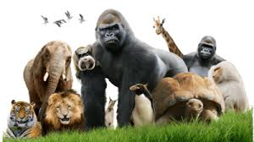

Learning Project Week beginning Monday 27th April - Animals
Age Range: Year 5/6
Weekly Maths Tasks (Aim to do 1 per day) | Weekly Reading Tasks (Aim to do 1 per day)
- Work on Times Table Rockstars.  - You can also access Numbots on the TT Rockstars page using the same login.  - White Rose Maths whiterosemaths.com/homelearning/ Go to the relevant year group and complete a lesson. Watch the tutorial to help you understand the topic and then complete the activity. The answers are provided so you can check your work when it’s completed.  - BBC Bitesize are now posting daily lessons for home schooling in Maths and English for every year group, simply pick your year group and off you go.  www.bbc.co.uk/bitesize/dailylessons  - In your exercise book, show everything you know about decimal numbers and/or percentages on a piece of paper. This could be pictures, diagrams, explanations, methods etc. Be as creative as you want to be.  - Play on Hit the Button -  www.topmarks.co.uk/maths-games/hit-the-button - focus on times tables, division facts and squared numbers.  - Compare decimal numbers on this game: www.teacherled.com/iresources/decimals/comparedecimals/ | - Listen to a book on Audible for free while schools are closed. Visit stories.audible.com/discovery and choose a book from your age range.  - Continue to read a chapter from your home reading book or a book that you have borrowed from the library.  - When you have completed the chapter, re-write this from the viewpoint of another character.  - Explore the opening of the Highwayman Poem. www.lovereading4kids.co.uk/extract/2077/The-Highwayman-by-Alfred-Noyes.html  Can you learn it by heart? Can you draw an alternative sketch to represent the Highwayman?  - Download ‘A Pinch of Magic’  authorfy.com/masterclasses/?age=&masterclass_author=&keywords=a+pinch+of+magic You can then complete the questions on page 4.  - You can log on to Bug Club/Oxford Owl and read a book that matches your book band. After this, review the text and justify your opinion with examples from the text.
Weekly Spelling Tasks (Aim to do 1 per day) | Weekly Writing Tasks (Aim to do 1 per day)
- Practise the Year 5/ 6 Statutory Spellings (see last page).  - Choose 5 Statutory Spellings. Then write a synonym, antonym, the meaning and an example of how to use the word in a sentence.  - Create a word bank about an animal of your choice which includes verbs, adverbs and expanded noun phrases. You can use this for your poetry writing.  - Proofread your writing from the day. You can use a dictionary to check the spelling of any words that you found challenging. This will also enable you  - to check that the meaning of the word is suitable for the sentence. | - Write a diary entry/newspaper report summarising the events from the day/week.  - You can write a formal letter to West Midlands Safari Park persuading them to close the park. They must justify their opinions with factual information.  - Choose an animal of your choice and think about how it moves, what sounds it makes and the environment that it lives in. You can then write a poem based around these ideas. You can repeat this activity for different animals.  - Animal’s hearts should be cut up for science experiments. Do you agree/disagree? Write a discussion about this statement.
Learning Project - to be done throughout the week
The project this week aims to provide opportunities for your child to learn more about key animals they are interested in. Learning may focus on exploring the physical aspects of an animal, their habitat, categorising animals etc.

● Visit Edinburgh Zoo via their webcams – you can watch pandas, penguins, tigers and koalas.
https://www.edinburghzoo.org.uk/webcams/panda-cam/

- Animals and their Environment – You can describe how animals such as Emperor Penguins, chimpanzees and orcas have adapted to suit their environment.

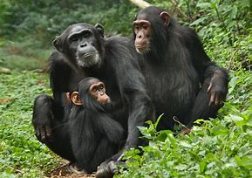
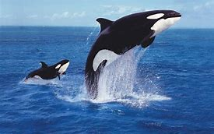
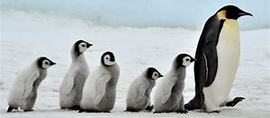

You can do this by writing a short summary after carrying out some research. After this, design a new wondrous animal that has evolved to suit its environment considering the environmental changes it has had to face over recent years.

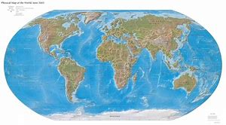
- Where Animals Originate From - Locate on a world map where different animals originate from and research why they live in these environments. Things for you to consider when researching why they originally lived in these countries are:
- Food sources
- Climate
- Weather
- Terrain
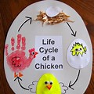
After doing this, think about how the animals you have selected have adapted so that they are able to live in the UK. Present your findings as a poster or in a PowerPoint presentation if you have access to a PC/laptop.

- Life Cycles - Research a mammal, an insect, an amphibian, a reptile and a bird. You can then choose one and draw the life cycle of an animal and label the diagram/model accordingly. How does the life cycle of the chosen animal differ to a human life cycle?

- Animal Prints - Using a variety of media (this could be materials from around the house such as cloth, newspapers or magazines, felt, etc.), create animal prints for a mammal, an insect, an amphibian, a reptile and a bird of their choice. You could create a collage of the animal prints you have made. You could always use a pencil or pen to sketch the animal prints!
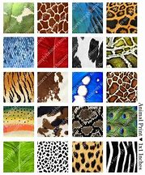

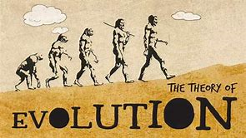
- The Life of Darwin - Who was Charles Darwin? Research the scientist’s theory on evolution. Where are the Galapagos Islands?
What species did and do still live there?
What makes these animals unique and extraordinary?
Write a biography about the life of Charles Darwin.

- Stay Active – it is important to keep active so you could join in with PE with
Joe on the Joe Wicks youtube Channel. The PE session is live every weekday at 9am but is also then available during the day. Visit: https://www.youtube.com/user/thebodycoach1
Or you could try Just Dance on Youtube:
Blue (Da Ba Dee) www.youtube.com/watch?v=AFIqSaZM2D0
Ghostbusters www.youtube.com/watch?v=izMJDiHQBH0&t=71
What does the fox say? www.youtube.com/watch?v=sVpKKWfiaKg
Timber www.youtube.com/watch?v=66wCy2KwlCk

- Staying Safe Online – Thinkuknow is the education programme from NCA-CEOP, a UK organisation which protects children both online and offline. It is important that your child knows how to keep themselves safe online, especially while we are asking them to complete lots of online learning tasks. The Thinkuknow website now has information for parents about keeping children safe online and home activity packs children can complete while schools are closed. Simply scroll down to the relevant age range pack by following the link below:
https://www.thinkuknow.co.uk/parents/Support-tools/home-activity-worksheets/

Additional learning resources parents may wish to engage with
Classroom Secrets Kids – The children all have a login to this website – the details are on the inside page of their exercise books. The site is split into different year groups and include activities linked to reading, writing, maths and practical ideas you can do around the home.
Twinkl - to access these resources click on the link and sign up using your own email address and creating your own password. Use the offer code UKTWINKLHELPS.
BBC Bitesize: daily lessons and activities in all different subjects
https://www.bbc.co.uk/bitesize/dailylessons

#TheLearningProjects
