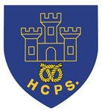
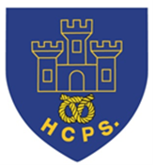
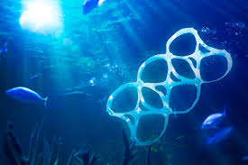
Learning Project Week beginning Monday 4th May – Environment.
Age Range: Year 5/6
Weekly Maths Tasks (Aim to do 1 per day) | Weekly Reading Tasks (Aim to do 1 per day)
- Work on Times Table Rockstars.  - You can also access Numbots on the TT Rockstars page using the same login.  - White Rose Maths whiterosemaths.com/homelearning/ Go to the relevant year group and complete a lesson. Watch the tutorial to help you understand the topic and then complete the activity. The answers are provided so you can check your work when it’s completed.  - BBC Bitesize are now posting daily lessons for home schooling in Maths and English for every year group, simply pick your year group and off you go.  www.bbc.co.uk/bitesize/dailylessons  - In your exercise book, show everything you know about shape. This could be pictures, diagrams, explanations, methods etc. Be as creative as you want to be.  - Here are some ​mini maths tasks​. Work your way through your year group’s activities.  - Select items in your house (rubbish, materials, household objects) and sort them into things that are recyclable and non-recyclable. What % and fraction of the items are recyclable?  - Play on Hit the Button -  www.topmarks.co.uk/maths-games/hit-the-button - focus on times tables, division facts and squared numbers. | - Listen to a book on Audible for free while schools are closed. Visit stories.audible.com/discovery and choose a book from your age range.  - Continue to read a chapter from your home reading book or a book that you have borrowed from the library.  - When you have completed the chapter, summarise what you have read. This could be as bullet points or as a cartoon strip.  - Read something from around the house that is not a book. In your exercise book explain what you have read (magazine, newspaper, recipe or even the back of a cereal box), what this text tells you and how a person could use the information gained.  List any unfamiliar words in this piece of text for one of the spelling activities.  - You can log on to Bug Club/Oxford Owl and read a book that matches your book band. After this, review the text and justify your opinion with examples from the text.
Weekly Spelling Tasks (Aim to do 1 per day) | Weekly Writing Tasks (Aim to do 1 per day)
- Practise the Year 5/ 6 Statutory Spellings (see last page).  - Choose 5 Statutory Spellings. Then write a synonym, antonym, the meaning and an example of how to use the word in a sentence.  - Create a mind map of adverbials to use in your writing tasks.  - Using the unfamiliar words in your reading activity text, explore the meaning of the word. Write the word in its original sentence and then use the word in a new sentence.  - Proofread your writing from the day. You can use a dictionary to check the spelling of any words that you found challenging. This will also enable you to check that the meaning of the word is suitable for the sentence. | - Predict what may happen over the bank holiday weekend. Record this as a newspaper article.  - Write a persuasive letter to Mrs Broome about the importance of recycling. You must include facts and statistics to support your argument. You can email your letters to headteacher@hassell.staffs.sch.uk  - Seaworld should close.  Seaworld is a theme and marine park based in Orlando, America. It is home to giant turtles, orcas and bottle-nosed dolphins to name a few. Do you agree/disagree with the statement? Write a discussion based on the above statement considering both sides of the argument.  - Write a biography about David Attenborough. Remember to include facts about his life; how he has helped the environment and the positive impact that he has had on global changes.  - Story task – continue with your fictional story. Think carefully about using a range of conjunctions, sentence openers, pronouns and adverbial phrases.
Learning Project - to be done throughout the week
The project this week aims to provide opportunities for your child to learn more about key animals they are interested in. Learning may focus on exploring the physical aspects of an animal, their habitat, categorising animals etc.

Endangered Species- ​The tiger, Amur leopard, orangutan, sea turtle and the Sumatran elephant are some of the most endangered animals on the planet.
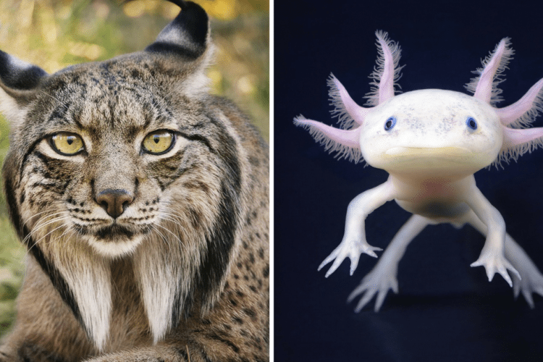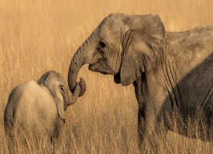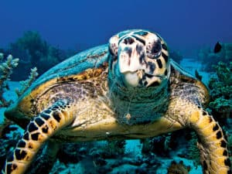
Choose an animal from one region and describe how it has evolved to suit its habitat. Now consider how your chosen animal may need to adapt due to the current environment and human threats it faces. Create an informative leaflet about the threat the animal faces and what humans can do to minimise these threats.

Upcycling, upcycling- ​Choose an item within the house that you do not really use anymore - this could be an old item of clothing, accessory or household item - and upcycle it to make a new item that you will use.
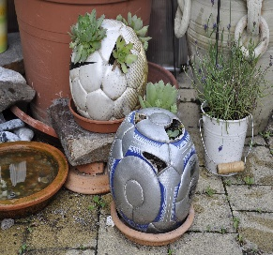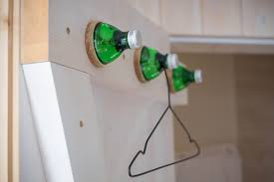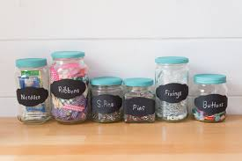
Evaluate the product and identify any areas that you could improve if you were to make it again. You may even want to write a set of instructions so that other people can upcycle the same item too.

Plastic pollution.
Benefits of plastic.
- Compile a list of ALL the plastic you use during the day. From your hairbrush or cereal inner lining to your bike helmet. How would your life be different without it?
- List all the good reasons for using plastic.
What can we do to help?
- Watch the following video clip - https://ypte.org.uk/videos/why-plastic-s-not-so-fantastic
- Audit your kitchen cupboards – see how much of the plastic is recyclable.
- Create a kitchen recycle plan – don’t forget to include what to do with non-recyclable materials.
- Make a poster to persuade your teacher to set up a recyclable centre in your class or in the school.

Protecting our Oceans- ​Marine life faces a number of threats including plastic pollution, tourism, habitat destruction, ocean warming and overfishing. How can we make a difference now? Sketch an image representing the impact society is having on today’s oceans using a drawing material of your choice. Afterwards, sketch an image of an ideal ocean environment. Use websites and books to find out what makes the best environment for marine life to flourish (you may wish to look at the Great Barrier Reef and its significance).
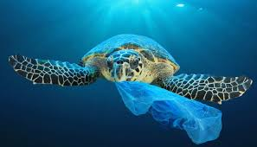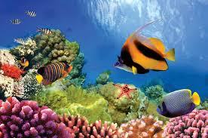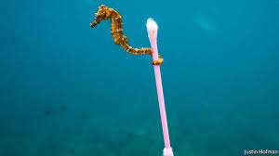

V.E day 75th Anniversary.

From Friday the 8th of May to Sunday the 10th of May, it is the 75th anniversary celebration of V.E day. The bank holiday has been moved from Monday the 4th of May to the Friday to celebrate this. Complete some of the following activities to celebrate this event.
- Write a diary of your V.E day. You could be a soldier, a mum whose son is at war, a child in a city used to hearing the bombing, an evacuee. (If you can’t remember our WW2 topic lessons, research it using books or online.)
Write about what you hear going on around you, how you feel at that moment, what it will mean to your future.
- Imagine that you are organising the street party to celebrate. Remember what year V.E day took place.
What food and drink will you have – think of the rationing that was still going on. What entertainment will there be – there was no internet or Tik Tok!!!! What decorations will you have – you wouldn’t be able to print out your decorations, create some examples of what you would use.
- Imagine you are hosting a party to celebrate the 75th anniversary. What food and drink would you have now; what entertainment would you put on; and what decorations would you create. How is it different from the original party?

Stay Active – it is important to keep active so you could join in with PE with
Joe on the Joe Wicks YouTube Channel. The PE session is live every weekday at 9am but is also then available during the day. Visit: https://www.youtube.com/user/thebodycoach1
Or you could try Just Dance on YouTube:
Havana - https://www.youtube.com/watch?v=WNM0VWlMSYo
Happy - https://www.youtube.com/watch?v=YteMhrQvfCo
Uptown funk - https://www.youtube.com/watch?v=cntzSx-KdWw

- Staying Safe Online – Thinkuknow is the education programme from NCA-CEOP, a UK organisation which protects children both online and offline. It is important that your child knows how to keep themselves safe online, especially while we are asking them to complete lots of online learning tasks. The Thinkuknow website now has information for parents about keeping children safe online and home activity packs children can complete while schools are closed. Simply scroll down to the relevant age range pack by following the link below:
https://www.thinkuknow.co.uk/parents/Support-tools/home-activity-worksheets/

Additional learning resources parents may wish to engage with
Classroom Secrets Kids – The children all have a login to this website – the details are on the inside page of their exercise books. The site is split into different year groups and include activities linked to reading, writing, maths and practical ideas you can do around the home.
Twinkl - to access these resources click on the link and sign up using your own email address and creating your own password. Use the offer code UKTWINKLHELPS.
#TheLearningProjects
