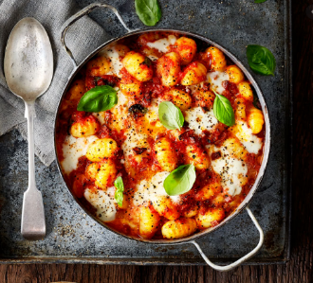
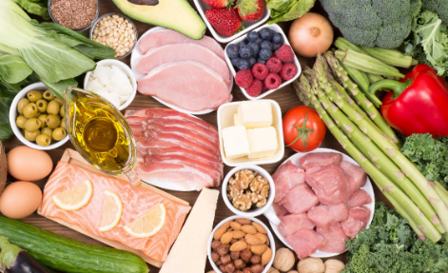
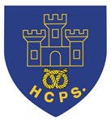

Learning Project Week beginning Monday 11th May – Food
Age Range: Year 5/6
Weekly Maths Tasks (Aim to do 1 per day) | Weekly Reading Tasks (Aim to do 1 per day)
Wednesday is National Numeracy Day! Visit the following website to get involved in the Numeracy Festival on Wednesday 13th May:  https://www.numeracyday.com/get-involved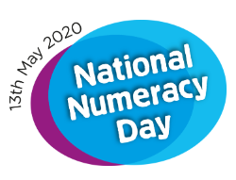  - Work on Times Table Rockstars.  - You can also access Numbots (to practise simple number bonds and number facts) on the TT Rockstars page using the same login.  - White Rose Maths whiterosemaths.com/homelearning/ Go to the relevant year group and complete a lesson. The lessons also now link to BBC Bitesize https://www.bbc.co.uk/bitesize/dailylessons.  Write on sheets and answers will be on the class page for Year 5/6  - Look at a recipe. How much of each ingredient would be needed if the amount of people it was cooked for was halved, doubled, tripled etc. Think about what maths you might need to think about to do this.  - Show everything you know about angles on a piece of paper. This could be pictures, diagrams, explanations, methods etc. Be as creative as you want to be.  - Play on Hit the Button -  www.topmarks.co.uk/maths-games/hit-the-button - focus on times tables, division facts and squared numbers. | - Read a chapter from your home reading book or a book that you have borrowed from the library.  - Following this, create a list of questions to interview the main character. You can test out the questions by answering in role as the character. Think about the traits of the character and how this will influence the answers.  - Note down any unfamiliar words from the chapter you have read. Explore the meanings of these words by using a dictionary, reading around the sentence or using print conventions.  - Why not read to an adult in your home? Identify somewhere in the house where you don’t usually read, and read a chapter or two aloud to someone. Ask them questions about what you read.  - Log on to Bug Club/Oxford Owl and read a book that matches your book band. After this, review the text and justify your opinion with examples from the text.  - Research the topic of ‘food’ by listening to these clips. You could write a summary of the key points from a clip of your choice. https://www.bbc.co.uk/bitesize/topics/zb4cwmn/resources/1
Weekly Spelling Tasks (Aim to do 1 per day) | Weekly Writing Tasks (Aim to do 1 per day)
- Practise the Year 5/ 6 Statutory Spellings (see last page).  - Choose 5 Statutory Spellings. Then write a synonym, antonym, the meaning and an example of how to use the word in a sentence.  - Most rap songs contain a rhyme scheme. You can create a word bank of rhyming words associated with food and its taste. You could then use this to help them with your rap writing task.  - Proof read your writing from the day. Use a dictionary to check the spelling of any words that you found challenging. This will also enable you to check that the meaning of the word is suitable for the sentence. | - Continue to write a diary entry/newspaper report summarising the events from the day/week.  - You could write a recipe to make a healthier option for making a pizza. Think about which ingredients you could switch so that this delicious treat is better for you. Test the recipe out!  - How does the human digestive system work? Write an explanation describing this and include diagrams to represent your explanations.  - There are lots of different types of food available for people to eat in the UK. You could write a rap about food. This could be about a particular food group or your favourite meal.  - Fast food establishments should not be within one mile of schools. Do you agree/disagree with the above statement? You can debate both sides of the argument.  - Story Task: You may be coming towards the end of your story. Start to think about how to conclude your story. Will the problem be solved? How has your main character changed and how will you show this through your language choice?
Learning Project - to be done throughout the week
The project this week aims to provide opportunities for you to learn more about food. Learning may focus on where different foods originate from, what makes a healthy meal, opportunities to cook etc.

Which Foods Contain the Most Sugar?

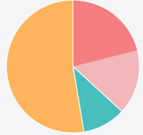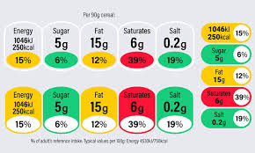

You could choose a selection of food items from the food cupboard, fridge and freezer. You can then identify the nutritional label and record the amount of sugar that each food contains. Once you have gathered the information, record the sugar contents on a pie chart and evaluate the data. How will your findings change what you eat?

Plough to Plate

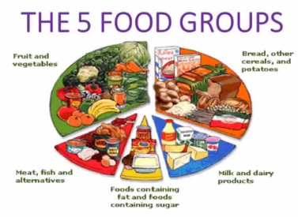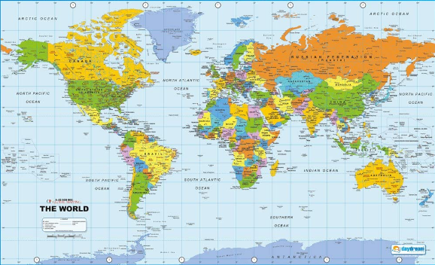

Choose a food from any of the 5 main food groups. You could then locate the country/countries of origin on a world map and work out how far the food item travels to get to your plate. Following this, sketch a diagram detailing the journey the food has taken and add captions and timeframes. What could we do to reduce how many miles our food travels?
Creative Creations

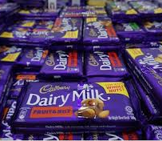

Cadburys are launching a new chocolate bar. You could create a criteria for Cadbury chocolate packaging by researching current Cadbury products. Once you have a criteria, you can use this to design your own packaging (you may want to do this on a computer if you have access to one). Finally, gather some feedback from the family about the design. You can use the feedback to adapt and refine the design. After creating the chocolate bar, you could then compose a jingle that could be used in an advert. This could be created by using household items such as pots and pans or by using virtual instruments. Take a look at some Cadburys adverts on YouTube, can you find the Gorilla advert or the one with the eye brow dance? Can you create your own creative advert idea and film it?

Come Dine with Me

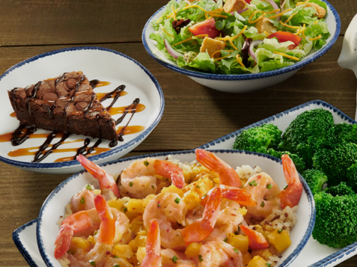

You are responsible for creating a three-course meal for four family members. You need to create the recipes for a starter, main meal and dessert. Think about what ingredients you will need to make your recipe and write a shopping list of items. Research how much the ingredients will cost using a supermarket website of your choice. Where is the most cost effective place to buy the ingredients? You could then test out a recipe by making it for dinner that evening. Family members may even wish to score each course!

A Balanced Diet

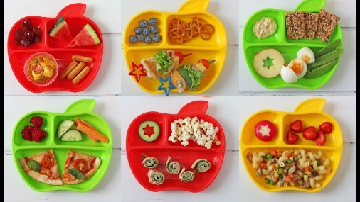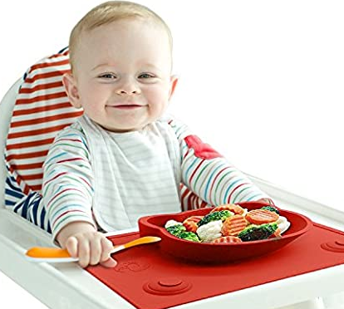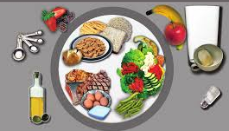

Think about the food a toddler might eat compared to an adult athlete. Then choose five different types of people (e.g. a child, teenager, athlete, teacher etc.) and draw a plate of food that will ensure they are eating a healthy, balanced diet. Underneath each plate, you can justify why you have chosen these foods. Think about the calorie intake each of these individuals might need. Can some people have more of one type of food group? If yes, why can they?

Stay Active – it is important to keep active so you could join in with PE with
Joe on the Joe Wicks YouTube Channel. The PE session is live every weekday at 9am but is also then available during the day. Visit: https://www.youtube.com/user/thebodycoach1

Or you could try Just Dance on YouTube:
Havana - https://www.youtube.com/watch?v=WNM0VWlMSYo
Happy - https://www.youtube.com/watch?v=YteMhrQvfCo
Uptown funk - https://www.youtube.com/watch?v=cntzSx-KdWw

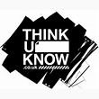
- Staying Safe Online – Thinkuknow is the education programme from NCA-CEOP, a UK organisation which protects children both online and offline. It is important that your child knows how to keep themselves safe online, especially while we are asking them to complete lots of online learning tasks. The Thinkuknow website now has information for parents about keeping children safe online and home activity packs children can complete while schools are closed. Simply scroll down to the relevant age range pack by following the link below:
https://www.thinkuknow.co.uk/parents/Support-tools/home-activity-worksheets/
Additional learning resources parents may wish to engage with
Classroom Secrets Kids – You all have a login to this website – the details are on the inside page of your exercise books. The site is split into different year groups and include activities linked to reading, writing, maths and practical ideas you can do around the home.
Twinkl - to access these resources click on the link and sign up using your own email address and creating your own password. Use the offer code UKTWINKLHELPS.
#TheLearningProjects
