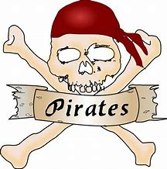
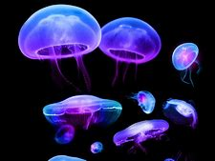
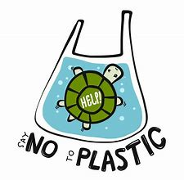
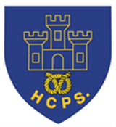
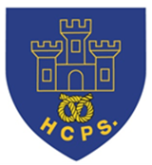

Learning Project Week beginning Monday 18th May - Under the Sea
Age Range: Y5/6
We hope you are all well and enjoying the different activities. The layout of the plan has changed this week across the school. There are activities in a suggested timetable for each day which may be of help but you do not have to follow this order or complete every activity- please continue to do what fits in best for your child and your family. We understand families have different work commitments and different access to online activities. Thank you very much for all the weekly emails and updates. Please send any further updates to your class teacher!
mrsgoodstadthassell@gmail.com mrsplummerhassell@gmail.com missstokeshassell@gmail.com

TT Rockstars

This week on TT Rockstars we have the battle of the maths classes! Earn as may points as you can for your maths class – it’s on!!!
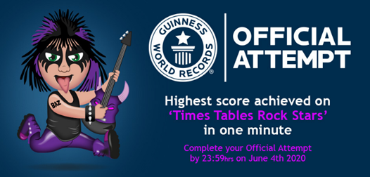

There is also exciting news about a Guinness World Record Challenge for you to try and achieve the highest score in under a minute!!

To make an Official Attempt, players need to record a video of themselves achieving their highest score in the Studio* and send the video to support@mathscircle.com by 23:59 UK time on 4th June 2020.
Please see the official letter for details of how to enter and what you need to include on our website.

How wonderful would it be to become an official World Record Holder!!!!! We know you can do it so why not give it a try!
Weekly Reading Tasks | Weekly Spelling Tasks
Monday- Read for enjoyment whilst listening to these sea noises. There are more choices on Google Books or Oxford Owl). | Monday- You can create a vocabulary bank about life under the sea which includes verbs, adverbs, expanded noun phrases and relative clauses.
Tuesday- Create a true or false quiz based on the book you read yesterday. Can you test it out (remotely) on a friend who has also read the book? | Tuesday- Some words end with a ‘shus’ sound. How many more words can you think of which end with -tious or -cious? Write the meanings.
Wednesday- Listen to and read along with The Mermaid’s Lament. Find the glossary in the Teach section and see if you can identify some of the terms used in the poem, for example rhyme and personification. | Wednesday- Pick 5 Common Exception words from the Year 5/6 spelling list. Challenge - pick one spelling at a time and write it as many times as you can in one minute. Can you beat your score?
Thursday- Click on this Oxford Owl link for a reading comprehension activity about sea adventures. Can you read the text in under 3 minutes and complete the comprehension questions? | Thursday- Create a glossary for these sea-related words: estuary, algae, plankton, tsunami & urchin. Can you draw illustrations to represent each of these words too?
Friday- Read the First News. Can you find the following: good news, bad news, reference to a famous politician, a story about a popstar and the name of a city or country. This could be completed with a free, local newspaper. | Friday- Proofread your writing from the day/week. Use a dictionary to check the spelling of any words that you found challenging. Can you improve any of your word choices?
Weekly Writing Tasks | Weekly Maths Tasks - Converting Time and Timetables.  You can either do the weekly tasks below or carry on with the White Rose Maths lessons.
Monday- Visit the Literacy Shed for this wonderful resource on The Lighthouse. Or you can create a diary entry based on a day in the life of a deep sea diver.  Tuesday-Can you compose your own poem of what a person wishes they could do if they were a sea creature? Why not perform it to the family?  Wednesday- Ask your child to choose one sea creature of interest. You can write a description about it in detail. Think about: its appearance, movement and actions. Remember to include ambitious vocabulary and complex sentences. | White Rose Maths  Go to your year group and complete a daily lesson. whiterosemaths.com/homelearning/ The write-on sheets and answers will be attached in this email and on the school website as they are no longer available on the website.  Extra practise:  BBC Bitesize daily maths lessons are now linked with Pearson Maths and follow the same topics as White Rose Maths but using different videos and worksheets. bbc.co.uk/bitesize/dailylessons
 | Monday- Write down the names and ages of each member in your household in years. Convert the ages into months, days, hours etc.
Thursday- Can you write an information report about your sea creature from yesterday? This should include: subheadings, key information, pictures and interesting facts. If you have access to a PC, you could type this up once you have edited your final version.  Friday - Write an under the sea adventure story. You should include: dialogue, ambitious vocabulary and a range of openers and conjunctions. | Tuesday- Choose a film to watch as a family daily. Add up the total running time and record it in hours and minutes - convert this into just minutes.
 | Wednesday- Make a timetable of your typical day at school. How many hours do you spend on each subject? Can you convert this into minutes spent on each subject? Can you convert this into seconds?
 | Thursday- Click firstgroup.com/potteries to find a timetable of your local bus route (type in the bus number under find a timetable). Pick different places to get to and work out which bus you need to catch. An example could be - ‘Which bus would I have to catch to get to Hanley for 14:25?’
 | Friday (theme)- Look at this image. Can you create a bar chart or pie chart showing the different living things found in the ocean?

Learning Project - to be done throughout the week
The project this week aims to provide opportunities for you to learn more about life in and around the sea. Learning may focus on the strange and wonderful creatures and plants that occupy our oceans, their habitats and how human beings affect this environment.

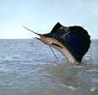
- Working Together to Save Our Oceans -The BBC programme Blue Planet 2 sparked an outcry about the health of our oceans and the huge threat caused by plastics, but lots of people around the world are working hard to help solve this problem. You can read about Madison Edwards, a 12 year old environmental activist. You could do your bit to help preserve our oceans by keeping a ‘plastic diary’ recording how much single-use plastic the family uses. You can write down one thing that your family will do to use less plastic.

- Speeding Through The Seas- Sailfish are the fastest fish in the ocean. Can you be just as speedy and complete the following 5 activities as fast as possible: Star jumps, tuck jumps, press-ups, squats and lunges. Record how many repetitions of each activity you can perform in 1 minute. Can you beat your personal best? Challenge - record your heart rate (beats per minute) after each activity. Recommendation at least 2 hours of exercise a week.

- Pirates: Daring Figures of History or Brutal Sea-Thieves?- Many books have been written and movies made about pirates. But who were the real pirates of the past? Explore these facts about real pirates from history. You could create a fact file or information report about what you have learned, including key dates and figures. Or, you could create a ‘wanted’ poster for a pirate, including facts about his/her deeds and adventures.

- Bioluminescence: Lighting up Our Oceans - Many sea creatures possess a fascinating light-producing ability called bioluminescence. Some fish dangle a lighted lure in front of their mouths to attract prey, while some squid shoot out bioluminescent liquid, instead of ink, to confuse their predators. You can find out about bioluminescence and how some sea creatures rely on this for their survival. You could then choose a sea creature which uses bioluminescence (like the anglerfish) and create a poster fact sheet about it, including what bioluminescence is and how your chosen sea creature uses it.
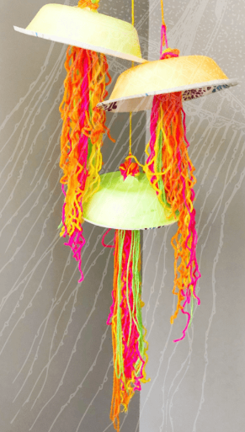
- Artwork to Light up Your Life- Following on from what you learned about bioluminescence, create a bioluminescent sea creature inspired piece of artwork. Based on the resources you have available at home, you could choose to express this as a drawing or as a model. Use bright colours and to be as realistic as possible.

- Stay Active – it is important to keep active so you could try a bit of ZumbaKids at: GoNoodle family.gonoodle.com/channels/zumba-kids

- Computer Coding – Amazon currently have some online computer coding programmes which you can do for free. Follow the link below and have a go yourself – it’s great fun! Why not try the Dance Party programme first and then, if you’re feeling confident, move on to the ‘Build The Future’.
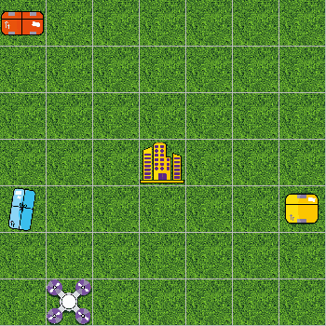
www.amazonfutureengineer.co.uk/free-virtual-coding-programmes

- Staying Safe Online – Thinkuknow is the education programme from NCA-CEOP, a UK organisation which protects children both online and offline. It is important that your child knows how to keep themselves safe online, especially while we are asking them to complete lots of online learning tasks. The Thinkuknow website now has information for parents about keeping children safe online and home activity packs children can complete while schools are closed. Simply scroll down to the relevant age range pack by following the link below:
www.thinkuknow.co.uk/parents/Support-tools/home-activity-worksheets/
STEM Learning Opportunities #sciencefromhome
Autosub 6000 Ocean Floor Mission

- Learners will need a basic understanding of Scratch before carrying out this Unit. Guides and online tutorials are available here if needed
- Use scratch to debug and improve the Autosub6000 around the ocean floor. Activity notes and instructions can be found here.

Additional learning resources you may wish to engage with:
- BBC Bitesize - Lots of videos and learning opportunities for all subjects.
- Classroom Secrets Learning Packs - Reading, writing and maths activities for different ages.
- Twinkl - Click on the link and sign up using your email address and creating a password. Use the offer code UKTWINKLHELPS.
- White Rose Maths online maths lessons. Watch a lesson video and complete the worksheet (can be downloaded and completed digitally).
- Times Table Rockstars and Numbots. Your child can access both of these programmes with their school logins. On Times Table Rockstars, children should aim to play Soundcheck for 20 minutes daily.
- IXL online. Click here for Year 5 or here for Year 6. There are interactive games to play and guides for parents.
- Mastery Mathematics Learning Packs. Take a look at the mastery mathematics home learning packs with a range of different activities and lessons.
- Y5 Talk for Writing Home-school Booklets and Y6 are an excellent resource to support your child’s speaking and listening, reading and writing skills.
#TheLearningProjects

