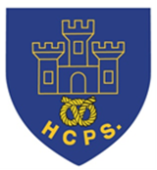
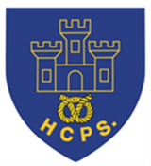
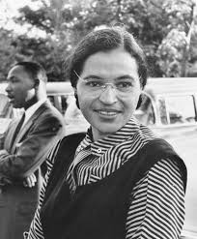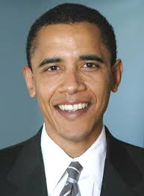
Learning Project Week beginning Monday 15th June – Famous and Significant People.
Age Range: Y5/6
We hope you are all well and enjoying the different activities. This week’s activities focus on Famous and Significant People throughout history. There is a lovely range of practical, craft, written and mathematical activities to work through, but please remember that these activities are meant to be a guide, and should be completed if you feel you can. We are very much looking forward to seeing what you get up to this week, so remember to email your class teacher with some pictures!
mrsgoodstadthassell@gmail.com mrsplummerhassell@gmail.com missstokeshassell@gmail.com

Weekly Reading Tasks | Weekly Spelling Tasks
Monday- Can somebody who is important to you read to you? Perhaps you could share an extract from your favourite book or a poem? | Monday- Practise spellings on Spelling Frame. Use a dictionary to clarify any unfamiliar vocabulary.
Tuesday- Read a newspaper article about a famous person. What can you tell about the person from the language used? Does the article criticise them or is it complimentary – how can you tell? | Tuesday- Choose 5 Common Exception words here. Write the meaning, synonyms (word with the same/similar meaning) and antonyms (word that has the opposite meaning) for each word.
Wednesday- Click here for a reading comprehension activity about a famous botanist. Challenge yourself to read the text in under 3 minutes and complete the comprehension questions. | Wednesday- Mind map vocabulary that you associate with the following significant people: The Queen, Guy Fawkes, Helena Lucas and Rosa Parks.
Thursday- Visit Ducksters and choose a person that interests you to read about. Can you record 10 facts you discovered? | Thursday- Complete this segment puzzle (click Spelling Tiles) which focuses on words ending in: -able, -ible, -ably and -ibly?
Friday- Character profile. Create a profile about a famous book character e.g. Harry Potter, Matilda Wormwood or Percy Jackson. | Friday- Pick 5 Common Exception words from the Year 5/6 spelling list here. Represent each word as a picture.
Weekly Writing Tasks | Weekly Maths Tasks-Converting Time and Timetables
White Rose Maths – week 8.
Go to your year group and complete a daily lesson. whiterosemaths.com/homelearning/ The write-on sheets and answers will be attached in this email and on the school website as they are no longer available on the website.
BBC Bitesize daily maths lessons are now linked with Pearson Maths and follow the same topics as White Rose Maths but using different videos and worksheets. bbc.co.uk/bitesize/dailylessons
Monday- Visit the Literacy Shed for this wonderful resource on The Clocktower or write a letter/email to an important family member updating them on events from the last few weeks. | Monday- What different calculations can you create when adding and subtracting the numbers 111, 8276, 529, 18391, 9238 and 4163? Make sure you check it is correct using the inverse operation. CHALLENGE: Can you make some decimal numbers and add these to one of the whole numbers.
Tuesday- Using the words FAMOUS PEOPLE, write an acrostic poem about significant British people in history. | Tuesday- Play this online addition and subtraction game. You can play it more than once to see if you can reach the top score.
Wednesday- Listen to Martin Luther King’s speech I Have a Dream. Write your own speech about your dreams. Use the same techniques such as repetition, personification and powerful verbs. | Wednesday- Play this missing box addition game or missing box subtraction game. Work on the level that adds/subtracts 3 digits by clicking on the orange three. Can you make your own addition/subtraction calculations like this?
Thursday- Create an information report about a significant/famous person of interest. Choose a famous author, athlete, popstar or even a local hero such as a doctor or nurse. Include: birthplace, what they’re most famous for, significant events/achievements and any other interesting facts. | Thursday- Roll a dice and make a 6-digit number (target number). If you do not have a dice, make up a 6-digit number. Write 2 addition and 2 subtraction calculations where the answer is the target number given. Make this easier by reducing the number of digits in the target number.
Friday- Following on from yesterday’s task, write in role as that person and create a short autobiography of their life. Think about the person’s emotions during key parts of their life. | Friday- Find out when each family member was born and record this. Add all of the years up together and find a total. Add up the years from the same generation - which decade has the most/least members?
Learning Project - to be done throughout the week
The project this week aims to provide opportunities for your child to learn more about famous or significant people. Learning may focus on past or present inventors, explorers or scientists and how they influence society today.
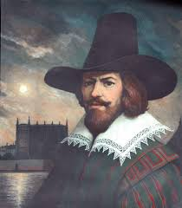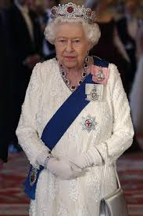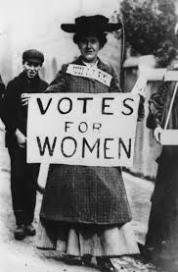
- Famous Brits- Lots of significant people in history have been British. Emmeline Pankhurst, Guy Fawkes and Mary Anning are just a few. Research one of these or another famous Brit of your choice. Create a fact file, a presentation, a chronological report of their life or present your research in any way you like.

- The Queen’s Speech- The Queen spoke to the nation on Sunday 5th April from Windsor Castle. She had an important speech to deliver where she wanted to thank people for what they were doing and to give hope that things would eventually return to normal. Think about what you would say if you had to speak to the nation? What messages of hope would you want to give to your friends and family? Write their speech or record yourself delivering your speech. Remember to tweet a video of their speech using #TheLearningProjects.

- Inspiration for Inventors- These inventors talk about where they found the inspiration for their inventions. What problems you incur in your daily life? What inventions would make your life easier? How could you turn your idea into a product? Mind map ideas of how you could solve the problem before designing and annotating a product. You may even want to make a prototype or test parts of your design to see if it would work.

- Significant to Me- Who is significant to you. This could be a famous person who has inspired you or someone who has made a positive impact on you from their everyday life. Discuss the attributes that this person has - why are they inspiring? Ask your parents to share someone who is significant to them and talk about how they have influenced your parent. You may wish to draw a portrait of this person.

What it Takes- Watch this interview with Paralympic gold medallist Helena Lucas. In this interview it talks about the dedication needed to be a successful sportsperson. Set yourself a goal to work on every day. Create a poster outlining your goal and the steps you will take each day to work towards it. Include steps you will take when you return to school.
- Stay Active – it is important to keep active so you could try a bit of ZumbaKids at: GoNoodle family.gonoodle.com/channels/zumba-kids

OR – continue or try a new sport that you learnt about the week before last.

Staying Safe Online – Thinkuknow is the education programme from NCA-CEOP, a UK organisation which protects children both online and offline. It is important that you know how to keep yourself safe online, especially while we are asking you to complete lots of online learning tasks. The Thinkuknow website now has information for parents about keeping children safe online and home activity packs children can complete while schools are closed. Simply scroll down to the relevant age range pack by following the link below:
www.thinkuknow.co.uk/parents/Support-tools/home-activity-worksheets/

Don’t forget Father’s Day,
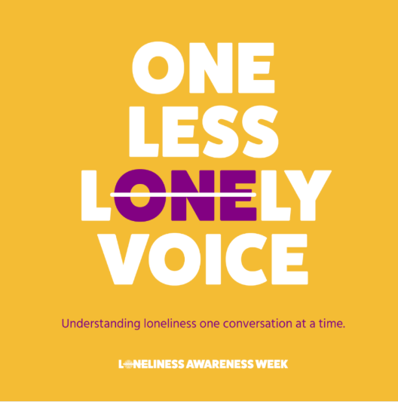
Loneliness Awareness Week 2020 – June 14th to June 19^{th.}
Due to the COVID-19 pandemic, instead of face-to-face events we’re hosting a virtual campaign called ‘One Less Lonely Voice’.
We are taking the ‘one’ out of loneliness, to signify one less lonely voice.

We all feel lonely at times – it’s a normal human emotion. You don’t have to be alone to feel lonely – you might feel lonely
spending time with friends and family. Other people spend time alone and live happily without much social contact.

Some social-distancing activities you can do to help you if you or a friend may be lonely:
* Send a letter or postcard to someone isolating. * Organise a weekly call with a friend or family member you’ve not seen for a
while. * Watch a film at the same time as a friend and video call. * Talk to a friend or family about your experiences of feeling
lonely whilst in lockdown. * Spend some time in nature, outside or tend to some indoor plants. * Prioritise looking after yourself,
make sure you are eating healthily, being active and sleeping well.
this weekend,
on Sunday 21st June.
STEM Learning Opportunities #sciencefromhome
Sophia Barnacle
- Sophia was a British inventor who invented the Helter-skelter in 1907. Try using junk box material to make your own helter-skelter or marble run.
- Try and make a run that takes exactly 60 seconds for the marble to complete the run.
To find out more about building your own marble run click here.
Additional learning resources you may wish to engage with:
- BBC Bitesize - Lots of videos and learning opportunities for all subjects.
- Classroom Secrets Learning Packs - Reading, writing and maths activities for different ages.
- Twinkl - Click on the link and sign up using your email address and creating a password. Use the offer code UKTWINKLHELPS.
- White Rose Maths online maths lessons. Watch a lesson video and complete the worksheet (can be downloaded and completed digitally).
- Times Table Rockstars and Numbots. You can access both of these programmes with your school logins. On Times Table Rockstars, you should aim to play Soundcheck for 20 minutes daily.
- IXL online. Click here for Year 5 or here for Year 6. There are interactive games to play and guides for parents.
- Mastery Mathematics Learning Packs. Take a look at the mastery mathematics home learning packs with a range of different activities and lessons.
- Y5 Talk for Writing Home-school Booklets and Y6 are an excellent resource to support your speaking and listening, reading and writing skills.
#TheLearningProjects

