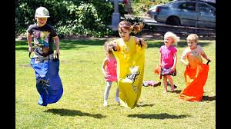
Learning Project Week beginning Monday 1st June – Sport
Age Range: Y5/6
We hope you are all well and enjoying the different activities. There are activities in a suggested timetable for each day which may be of help but you do not have to follow this order or complete every activity- please continue to do what fits in best for your child and your family. We understand families have different work commitments and different access to online activities. Thank you very much for all the weekly emails and updates. Please send any further updates to: mrsplummerhassell@gmail.com mrsgoodstadthassell@gmail.com missstokeshassell@gmail.com Take care and hope to see you soon.
Weekly Reading Tasks | Weekly Spelling Tasks
Monday- Read the sports pages of a newspaper and consider the language used. Can you add interesting language to a sports’ word bank? | Monday- List sport related noun phrases and verbs that correspond with each letter of the alphabet. This will support your writing tasks.
Tuesday- Here is a reading comprehension activity about circus performers. Read the text in under 3 minutes and complete the questions. | Tuesday- Complete this word search which focuses on words ending in -cial or -tial. Find the meanings of these words too.
Wednesday- Listen to and read along with Arundel Swimming Pool. Summarise each verse using one word only. | Wednesday- Create your own sporting wordsearch. This could include the names of athletes, sports or sporting equipment.
Thursday- Listen to a free age-appropriate audiobook here, choose a book from Oxford Owl or continue with your chapter book. | Thursday- Unscramble these sporting words: queenmipt, poicmlys, tannidmob, cagminssty & pochmashpini.
Friday- Consider the actions of a character in a book you’ve recently read. Do you agree or disagree with the actions? You should verbally give reasons for your opinions and justify them using evidence from the text. | Friday- Pick 5 Common Exception words from the Year 5/6 spelling list. Spell them as you throw a ball in the air or to another person. Every time the ball is thrown the next letter must be said.
Weekly Writing Tasks | Weekly Maths Tasks-Converting Time and Timetables
White Rose Maths – week 6.
Go to your year group and complete a daily lesson. whiterosemaths.com/homelearning/ The write-on sheets and answers will be attached in this email and on the school website as they are no longer available on the website.
BBC Bitesize daily maths lessons are now linked with Pearson Maths and follow the same topics as White Rose Maths but using different videos and worksheets. bbc.co.uk/bitesize/dailylessons
Monday- Visit the Literacy Shed for this wonderful resource on The Catch. Or create a short victory story about a character succeeding. | Monday- Watch this video to understand the difference between reflection, translation and rotation.
Tuesday- Write two newspaper articles on a sport of your choice, one reporting on an event and the other reporting ‘behind the scenes’. Pay attention to the different language that will be used in each. Include direct speech from ‘interviews’. Present this on Word or Google Docs if you have access to a PC. | Tuesday- Place several household objects on the ground indoors or in the garden spaced apart. Ask an adult to blindfold you, using a scarf, and using the positional language, such as turn left, right, forwards, clockwise etc, give you instructions to lead you to the items. They could say something like: “Turn 90 degrees left, move forwards 3 spaces.” Can you follow the given instructions to find the object?
Wednesday- Choose a sports person you admire. Create a biography which tells the story of their life in chronological order. | Wednesday- Using this online resource, make a pattern and then reflect it. Or try this activity that allows reflecting, translating and rotating practice.
Thursday- Choose a sport which is popular in another country and write an information report, giving key details about the sport and its history. | Thursday (theme)- Look at the picture of the sport equipment below. How many different ways can you classify/sort the PE equipment?
Friday- Create a persuasive leaflet for a new school sports club.  Use persuasive language including modal verbs (e.g. will, should) and adverbs of possibility (certainly, probably). | Friday (theme)- Play catch. Each time the ball is caught, count up in a particular multiple (this could be any number between 2 and 100). If the ball is dropped, start again. You can be make it harder by spacing out or by giving a higher target number.
Learning Project - to be done throughout the week
The project this week aims to provide opportunities for you to learn more about sports and games. Learning may focus on the history of sport, sporting-heroes, physical challenges and performance.
Sport Genius- Research about sporting history and see how many different facts you can find out about sports from the past. Create your own sporting trivia quiz which you can test out on members of the household. Or place different sporting events from the last 100 years onto a timeline.

- Sporting Heroes- Select your favourite sporting star. You can draw a portrait of them in the style of the famous pop artist Roy Lichtenstein using felt tip pens or paint. Share their creation at #TheLearningProjects.

- Name that Sport - Create an orienteering map of your home/garden. At each location you will need to create a question relating to a sport e.g. Which sport has the most rules? The answers can then be recorded on an orienteering sheet. How about giving yourself a challenge? Create an answer that begins with the letter of the next location? Test it out on a family member.

- Beat It! - Begin by measuring your resting heart rate by counting how many beats in a minute. Then carry out an exercise e.g. running, skipping, star jumps etc. for 3 minutes. Once you have completed this, carry out a recovery activity e.g. walking or sitting and see how long it takes for your heart rate to go back to normal. Repeat this with different recovery exercises to see which is the most effective at getting your heart rate back to normal the quickest. Create a way of showing their results?
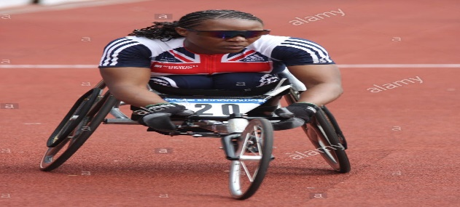
- Anyone Can Be a Champion! - This activity is all about exploring the diversity of sport. Research the history of the Paralympics . Discuss why we have the Paralympics. Create a poster which presents the importance of the Paralympics and the range of different sports there are.

- Stay Active – it is important to keep active so you could try a bit of ZumbaKids at: GoNoodle family.gonoodle.com/channels/zumba-kids

- Create a circuit training course in your house or garden using household objects – e.g. cans of beans for weights.
- Do a form of exercise you have not done for ages or even done at all – skipping, star jumps, yoga, ballet, Shuttle runs.
- Challenge yourself to complete a different sport five times this week – keep a diary of how much you did and for how long.

National Growing for Wellbeing Week is 1st – 7th June.
Gardening improves mental health, enables better
physical, acquire new skills and enjoys the outdoors.
It’s not what you grow it’s how you grow!
* Grow something at home. It can be a simple as you like,
cress grown in egg boxes on top of cotton wool; herbs on
a window sill. Or it can be as grand as you like, create a
rainbow planter or hanging basket.
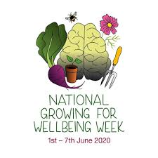
June 1st is Global Parent’s Day.
The day was first proclaimed in 2012, it honours
parents and acknowledges their selfless
commitment to their children.
* Do something nice for your parents or carers
today – make them a cup of tea; tidy the kitchen
after your evening meal; thank them for all they
do for you; give them a big, juicy hug.
- Staying Safe Online – Thinkuknow is the education programme from NCA-CEOP, a UK organisation which protects children both online and offline. It is important that you know how to keep yourself safe online, especially while we are asking you to complete lots of online learning tasks. The Thinkuknow website now has information for parents about keeping children safe online and home activity packs children can complete while schools are closed. Simply scroll down to the relevant age range pack by following the link below:
www.thinkuknow.co.uk/parents/Support-tools/home-activity-worksheets/
STEM Learning Opportunities #sciencefromhome
Heart Beaters
- Can you tickle yourself? How many litres of blood do you have in your body? How many times does your heart beat in a day? Test your family with a body trivia quiz. Create your own cards or download some from here: https://bit.ly/2RFJVRN

The complete resource can be downloaded here: https://bit.ly/3a9VtTU
Additional learning resources you may wish to engage with:
- BBC Bitesize - Lots of videos and learning opportunities for all subjects.
- Classroom Secrets Learning Packs - Reading, writing and maths activities for different ages.
- Twinkl - Click on the link and sign up using your email address and creating a password. Use the offer code UKTWINKLHELPS.
- White Rose Maths online maths lessons. Watch a lesson video and complete the worksheet (can be downloaded and completed digitally).
- Times Table Rockstars and Numbots. You can access both of these programmes with your school logins. On Times Table Rockstars, you should aim to play Soundcheck for 20 minutes daily.
- IXL online. Click here for Year 5 or here for Year 6. There are interactive games to play and guides for parents.
- Mastery Mathematics Learning Packs. Take a look at the mastery mathematics home learning packs with a range of different activities and lessons.
- Y5 Talk for Writing Home-school Booklets and Y6 are an excellent resource to support your speaking and listening, reading and writing skills.
#TheLearningProjects

