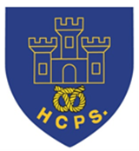
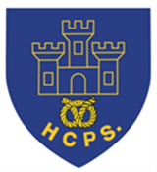
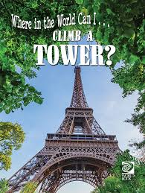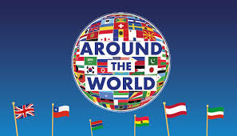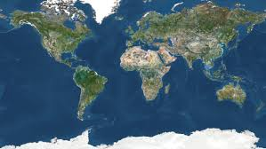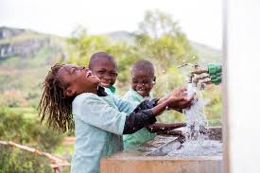

Learning Project Week beginning Monday 22nd June – Around the World
Age Range: Y5/6
Weekly Reading Tasks | Weekly Spelling Tasks
Monday- Read the world news section of a newspaper. Discuss with what you have found out. | Monday- Complete an alphabetical list of cities from around the world. Where possible, include capital cities.
Tuesday- Visit Worldbookonline and login using Username: wbsupport and Password: distancelearn. Select eBooks and read ‘Where in the World can I Climb a Tower?’. Design your own tower, thinking about where in the world it should be, its features and purpose. | Tuesday- Record the meaning, an example sentence using the word, associations, synonyms (word with the same/similar meaning), antonyms (word that has the opposite meaning) and a dictionary definition of the following words: appreciate, guarantee and occupy.
Wednesday- Click here for a reading activity about The Lost World. Challenge yourself to read the text in 3 minutes and complete the questions. | Wednesday- Complete this prefix challenge from Talk for Writing? Choose 5 words and apply them into different sentences.
Thursday- Read an age-appropriate story from another culture. This could be from your own collection, Google Books or Oxford Owl. | Thursday- Mind map words you associate with Birmingham and words they associate with Johannesburg (see here). This will support a later task.
Friday- Summarise a book you’ve read this week in 100 words. Alternatively, summarise the main events in the form of a cartoon strip. | Friday- Pick 5 Common Exception words from the Year 5/6 spelling list. Choose 4 words that have something in common and an odd one out.
Weekly Writing Tasks | Weekly Maths Tasks- Multiplication and Division
White Rose Maths – week 9.
Go to your year group and complete a daily lesson. whiterosemaths.com/homelearning/ The write-on sheets and answers will be attached in this email and on the school website as they are no longer available on the website.
BBC Bitesize daily maths lessons are now linked with Pearson Maths and follow the same topics as White Rose Maths but using different videos and worksheets. bbc.co.uk/bitesize/dailylessons
Monday- Visit the Literacy Shed for this wonderful resource on The Blackhat Write a description about their ideal world. | Monday- Test their times table knowledge by finding the products and factors in this game. Can you work through all of the levels?
Tuesday- Pick a city of choice and create a travel leaflet all about it. Make sure that you include information on: weather, travel time, key tourist spots, accommodation and the local cuisine. | Tuesday- Play multiplication war with your parents with a deck of cards. Flip two cards over and multiply. Whoever has the highest product keeps the cards. What would the inverse division fact be? Use 3 cards as a challenge.
Wednesday- Listen to Zahra. Discuss what the story is about and how we know Zara is from a different country. Rewrite the story of Zahra. | Wednesday- Practise your column multiplication and short division with these missing digit games. Can you make your own versions?
Thursday- Use the story of Zahra to create an advert to support WaterAid. What persuasive language could you use? How could you make your advert eye-catching? | Thursday (theme)- Choose three or four countries and record the temperature over the course of a week for each of the countries in a table. Draw a line graph showing each country's temperature each day across the week.
Friday- Create a poster which will assist younger children to learn about where the continents, particular countries and oceans of the world are. It must provide key facts and an imaginative layout/design to get children to learn where key places are around the world. | Friday (other)- Use the digits 3, 7, 8, 0, 6 and make as many whole numbers as you can. How can you be sure you have found all the potential numbers? After, use five different digits and repeat. Do you find the same amount of potential numbers? If so, why could this be?
Learning Project - to be done throughout the week
The project this week aims to provide opportunities for you to learn more about countries and cities around the world. Learning may focus on different cultures and traditions, famous landmarks, food and clothing.
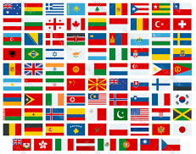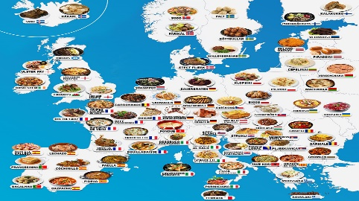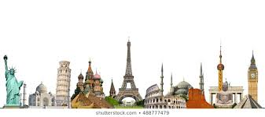
- Flags of the World- Flags are a national symbol for all countries. Cultures use different symbols and colours on their flags which are meaningful to them and represent their history and people. Pick 5 countries and investigate their flags. What symbols and colours have they used? Why are these significant to this country? Create a flag for the UK which they feel represents our culture, history and people? Share at #TheLearningProjects.

- Tastes of the World- Children all around the world eat a variety of food and many of the foods we eat today are inspired by other countries. Research and make a dish from another country which you have not tried before? You could find a recipe, source the ingredients via an online shop and follow the recipe to create a dish for the whole family.

- International Games- As part of the London 2012 Olympics a variety of countries were asked to name a traditional game which represented their culture and traditions. These can be seen here. Research these games and take inspiration from them to design your own game. Think about how the game is played, how you win and what equipment is needed. Where possible, test your game and make any changes needed. Present your game through writing and pictures. These could be handwritten or digital.

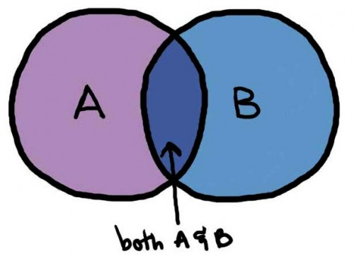
- From Birmingham to Johannesburg- Think about what it would be like to live in another country. Do you think your life would be the same or completely different? Use the following clip to compare living in Birmingham to Johannesburg. Show the similarities and differences between your life and Nwabisa’s life in South Africa. You may wish to show this in a Venn diagram, table or a poster.

- Exploring the World- Throughout history many people have explored new places. You can find out about some of them here. Pick an explorer from the list or one of your choice. Map out the places that the explorer visited or create a piece of art inspired by the places they visited using digital images as support. Write a diary entry from the explorer’s point of view to share what they have seen and experienced.
- Stay Active – it is important to keep active so you could try a bit of ZumbaKids at: GoNoodle family.gonoodle.com/channels/zumba-kids
- It’s National School Sport Week – read below to see how you can join in.

Staying Safe Online – Staying safe online is called 'digital literacy' and this means having the skills and knowledge to use the internet safely and responsibly. It is where someone can manage online content and communication, spot possible risks, and find ways to protect themselves from these risks. You can find out more by visiting Childnet.

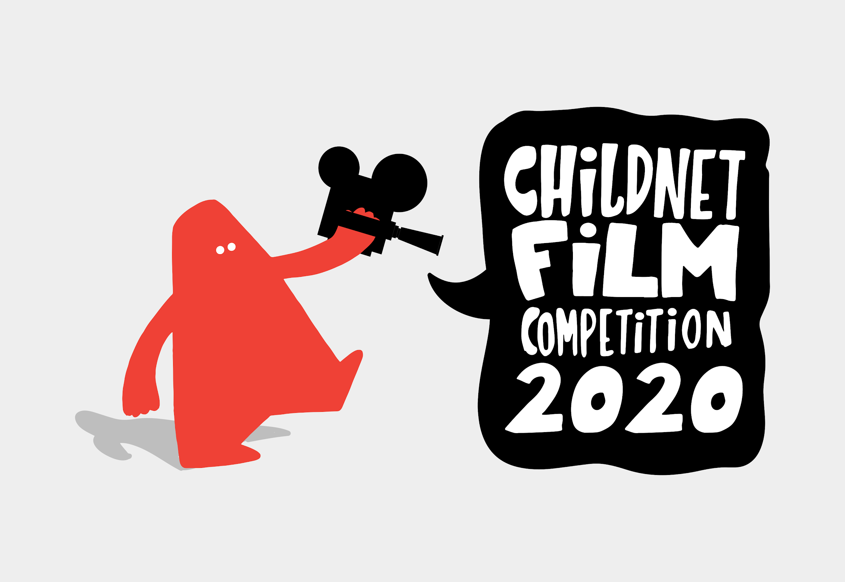
Have a go at entering The Childnet Film Competition which invites young people aged 7-18 to create a 2 minute online safety film to inspire their peers to create a safe, supportive and fun online world around the theme ‘We want an internet where we’re free to…’ The entries that make into the final shortlist will be judged by a prestigious panel made up of representatives from BAFTA, the BBC, the British Board of Film Classification, the BFI, Disney and the Motion Picture Association. The young people who create winning films and storyboards will receive great filmmaking and creative prizes for their school or youth group. Whether used at school or as a home learning project, the competition is a great way of exploring important internet safety messages with young people of all ages. Find out more here.
National School Sports Week - At Home. Saturday 20th to Friday 26th June 2020.
Taking place from 20 to 26 June, the UK-wide campaign will give families, communities, schools and sports clubs the opportunity to engage in a series of virtual sporting challenges which help young people capture the enjoyment, competition and camaraderie they have been missing out on during weeks of school closures and social distancing.
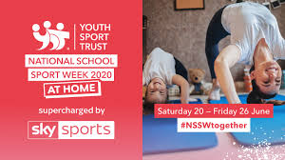
People can register to take part in the campaign from today. Anyone signing up will receive videos and activity cards to help them plan a series of challenges across the week for their families, neighbours, friends or colleagues. Use the following weblink to sign up https://www.youthsporttrust.org/national-school-sport-week-home
In previous years National School Sport Week has seen thousands of schools join in a week-long celebration of school sport and Physical Education, and their important role enhancing young people’s wellbeing.
Coronavirus and Wellbeing- Coping with Change
The change that Covid-19 has caused to our lives has been difficult and has provided countless challenges. For many children, the uncertainty and disruption to everyday life has caused worry and anxiety. These tasks are designed to help you process the current situation, begin to make sense of it and plan for returning to a different normal.

Think
- Explaining to children what the Coronavirus is and how to stop the spread can be a challenging task. This fact sheet does this in a child-friendly way. Alternatively, there is an animated version here.

Talk
- Talk to your parents about your worries and anxieties, considering what you can control and what you cannot control e.g. I can keep up with my home learning by checking which tasks I have to do today. I cannot control when this will all be over. Scientists, doctors and governments will help to manage this.

Do
- Make 2 lists: one listing all of the issues that are not within your control and the other listing issues that are within your control. After this, ask your parents to support you with listing who is responsible for the issues out of your control and then what you can do to support the issues within your control. This activity should help you feel more in control about the current situation.

Visit
This document from Emerging Minds offers evidence based advice for anyone supporting children and young people with your worries.

STEM Learning Opportunities #sciencefromhome
Engineering Around the World – Telescopes
- The James Webb telescope will be the largest, most powerful and complex space telescope ever built and launched into space in 2021.
- The telescope will be launched into space using a rocket, this means it will have to be strong enough to withstand the vibrations during the launch. Use an egg to represent the telescope and design a rocket that will surround and protect the egg/telescope during the launch.
- For more information and ideas look here.
Additional learning resources you may wish to engage with:
- BBC Bitesize - Lots of videos and learning opportunities for all subjects.
- Classroom Secrets Learning Packs - Reading, writing and maths activities for different ages.
- Twinkl - Click on the link and sign up using your email address and creating a password. Use the offer code UKTWINKLHELPS.
- White Rose Maths online maths lessons. Watch a lesson video and complete the worksheet (can be downloaded and completed digitally).
- Times Table Rockstars and Numbots. You can access both of these programmes with your school logins. On Times Table Rockstars, you should aim to play Soundcheck for 20 minutes daily.
- IXL online. Click here for Year 5 or here for Year 6. There are interactive games to play and guides for parents.
- Mastery Mathematics Learning Packs. Take a look at the mastery mathematics home learning packs with a range of different activities and lessons.
- Y5 Talk for Writing Home-school Booklets and Y6 are an excellent resource to support your speaking and listening, reading and writing skills.
#TheLearningProjects

