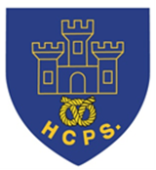
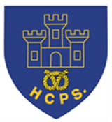
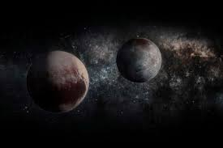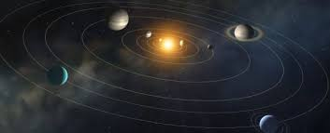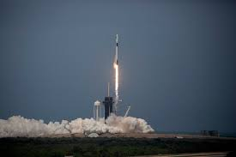
Learning Project Week beginning Monday 6th July – Space
Age Range: Y5/6
Weekly Reading Tasks | Weekly Spelling Tasks
Monday- Read unusual things in unusual spaces e.g. a recipe book in the bath. How many unusual spaces can you find over the week? | Monday- Pick 5 Common Exception words from the Year 5/6 spelling list here. Challenge yourself to create a word web by finding 5 other related words.
Tuesday- Visit Worldbookonline and login using Username: wbsupport and Password: distancelearn. Read the eBook Human Space Exploration. Note down unfamiliar words and find out their meanings. | Tuesday- Organise these synonyms from slowest to fastest: quickly, speedily, swiftly, hurriedly & in a flash. Which best describes a rocket launching into space?
Wednesday- Click here for a reading activity about Space Tourism. Challenge yourself to read the text in 3 minutes and complete the questions. | Wednesday- Some words contain the letter string -ough- Can you use this knowledge to complete these sentences against the clock?
Thursday- Listen to or read along to the poem Cosmic Disco. What does you think is the main idea in the poem? | Thursday- Identify any space related words from the poem Cosmic Disco. Can you draw illustrations to represent these words too?
Friday- Research information on past space expeditions here. Which expedition was the most impressive? Why? | Friday- Proofread your writing from the day. Use a dictionary to check the spelling of any words that you found challenging.
Weekly Writing Tasks | Weekly Maths Tasks
White Rose Maths – week 11.
Go to your year group and complete a daily lesson. whiterosemaths.com/homelearning/ The write-on sheets and answers will be attached in this email and on the school website as they are no longer available on the website.
BBC Bitesize daily maths lessons are now linked with Pearson Maths and follow the same topics as White Rose Maths but using different videos and worksheets. bbc.co.uk/bitesize/dailylessons
Monday- Visit the Literacy Shed for this resource on Broken: Rock, Paer, Scissors or you can create a comic strip retelling Armstrong's mission to the moon. | Monday- There are a range of interactive quizzes linked to area and perimeter that you can work through on this website. There are videos to help too.
Tuesday- Pretend you have woken up to find an alien at the end of your bed. Write a detailed description of the alien thinking about size, appearance and the sounds it makes. Draw it too! | Tuesday- Find objects around the home and estimate the area and perimeter and then measure the actual area and perimeter. If you have not got a ruler at home use this online resource.
Wednesday- Imagine that you are a news reporter, reporting on this alien visit. You can write a newspaper report. Remember the features of a newspaper. If you have access to a PC, you can type up your finished report on Word or Google Docs. | Wednesday- Make a map of a newly discovered planet, drawn onto paper. Each square on the map represents 5 metres squared (m²). It must include: mountains 220m², a water source 140m², three islands that must each be between 120m² and 240m².
Thursday- Create a travel brochure for a newly discovered planet. Consider: travel time, location, accommodation and things to do and see. | Thursday- Have a go at the different activities in this NRICH task. This can be done on paper.
Friday- Write a persuasive letter/job application to NASA asking to be the next astronaut to go into space. You must include the skills you have that would make you the best candidate. | Friday- Order the planets based on the number of Earth days it takes for them to orbit the Sun- Saturn: 10,759 days, Earth: 365 days, Mercury: 88 days, Uranus: 30,687 days, Jupiter: 4,333 days, Mars: 687 days, Venus: 225 days & Neptune: 60,190 days.
Learning Project - to be done throughout the week
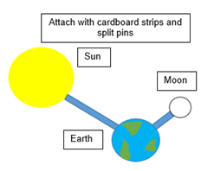
The project this week aims to provide opportunities for you to learn more about space. Learning may focus on our Solar System, the Sun and the Moon. It could look at life in outer space from the view of an astronaut and travelling through space.

- Moon Moves - Research the importance of the Moon to life on Earth. Research the movement of the Moon relative to the Earth and create a model of the Earth, Moon and Sun. Here is an idea of how you could do it.

- Through Space and Time- Research space exploration history and create a timeline of how people have travelled into space. Think about when the first rocket was launched? When did the first man travel to space? How about the first woman? What other significant events can they add to their timeline?

- Connect the Dots- Examine the different life stages of a star and explore the names and shapes of some famous constellations. Create a poster displaying the different constellations which can be used to teach others. Make it as creative as possible.

- Dancing into Space- Listen to Holst’s 'The Planets'. Select a planet and decide what they think that planet would be like. Create a dance/ set of movements to go with the music which will portray this. Take a video of your dance to share with the family and self-evaluate it whilst watching the video. Remember to tweet a video of your dance at #TheLearningProjects.

- Mission to Space- Research the different components of a spacecraft and using your understanding of this, design your own spacecraft. Think carefully about what it needs to include in order for astronauts to survive in space. Can you make a small scale model using resources from around the home? There might be inspiration here.

- Stay Active – it is important to keep active so you could try a bit of ZumbaKids at: GoNoodle family.gonoodle.com/channels/zumba-kids
- Or you could try Just Dance on YouTube:
Havana - https://www.youtube.com/watch?v=WNM0VWlMSYo
Happy - https://www.youtube.com/watch?v=YteMhrQvfCo
Uptown funk - https://www.youtube.com/watch?v=cntzSx-KdWw

STEM Learning Opportunities #sciencefromhome
Mission X – Building a Bionic Hand
- It is difficult and tiring for humans to work in space. Bionic hands that can be remotely operated can help humans work more efficiently in space. Try making a model bionic hand using cardboard, straws, string and elastic bands. You will need to think about how a human hand works to help you with your design. You can find out more here.
- Sign up and access all of the Mission X resources here.
Additional learning resources you may wish to engage with:
- BBC Bitesize - Lots of videos and learning opportunities for all subjects.
- Classroom Secrets Learning Packs - Reading, writing and maths activities for different ages.
- Twinkl - Click on the link and sign up using your email address and creating a password. Use the offer code UKTWINKLHELPS.
- White Rose Maths online maths lessons. Watch a lesson video and complete the worksheet (can be downloaded and completed digitally).
- Times Table Rockstars and Numbots. You can access both of these programmes with your school logins. On Times Table Rockstars, you should aim to play Soundcheck for 20 minutes daily.
- IXL online. Click here for Year 5 or here for Year 6. There are interactive games to play and guides for parents.
- Mastery Mathematics Learning Packs. Take a look at the mastery mathematics home learning packs with a range of different activities and lessons.
- Y5 Talk for Writing Home-school Booklets and Y6 are an excellent resource to support your speaking and listening, reading and writing skills.
#TheLearningProjects

