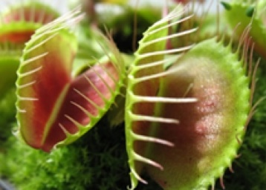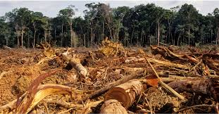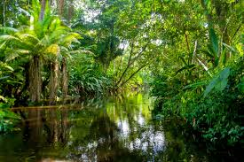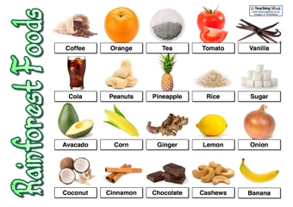
Learning Project Week beginning Monday 8th June – Rainforest
Age Range: Y5/6
We hope you are all well and enjoying the different activities. The layout of the plan has changed this week across the school. There are activities in a suggested timetable for each day which may be of help but you do not have to follow this order or complete every activity- please continue to do what fits in best for your child and your family. We understand families have different work commitments and different access to online activities. Thank you very much for all the weekly emails and updates. Please send any further updates to your class teacher!
mrsgoodstadthassell@gmail.com mrsplummerhassell@gmail.com missstokeshassell@gmail.com

Weekly Reading Tasks | Weekly Spelling Tasks
Monday- Listen to a free age-appropriate audiobook here, or choose a book from Oxford Owl. Why not read under a tree in the garden for a welcome change? | Monday- In the garden or during your daily walk, list nature related expanded noun phrases (e.g. the tall conifer by the wall). This may support your writing this week.
Tuesday- Read an account of living in a rainforest here. Record what the you like and don’t like about living in the rainforest. | Tuesday- Complete these tasks relating to words ending in -ant, ance, ancy, ent, ence or ency?
Wednesday- Listen to and read along with A Blade of Grass. What message is the poet trying to convey to the reader? | Wednesday- Create your own rainforest themed crossword. You will need to include a list of clues and an answer sheet.
Thursday- Find a recipe involving chocolate in a recipe book or here. Find out about chocolate here and summarise your learning. | Thursday- Create a rainforest glossary using these words as a starting point: canopy, monsoon, colony, extinct & deforestation.
Friday- Create a rainforest themed bookmark for a younger sibling or family member. | Friday- Pick 5 Common Exception words from the Year 5/6 spelling list. Create a mnemonic for each word e.g. Rhythm Has Your Two Hips Moving.
Weekly Writing Tasks | Weekly Maths Tasks-Converting Time and Timetables
White Rose Maths – week 7.
Go to your year group and complete a daily lesson. whiterosemaths.com/homelearning/ The write-on sheets and answers will be attached in this email and on the school website as they are no longer available on the website.
BBC Bitesize daily maths lessons are now linked with Pearson Maths and follow the same topics as White Rose Maths but using different videos and worksheets. bbc.co.uk/bitesize/dailylessons
Monday- Visit the Literacy Shed for this wonderful resource on The Alchemist’s Letter or take part in a writing master class. | Monday- Play ‘Match the Fraction’. Challenge yourself by trying the mixed numbers.
Tuesday- After the reading task, write a diary entry from the viewpoint of the child who lives in the rainforest. Alternatively, write a diary entry in the day in the life of Toki. What is the message of the story and how he felt throughout the clip? What emotive language could you use? | Tuesday- Practise converting decimals to fractions and write fractions in their simplest form on this online activity. Click the box that says ‘decimals fractions’ and select one of the options on the right. Record your answers on a piece of paper before checking by opening the boxes.
Wednesday- Write a poem about the rainforest. Try and create 4 stanzas about the climate, animals, what you like about it and the potential dangers. Now perform your poem. | Wednesday- Divide a piece of paper into four and select four cards from a pack of playing cards and make two fractions by placing a card in each quadrant. Compare the two fractions using the inequality symbols ( < > and =).
Thursday- Write two contrasting descriptions of the rainforest. One depicting the rainforest’s beauty and the other deforestation. | Thursday (theme)- Find the distance from Birmingham Airport to the Amazon Rainforest using Google maps? When is the best time to visit?
Friday- Rainforests are destroyed by nature too so we should make use of their products rather than waste them. Write a balanced argument. | Friday (other)- Have a go at this negative numbers game and/or this whole numbers game.
Learning Project - to be done throughout the week
The project this week aims to provide opportunities for you to learn more about the world’s rainforests. Learning may focus on the plants, animals and insects that inhabit the rainforest, food that originates there and weather patterns. It could look at plants and animals that can be found in the garden too.
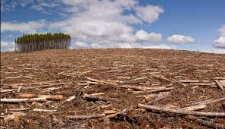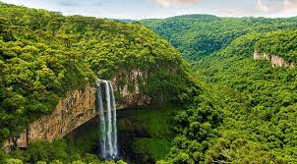

- Deforestation: Destroying Animal Habitats and The Homes of Humans- Deforestation occurs in rainforests throughout the world. Trees are cut down on a huge scale, often to create space for grazing livestock or buildings. As part of this process, animal habitats and the homes of native people are often destroyed. Create a poster highlighting the impact of deforestation on both humans and animals. Think of possible solutions to some of these challenges and include these solutions on their posters. Remember to tweet a photo of their poster using #TheLearningProjects.
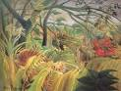
- Welcome to The Jungle: Let Creativity Roar! - Henri Rousseau was a French painter from the 19th Century who created many paintings inspired by jungles and rainforests, although he never actually visited one. Explore facts about this famous painter and create a jungle/rainforest piece of artwork in his style. You could draw, paint or create a collage, depending on the resources you have available at home.

- Discovering Far off Lands- In the 16th century, Sir Walter Raleigh sailed the Atlantic Ocean in search of a place called El Dorado. His expedition took him to Guyana and his search led him to discover the country’s rainforest. 400 years on, a group of children have taken on the challenge to follow in Sir Walter’s footsteps in their own expedition to Guyana. Watch this clip and explore the others on the BBC Teach website. Plan your own expedition and consider what you would need to take. Alternatively, write a first-hand account of your time in the rainforest from the perspective of Sir Walter. Remember that Sir Walter would not have had access to the mod cons we do now.

- Deforestation: Our Climate and Our Planet- As well as impacting on animal habitats and native people, deforestation is also a major contributor towards climate change. Create an awareness leaflet about the effects of climate change on our planet and how deforestation is contributing towards this.

- Stay Active – it is important to keep active so you could try a bit of ZumbaKids at: GoNoodle family.gonoodle.com/channels/zumba-kids

- Rumble in The Jungle - Get that Heart Rate Going! - Increase their heart rate by challenging themselves and members of the family to mimic the actions of animals which inhabit rainforests. Actions could include: jumping over logs, ducking under branches, high knees through quicksand, running from a tiger etc. Challenge them to record their heart rate (beats per minute) after each activity. Which activity increased their heart rate most? Recommendation at least 2 hours of exercise a week.
Bike week 2020 – online from June 6th to June 14^{th.}

In these uncertain times, coming together to ride is not possible,
so there is a series of fun Bike Week events online this June.
Cycling remains a great way to keep fit and active and is a good way to boost immunity,
it’s also great for your mental well-being. You can be a cycling hero by taking in cycling challenge this
Bike Week, there is a chance for you to win prizes

- Staying Safe Online – Thinkuknow is the education programme from NCA-CEOP, a UK organisation which protects children both online and offline. It is important that you know how to keep yourself safe online, especially while we are asking you to complete lots of online learning tasks. The Thinkuknow website now has information for parents about keeping children safe online and home activity packs children can complete while schools are closed. Simply scroll down to the relevant age range pack by following the link below:
www.thinkuknow.co.uk/parents/Support-tools/home-activity-worksheets/
STEM Learning Opportunities #sciencefromhome
Rainforest Leaf Adaptation
- Watch this video.
- Many tropical rainforest leaves have a drip tip to help them cope with high rainfall. It is thought that these drip tips enable rain drops to run off quickly. Plants need to shed water to avoid growth of fungus and bacteria in the warm, wet tropical rainforest. Have a look at some other common leaf adaptations here.
Look at the leaves in your garden or out on a walk. What adaptations do they have? Create a branching identification key to help identify the leaves in your area.
Additional learning resources you may wish to engage with:
- BBC Bitesize - Lots of videos and learning opportunities for all subjects.
- Classroom Secrets Learning Packs - Reading, writing and maths activities for different ages.
- Twinkl - Click on the link and sign up using your email address and creating a password. Use the offer code UKTWINKLHELPS.
- White Rose Maths online maths lessons. Watch a lesson video and complete the worksheet (can be downloaded and completed digitally).
- Times Table Rockstars and Numbots. You can access both of these programmes with your school logins. On Times Table Rockstars, you should aim to play Soundcheck for 20 minutes daily.
- IXL online. Click here for Year 5 or here for Year 6. There are interactive games to play and guides for parents.
- Mastery Mathematics Learning Packs. Take a look at the mastery mathematics home learning packs with a range of different activities and lessons.
- Y5 Talk for Writing Home-school Booklets and Y6 are an excellent resource to support your speaking and listening, reading and writing skills.
#TheLearningProjects

