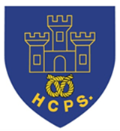
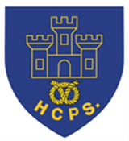
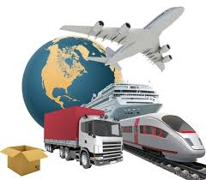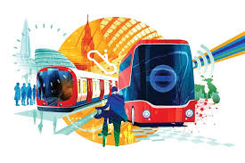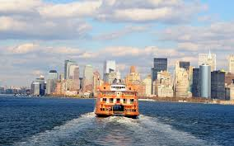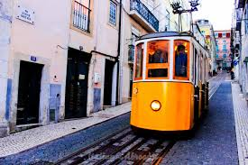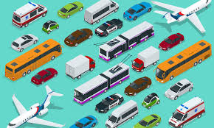
Learning Project Week beginning Monday 13th July – Transport
Age Range: Y5/6
Weekly Reading Tasks | Weekly Spelling Tasks
Monday- Listen to an audiobook on your daily walk here. Perhaps you could choose a journey tale? | Monday- Pick 5 Common Exception words from the Year 5/6 spelling list here.  Challenge yourself to write three clues for each of your words.
Tuesday- Look at a car manual and look up any new technical terms. Design your own manual for a vehicle of your choice. | Tuesday- Create a transport glossary of these terms: underground, cargo, gangway, pedestrian, terminal & voyage?
Wednesday- Click here for a reading activity about The Titanic. Challenge yourself to read the text in 3 minutes and complete the questions. | Wednesday- Using the vocabulary from yesterday, apply these words into sentences to show your understanding of the meanings.
Thursday- Look at leaflets, newspaper articles or other literature about transport. What does the information tell you about how we use transport? | Thursday- Work out the Year 5/6 words from these bouncing anagrams?
Friday- Learn all about Robert Fulton here. Take the quiz about this famous inventor, located at the bottom of the page. | Friday- Task yourself with creating a space themed word boardgame. When it’s complete, play together as a family.
Weekly Writing Tasks | Weekly Maths Tasks
White Rose Maths – week 12.
Go to your year group and complete a daily lesson. whiterosemaths.com/homelearning/ The write-on sheets and answers will be attached in this email and on the school website as they are no longer available on the website.
BBC Bitesize daily maths lessons are now linked with Pearson Maths and follow the same topics as White Rose Maths but using different videos and worksheets. bbc.co.uk/bitesize/dailylessons
Monday- Visit the Literacy Shed for this wonderful resource on Ruckus or you can make a poster to promote travelling on the Eurostar. | Monday- Watch this online video to develop an understanding about what volume is.
Tuesday- Design your own mode of transport and then create an information leaflet all about it. Think about how it works, what it looks like and safety procedures whilst on board. What destinations does the vehicle travel to and how long is travel time? | Tuesday- Using sugar cubes, marshmallows, cubes if you have them, make a shape with a volume of 24 centimetres cubed. How many different shapes can you make? Can you draw each shape you make? Will you make more or less shapes if you are given a bigger volume?
Wednesday- Create a menu for guests on board their new form of transport. Make it as creative as possible and think about the layout. This could be done on Word or Google Docs if you have access. | Wednesday- Find the volume and surface area of these rectangular prisms in this online game.
Thursday- Write a job application as someone who would like to work on board this new mode of transportation. Think about the skills you need for the job. Here is an example. | Thursday (theme)- Plan a day out for the family at a location of choice. Think about the different ways you could travel to the location. Work out the cost of using the different transport modes, how long each would take and think about the most environmentally friendly mode of transport.
Friday- Research the famous explorer Christopher Columbus, how he travelled and his voyages. Create a journey story to retell this. This could be written in the first person as Columbus himself. | Friday (theme)- Draw an aerial map from your house to a location of choice (this could be school, the shops, the park etc). Write a set of directions on how to use the map using positional language.
Learning Project - to be done throughout the week
The project this week aims to provide opportunities for you to learn more about transport. Learning may focus on modes of transport, transport in the past, the science behind transport, road safety and how to be safe around water.
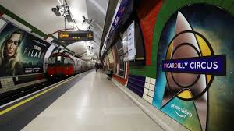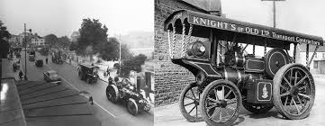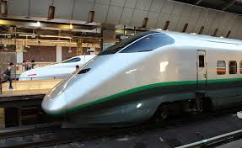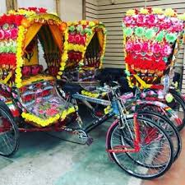
- Is it a Bird? Is it a Plane?- Choose a major city from each continent and look at the population’s primary mode of public transport, e.g. rickshaws and Skytrain in Bangkok, Asia, the Tube in London, Europe etc. Create a fact-sheet showing each city’s most popular mode of transport and decide which is your favourite, providing reasons for your opinions.
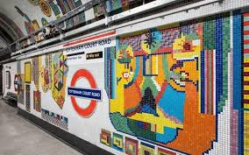
- Creativity in the Underground- Many of the London Underground tube stations have their own unique, tiled designs. Think of your own London Underground tube station name and create a tile design to accompany it. You could simply draw the design using crayons, felt tips or paint. Alternatively, you may choose to represent the design in the form of a collage, cutting out your own tiles of paper, newspaper, magazines, cardboard, or whatever you have access to at home. Remember to tweet a photo of their design using #TheLearningProjects.

- From Horse-Drawn Cart to Jumbo Jet- Select 10 modes of transport from throughout history using this link. Research the modes of transport and present them on a timeline, writing a description for each one, explaining what it was and who would have used it - bonus points for including the inventors!
- Faster Than a Speeding Bullet...Train- The Shanghai Maglev, also known as Shanghai Transrapid, is currently the fastest train in the world, running between Shanghai and Beijing in China. Challenge yourself to be just as speedy and complete the following 5 activities as fast as possible: Star jumps, tuck jumps, press-ups, squats and lunges. Record how many repetitions of each activity you can perform in 1 minute. Can you beat your personal best? Challenge yourself to record your heart rate (beats per minute) after each activity. Recommendation at least 2 hours of exercise a week.

- Make and Do - Make it Go!- Try this hover balloon activity. You will need the following equipment: CD, bottle top with push/pull closure, like those on some sports drinks or water bottles, blu-tack or glue and a balloon. Alternatively, you could have a go at creating a baking powder powered boat. You will need the following equipment: empty water bottle, baking powder, kitchen roll or tissue, scissors, straw, vinegar, sellotape. If you don’t have access to this equipment, you can watch and read about the experiments and can discuss with your parents your favourite, providing reasons for your opinions.

- Stay Active – it is important to keep active so you could try a bit of ZumbaKids at: GoNoodle family.gonoodle.com/channels/zumba-kids
- Or you could try Just Dance on YouTube:
Havana - https://www.youtube.com/watch?v=WNM0VWlMSYo
Happy - https://www.youtube.com/watch?v=YteMhrQvfCo
Uptown funk - https://www.youtube.com/watch?v=cntzSx-KdWw

STEM Learning Opportunities #sciencefromhome
Brilliant Boats
- Watch this video about boat designs.
- Try creating your own boat designs and testing them. You might like to use something smaller and more waterproof than a bag of sugar for testing though!
Additional learning resources you may wish to engage with:
- BBC Bitesize - Lots of videos and learning opportunities for all subjects.
- Classroom Secrets Learning Packs - Reading, writing and maths activities for different ages.
- Twinkl - Click on the link and sign up using your email address and creating a password. Use the offer code UKTWINKLHELPS.
- White Rose Maths online maths lessons. Watch a lesson video and complete the worksheet (can be downloaded and completed digitally).
- Times Table Rockstars and Numbots. You can access both of these programmes with your school logins. On Times Table Rockstars, you should aim to play Soundcheck for 20 minutes daily.
- IXL online. Click here for Year 5 or here for Year 6. There are interactive games to play and guides for parents.
- Mastery Mathematics Learning Packs. Take a look at the mastery mathematics home learning packs with a range of different activities and lessons.
- Y5 Talk for Writing Home-school Booklets and Y6 are an excellent resource to support your speaking and listening, reading and writing skills.
#TheLearningProjects

