Year 6 Transition Learning Projects
WC 06.07.2020: Individual qualities.
This week’s learning project focuses on your qualities that make you unique and special.
It will give you the opportunity to reflect on what you like, dislike and excel in.
Transition Activities:
Monday-Think about what makes you special. What qualities do you possess which you think makes you unique? Independently write 5 down which you think are the most important. Ask a parent or your family, to come up with 5 qualities which they think make you special. Come together to compare the qualities listed and explain why each person chose the qualities they did. You could then write your three best qualities down, explaining why you chose these.
Tuesday-Think about the qualities you discussed yesterday and what each of them mean. Can you create a piece of artwork in the shape of a star to represent your ‘star qualities’? Can you make the outline of the star using the words chosen or include your qualities within the star itself? Be creative in how you want to display your individual qualities.
Wednesday- Art can be a great tool for self-exploration and self-expression. Create a piece of artwork which represents your personality. This could be a picture or something more abstract using materials available at home. You may find listening to their favourite music encourages your own expression or being able to complete this in their bedroom if possible. Once completed, discuss your artwork with your parents. What did you want to represent in this piece? How did you try to show off your personality through your artwork?
Thursday- Children have many talents which should be celebrated. Talk to your parents about the talents that you have. Together, look at the website for your secondary school and research which extra-curricular clubs are on offer. Can you celebrate your ICT skills at a Coding Club or your problem solving skills at the school Chess Club? If there isn’t a club that suits your capabilities, look at alternative ways you could practice your skills e.g. local clubs or online learning.
Friday- Every child is unique and special. Using the template below, talk to your parents about what makes you, you. Write a paragraph for each heading or draw an illustration in each section. Consider: interests, talents, things you would like to be better at and your hopes and aims for secondary school.

WC 06.07.2020: Individual qualities. - Example Work
Below are some examples of how you could set out your work:
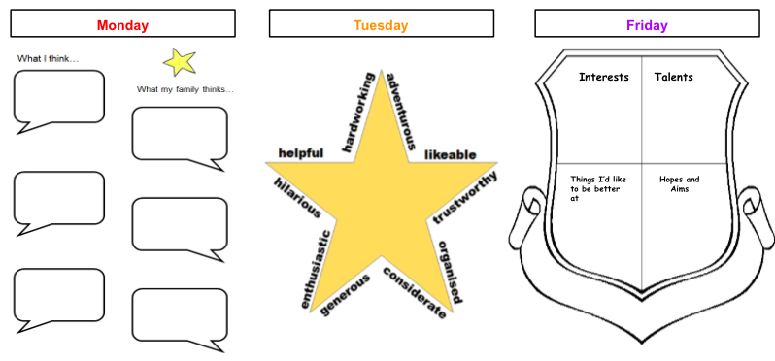
Additional Learning Resources Parents May Wish To Engage With:
- This website explains why self confidence is so important and gives some activities on how to build self confidence.
- Premier League Stars have created some helpful videos and activities for self-esteem
- Childline want to help bring out the best in your child through some easy-to-do activities.
- An article for parents which can help with discussions about how to develop self-belief and confidence in children.

