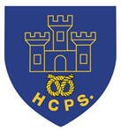

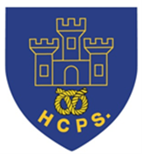
Year 6 Transition Learning Projects
WC 13.07.2020: Valuing your achievements.
This week’s learning project focuses on your successes throughout your time at school.
It will give you the opportunity to reflect on what you have enjoyed and achieved throughout your time in primary school life..
Transition Activities:
Monday- You have achieved so much at primary school and now it is time to reflect on what makes you proud. Create a ‘Wheel of Achievements’ that displays your proudest moments. Label each section with headings such as ‘Maths’, ‘English’, ‘P.E’, Music, ‘Friendships’, ‘Hobbies’. Inside each segment you can either draw a picture or write a sentence to show what you are proud of. You can decorate it using bright colours so your wheel shines with pride. Share your work on Twitter using #thelearningprojects
Tuesday- Some of the best memories of childhood are the silly ones that make you giggle. Create an amusing comic strip of a funny moment from your school journey. Include thought bubbles and speech bubbles to bring the comic to life. Comic strips are usually vibrant in colour so use bold colours for your illustrations. If you cannot recall a funny moment, create a comic strip of any key moment that is significant to you. For example, meeting your best friend for the first time, competing in Sports Day or a favourite school trip.
Wednesday- At the end of Year 6, you would ordinarily have the opportunity to gather ‘goodbye and good luck’ messages from your Teachers and friends, often written in a book which you can keep and treasure. Today’s task will create a ‘Virtual Leavers Book’ in which you will write a message to your Year 6 peers. Write a message of farewell and good luck to your Year Group and send this in to your Teacher through your online learning platform.
Thursday- Not only is it important for you to value your past achievements, it is important for you to plan to achieve new goals. Create a ‘bucket list’ of things you wish to achieve in your first year of secondary school. This could include points such as making new friends, taking the bus to school by yourself etc. Once you have completed this, create a bucket list of things you hope to achieve before secondary school begins. This could include points such as learning to tie a tie, completing a Summer Reading Challenge, baking a cake and more.
Friday- Coming together to celebrate the end of Year 6 is an important ritual for you. Today’s task metaphorically brings you all together by joining your memories in a jigsaw. Use the puzzle piece template to write your best moment of Year 6. All of Year 6 have been asked to complete this task and all of their individual memories on the jigsaw pieces will slot together to create one fantastic ‘Jigsaw of Memories’.

WC 13.07.2020: Valuing your achievements. - Example Work
Below are some examples of how you could set out your work:
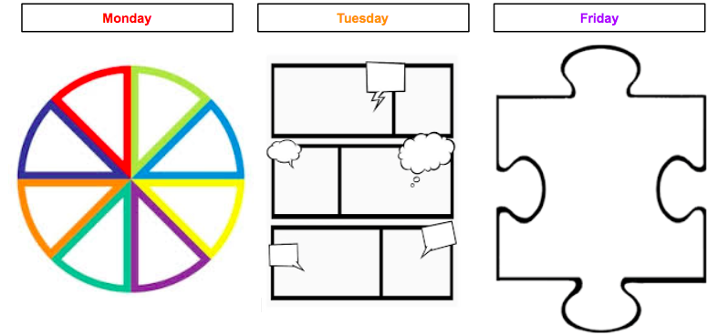

Additional Learning Resources Parents May Wish To Engage With:
- There are some useful tips about coping with anxiety in children on the NHS website
- This website provides some useful tips to parents of pupils transitioning to Secondary School
- Useful tips from The School Run website, which also provides general information and advice about your child’s learning journey.
- This website provides advice for supporting pupils with additional needs in transitioning to Secondary School.

