Year 6 Transition Learning Projects
WC 22.06.2020: Growing your independence.
This week’s learning project focuses on building your independence for your transition to secondary school.
It will give you the opportunity to plan for the different lessons you will have at secondary school and to organise a time for your studies at home.
Transition Activities:
Monday- Next year, you will have to be more responsible for things. Work with your parents to create an agreement of when you will spend time completing your homework. It might be worth discussing with how often you can go on your phone/computer/game console and when you need to have a break from them. After discussing this with them, create a screen time agreement together that includes when and how often you can use your devices.
Tuesday- As you move onto secondary school, you will learn many new things and develop new interests. It would be good to work on developing a new skill. This could be something you have always wanted to have a go at, such as cooking or gardening, or could be a new skill that you could explore with your parents, such as learning first aid or DIY around the home. After working on the new skill, you could write a blog post or an information poster about the new skill/hobby you have discovered.
Wednesday- As you grow more independent, it might be useful for you to have a key message/messages that you want to stick by. Create your own affirmation, quote or slogan that you will stick by when you are struggling with something and that will offer emotional support and encouragement as you develop your independence.
Thursday- You will be faced with scenarios that you will have to solve independently. Some of these will involve communicating effectively to your parents. Look at the different scenarios and decide the best way to solve them. You might want to discuss, with your parents, different ways you could approach these and decide together which would be the best solution.
Scenarios:
Scenario 1: You have got a detention at school. How are you going to explain this to your parents?
Scenario 2: Explain to your parents about the after school clubs that take place at your school. Which ones do you want to take part in?
Scenario 3: You return back to school but you have to social distance from your classmates. How is this going to work? How are you going to abide by these rules?
Scenario 4: Your parents want to know how you are going to get to school safely. Explain your route to them and also your back up plan. How long will it take you? When will you arrive at school and return from school? How will you let your family know you are safe? Use the route you created in week 2 to help you.
Friday- There are many things you need to become an independent thinker. Create an independence plant, flower or tree. On it you should label all the things you need to help you to grow independence. What skills and attributes do you need? Create this as a poster that you could hang up in you room. The next page has an example of how you could present this.

WC 22.06.2020: Growing Your Independence. - Example Work
Below are some examples of how you could set out your work:
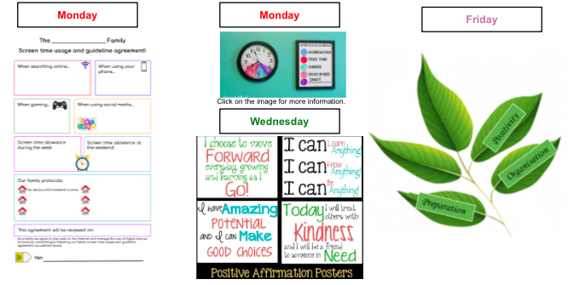

Additional Learning Resources Parents May Wish To Engage With:
- This website gives some ideas on how your child could approach writing their own affirmations.
- On this website, there are some useful ways you can support your child to develop their own independence.
- Here are a range of examples of screen time agreements that you could adapt for your child/home.
This short video gives advice about how your child can stay safe online and suggests how parents can support this. You could watch this with your child and maybe get them to include some of the things in their screen time agreement. There is also this screen time top tips for parents poster, which might be useful.

