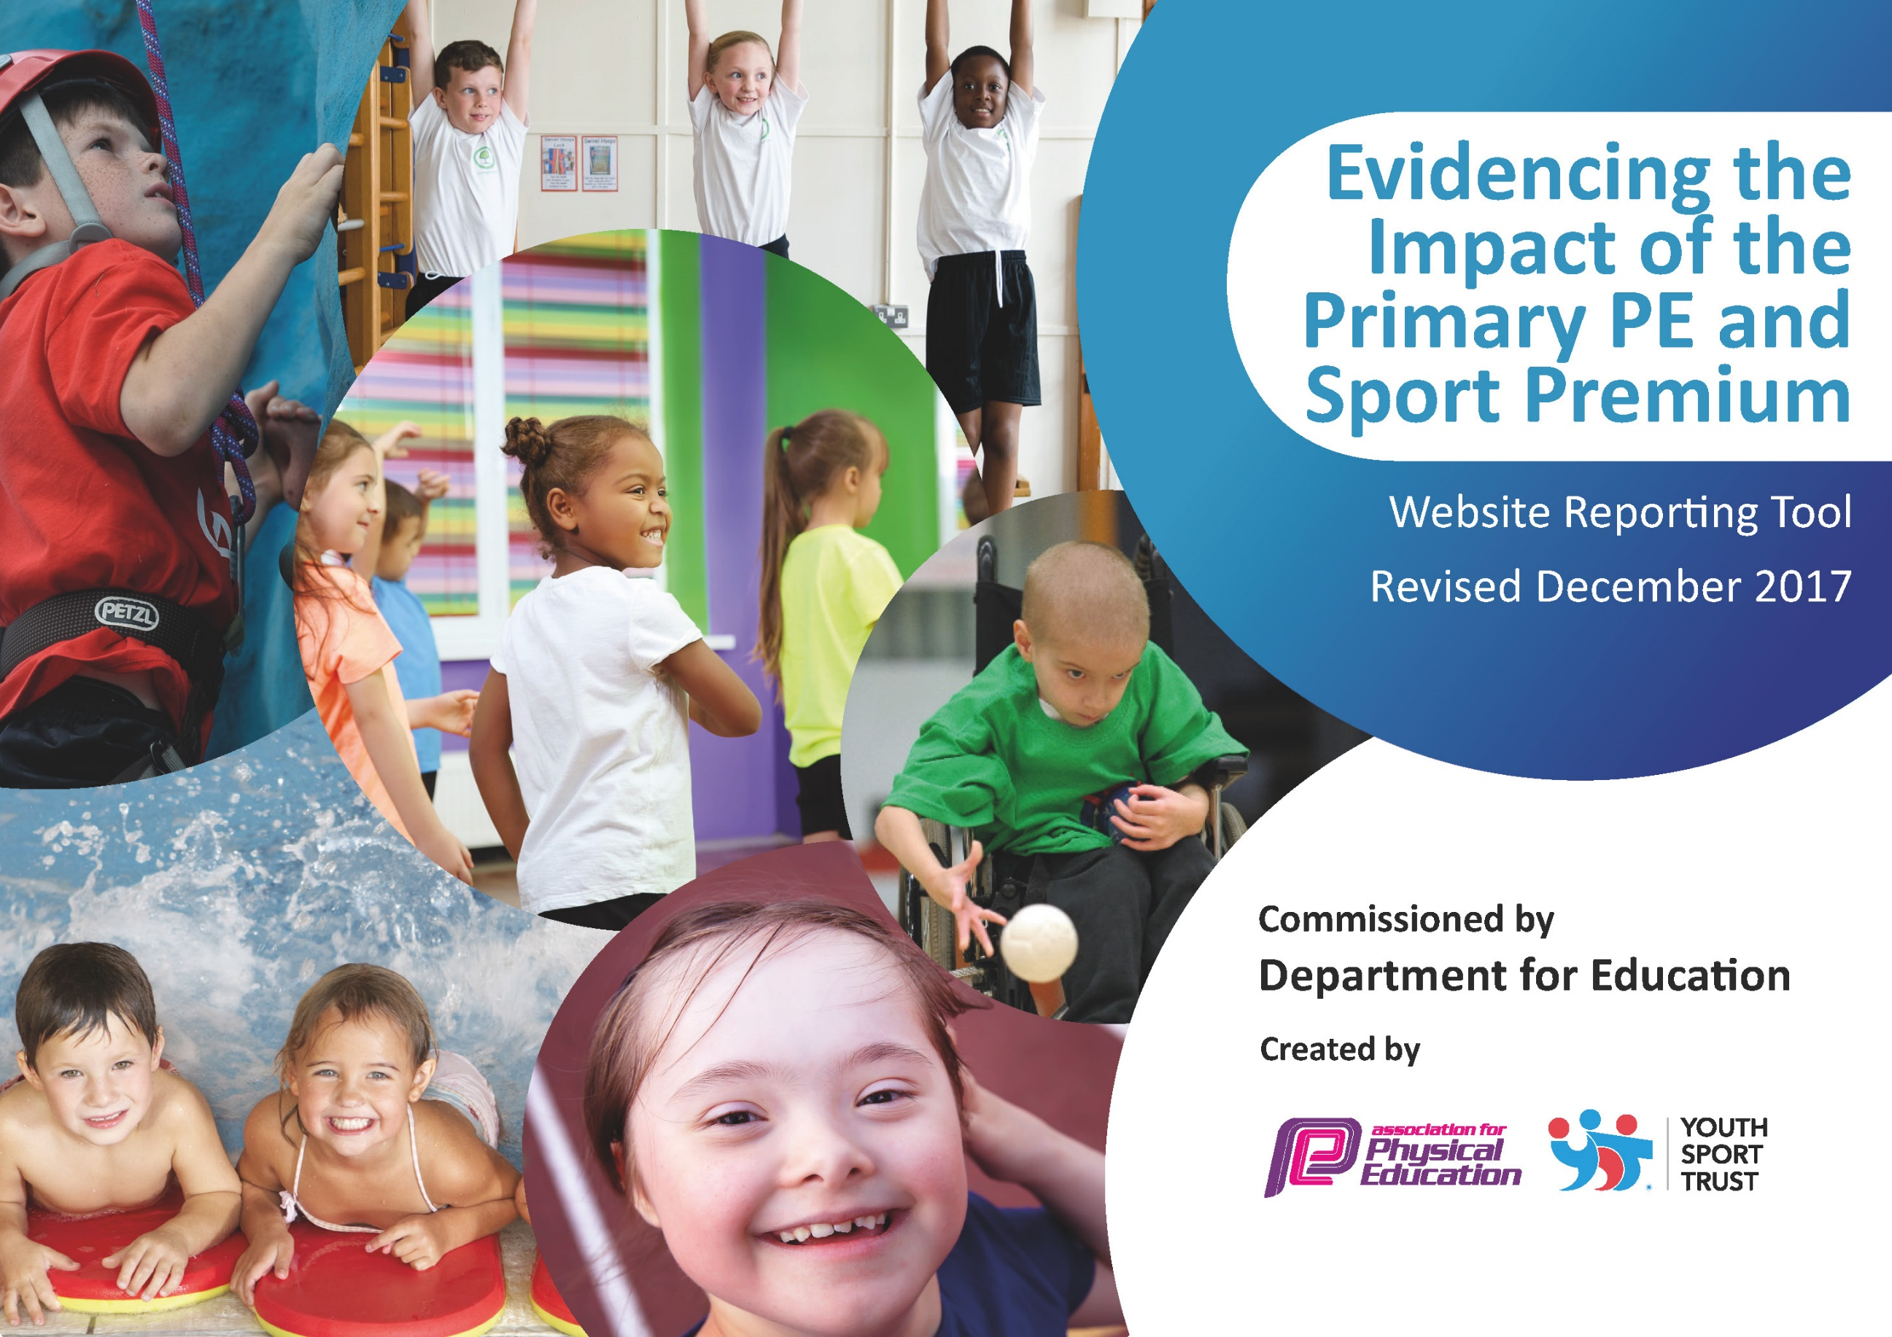

Support for review and reflection - considering the 5 key indicators from DfE, what development needs are a priority for your setting and your students now and why? Use the space below to reflect on previous spend, identify current need and priorities for the future.

Key achievements to date: | Areas for further improvement and baseline evidence of need:
Involvement in local school competitions (inter sports) including some 1st/2nd/3rd place allocations.  Raised profile of physical exercise and physical education across the school.  Most pupils have a good understanding of and adhere to healthy life choices  Increased number of pupils access sports activities after school.  Intra and inter school competition participation | Vision for PE and Sport needs further development  Need to develop confidence and consistency of PE teaching  Differentiation of lessons to challenge all pupils  Some pupils do not engage with extra-curricular sports clubs  Some pupils do not adopt healthy eating patterns
Meeting national curriculum requirements for swimming and water safety |  | Please complete all of the below*:
What percentage of your current Year 6 cohort swim competently, confidently and proficiently over a distance of at least 25 meters? |  | Children leave our school at the end of year 4 to join the local middle school. 64% of children (7/11) leaving us at the end of year 4 in 2016 were able to swim at least 25 meters.
What percentage of your current Year 6 cohort use a range of strokes effectively [for example, front crawl, backstroke and breaststroke]? |  | Children leave our school at the end of year 4 to join the local middle school. 55% were able to use a range of strokes. (6/11 children)
What percentage of your current Year 6 cohort perform safe self-rescue in different water-based situations? |  | Children leave our school at the end of year 4 to join the local middle school. 36% were able to (4/11 children)
SchoolscanchoosetousethePrimaryPEandSportPremiumtoprovideadditionalprovisionforswimming but this must be for activity over and above the national curriculum requirements. Have you used it in this way? |  | Yes/No  All pupils from year 1-4 attend 45 minutes swimming lessons each week

Action Plan and Budget Tracking
Capture your intended annual spend against the 5 key indicators. Clarify the success criteria and evidence of impact that you intend to measure to evaluate for students today and for the future.

Academic Year: 2017/18 | Total fund allocated: £ | Date Updated: 10th January 2017
Key indicator 1: The engagement of all pupils in regular physical activity – Chief Medical Officer guidelines recommend that primary school children undertake at least 30 minutes of physical activity a day in school |  |  |  | Percentage of total allocation:
 |  |  |  | %
School focus with clarity on intended impact on pupils: | Actions to achieve: | Funding allocated: | Evidence and impact: | Sustainability and suggested next steps:
Increase physical  development in Early Years | Promote physical fitness as being fun in order to make being active a lifelong and natural habit. | £250 | Children will be able to acquire basic body management skills such as, balance and control and spatial awareness as well as having good fine motor skills. | Add to resources as necessary
Promote Healthy Lifestyles | Children to enjoy participating in a range of physical activities to promote healthy living and understanding the importance of making healthy choices, through cross curricular work.  Daily active challenge to encourage all pupils to be more active during the school day. Focus on children who are not naturally active and don’t take part in other activities.  As part of Sports Relief, physical activity to be completed everyday by all pupils. Earn points for their houses, fun competition – accessible to all children. | Free | Children will be healthier and more active. They will be encouraged to live a healthy lifestyle through healthy eating and being physically active.  Progress record kept of activities, i.e. Distance covered, jumps completed etc. All pupils to be actively involved.  Information to be sent out to parents and photos to be taken during all events and published on school website and social media page.  Team games/ activities being attended by pupils. Leadership skills being developed in the leaders. | Can be repeated each year in line with sports relief.
Purchase new equipment – allow for delivery of new sports | Children are able to access sports equipment for new sports to develop their interest in PE and sport. Equipment will allow for new and exciting after school clubs to increase number of participants. | Tri Golf £342.98  Table Tennis sets £150 | Number of children attending after school clubs.  Number of children participating in level 2 sports games.
Increase physical development during break times. | Year 4 pupils to complete the primary stars play maker award in order to lead play. (Playmaker Programme – Monday, September 11th to October 16th.)  Meetings required with play-ground staff so they can oversee the activities. | £240 | Play Makers organising play-ground activities for the rest of the school during lunch time play. This is to include wet play time.  Certificates given to play makers on completion of course. Photograph activities | This can be continued indefinitely as part of the daily school routine, with the activities becoming more complex as the children develop.New play makers will need to Year 3 children to ‘shadow’ during the summer term then joint plan some activities during the final half term. Playmakers to oversee.
Increase levels of physical activity outside of school hours | Creation of physical activity bags for pupils to access outside of school hours. Bags to include suggested activity cards and the necessary equipment. | £100 | Questionnaire about accessing physical activity to be completed at the beginning and end of the year. Results to be analysed for increased uptake outside of school hours.  Sporting bags regularly accessed by pupils.

Key indicator 2: The profile of PE and sport being raised across the school as a tool for whole school improvement |  |  |  | Percentage of total allocation:
 |  |  |  | %
School focus with clarity on intended impact on pupils: | Actions to achieve: | Funding allocated: | Evidence and impact: | Sustainability and suggested next steps:
Inspire children to have a continued positive attitude towards PE and Sport. | Children to experience a day in the life of Stoke City. (KS1 and KS2) | £250 (visit) plus  £180 (transport costs) | Valuable experience for pupils – positively impacting on motivation and achievement. | .
 | Children to participate in ‘World Cup Week’. Each class to research a different country. Whole school celebration of findings. Football match(intra school) – whole school to watch. Winning team to be presented with the world cup. | Free | Supports school theme, ‘Around the world’. Broadens pupils’ horizons and knowledge of different cultures.  Inspires pupils to compete in intra school competition.
 | Inspirational sports person to visit the school to inspire and encourage children to be involved with sport. | £500 | Valuable experience for pupils, impacting positively on motivation and achievement. Children will use the experience to produce high quality writing, following visit, as this is a real life experience.
 | Certificates for any sporting achievement to be presented in Celebration Assembly to ensure the whole school is aware of the importance of PE, sport and health. Premier League, Primary Stars certificates to be awarded: ‘Be connected, Be ambitious, Be inspiring, Be fair’ to be awarded during Celebration Assembly. | Free | Sporting achievements celebrated in assembly with details of event/sport and sports clubs – inspiring other pupils to get involved. Questionnaire about accessing sports to be completed at the beginning and end of the year. Results to be analysed for increased uptake. Parents invited to attend celebration assembly – parents value PE and Sport.
 | PE / Sports display area in school to raise the profile of sport, the outdoors and healthy living to pupils and visitors. Board to also celebrate sporting achievements and provide information of upcoming events. | Free | Sporting photographs to be taken and used on schools social media.  Sports noticeboard regularly updated with sporting achievements, pictures and results.
 | Primary Stars Reading Programme (Years 3 and 4) in partnership with Stoke City | £350 (10 week course) | Valuable experience for pupils, impacting positively on motivation and achievement.
 | Primary Stars Maths Programme (Years 1 and 2) in partnership with Stoke City | £210 (6 week course) | Valuable experience for pupils, impacting positively on motivation and achievement.
 | Introduction of Sports Ambassadors and Play leaders | £15 badges | Raised profile of sports and physical activity in school.  Sports ambassadors attend the PE steering group meetings at Stoke City with headteacher and report back to the rest of the school.
 | Purchase staff tracksuits to be worn during PE sessions | £300 | Staff appropriately dressed for PE.

Key indicator 3: Increased confidence, knowledge and skills of all staff in teaching PE and sport |  |  |  | Percentage of total allocation:
 |  |  |  | %
School focus with clarity on intendedimpact on pupils: | Actions to achieve: | Funding  allocated: | Evidence and impact: | Sustainability and suggestednext steps:
Specialist coaches to deliver PE curriculum alongside staff members and provide extra curricular staff, whilst developing CPD for staff. | Employ a specialist sports coach to work alongside the staff in KS1 and 2 to allow for sharing good practice.  Sports coaches to support and promote a variety of after school clubs and sports competition opportunities. | £3500 | High quality teaching and learning in PE curriculum.  More opportunities for pupils to access extra curricular activities.  CPD – sharing good practice and team teaching to upskill teaching PE and coaching in clubs. | Staff team teach and share good practice
CPD for staff | 6 week 1:1 coaching and team teaching sessions with an experienced PE teacher for KS2 staff. | £300 (6x1 hour sessions) | Staff will have improved subject knowledge and be more confident in delivering PE lessons and be able to provide feedback and lead discussions.
Appoint PE lead to work alongside staff and external sports coaches, and provide extra curricular activities. | Sports lead to complete AFPE Level 5 qualification. | £3000 (towards salary – delivering PE for 2 hours per week)  £900AFPE course | Good practice shared. Staff upskilled through PE lead disseminating key information. PE lead confident in her role. PE and Sport have a high profile within school.  Lunch time running club established. More pupils attending inter school cross country events.
High quality PE and Sport in early years with high number of children achieving their milestones for physical development. | Children in early years access 1 hour per week of high quality PE and sport activities. Physical development opportunities available through continuous provision throughout the rest of the week. | As part of PE leads role | Children in Early Years to access high quality PE lessons to develop early development of fundamental skills.  High number of children achieving physical development objectives by the end of the year.
Increased staff knowledge o a variety of activities | Forest school training to be completed by one member of staff  Purchase equipment required to deliver forest schooling to all key stages | £950 (level 3 course)  £135 First Aid course  £300 Equipment | Children able to access forest school activities as part of the curriculum | Staff member will deliver as part of teaching contract/commitment  Resources would need to be replaced when necessary

Key indicator 4: Broader experience of a range of sports and activities offered to all pupils |  |  |  | Percentage of total allocation:
 |  |  |  | %
School focus with clarity on intended  impact on pupils: | Actions  to achieve: | Funding  allocated: | Evidence and impact: | Sustainability and suggested  next steps:
Continue to offer a wide range of activities both within and outside the curriculum. | Survey parents to ascertain sporting clubs that pupils already attend. Invite local providers to offer demonstration sessions in school and to advertise their services in the foyer. | Free | More pupils will be involved in a wider range of sporting activities both in school and the wider community. | Look at additional organisations that hold taster days at reduced costs.
Broader experience of a range of activities | Children in Key Stage One to participate in the Pottermus Challenge (Stoke City) – inter schools competition | Free event  £180 transport costs | Sports ambassadors to report back to the Stoke City steering group (written report)
Increase range of activities on offer in school | British cycling day  Year 4 residential trip to Laches Wood (outdoor activities)  Sports Relief Challenge Week | Free | Children in Early years and Key Stage 1 to experience riding balance bikes
Increased percentage of pupils being able to swim 25m | Children in Years 1-4 will access weekly swimming sessions with a qualified instructor (45 minute sessions) | £4000  Includes transport | Pupils able to swim 25 metre with confidence. Swimming records to show achievements. | Possible reduction in hours and sessions offered in future years.
Increase pupils participation in  competitions and/or festivals | Arrange transport to sporting events | £500 towards transport | Attend all Leek School Competitions  Children feel confident to take part and are able to understand and explain competition. | Parental contributions might be necessary in the future to support transport costs.

Key indicator 5: Increased participation in competitive sport |  |  |  | Percentage of total allocation:
 |  |  |  | %
School focus with clarity on intended  impact on pupils: | Actions to achieve: | Funding  allocated: | Evidence and impact: | Sustainability and suggested  next steps:
Increase number of pupils participating in competitive sports | The pupils will continue to compete in the Leek Schools and Small Schools Tournaments.  Hold practice sessions for the different events in PE lessons and at other times to enable the pupils to have a sound knowledge of the sport before competing in the tournament. Book transport and send consent letters to parents. | £500 (as above) | Results from the tournaments. The impact of these are:  Team bonding  Increased fitness  Wider range of sports knowledge  Experience of competition against other schools. | Transport is the only funding issue that would need to be sustained.  To look at non-school competition that our pupils may like to get involved in.
Increase participation | Register and work towards the School Games Mark in order to gain Bronze this year Identify a member of staff to look at the Schools Games Mark criteria and put together the application. | Free | Gain Bronze award.  Raising the schools profile. Evidence to be displayed in sports display area and on the schools social media. | Aim for the Bronze Mark and possibly the Silver this year. Once the mark is achieved continue to work to those standards.

